

Minutes of the Meeting of the
Preston Seton Gosford Area Partnership
Wednesday 15th January 2025, 7-9 pm
Pennypit Centre, Prestonpans

Members (and substitute members) present:
Ben Morse, Chair (BM)
Cllr Colin Yorkston, East Lothian Council (CY)
Pamela Fraser, Cockenzie and Port Seton Community Gala (PF)
Sandra Bell, Chairperson Port Seton Centre Management Committee (SB)
Carla Allan, Volunteer Centre East Lothian (CA)
Janis Wilson, Prestonpans Community Council (JW)
Paul Ince, Longniddry Community Council (PI)

Others in attendance:
Emma Brown, Connected Communities Manager, ELC (EB)
Shirley Gillie, Business Support, ELC (SG)
Lorna Bellany, NHS Public Health (LB)
Michaela Taylor, Working for Change Collective (MT)
Chris Milne , ELC Roads Officer, Sustainable Travel (CM)
Callum Allan, AECOM (CalA)
Yousif Ali, AECOM (YA)

Apologies:
Alan Sneddon, Prestonpans Children’s Gala (AS)
Sheila Chambers, Cockenzie & Port Seton In Bloom (SC)
Graeme Hutchison, Prestonpans Children’s Gala (GH)
Gill Harman, Community Development Officer (GH)
Hannah Montgomery, Lighthouse Central (HM)

AGENDA ITEM |  |  |  | KEY DISCUSSION POINTS
- Welcome, Introductions & Apologies
 |  |  |  | BM welcomed everyone and apologies were noted. BM confirmed the meeting is unfortunately not quorate.
- Minutes of previous meeting
Minutes from previous meeting on 20.11.24 were unable to be approved as the meeting is not quorate.

BM asked CY if he had had any update re Blindwells? CY confirmed not had much contact, though he is aware of meeting later this month. CY will feedback his knowledge to Longniddry & Prestonpans Community Councils.
- Matters Arising
 |  |  |  |  | BM discussed membership and the provision In our standing orders where any non core member who has not attended at least 2 meetings can be removed. This would assist with our quoracy level although we cant do anything tonight with not being quorate. JW advised Preston Tower Group now a constituted and would like to join the Area Partnership. BM confirmed we had received a request and will go back to them.  Regarding voting at future meetings we are going to start acting on the standing orders. BM advised he will contact the core members and look at any issues regarding Community Councils and start a dialogue to try and resolve it. BM thanked CY stalwart attendance at AP meetings.  Hoping to work something out with councillors soon. SG/EB to prepare a list of Members who have not attended the last 3 meetings and have not given apologies.  Pushed HY Community Heat Team item from the agenda last time. PI didn’t have an update form HY. BM will check with HY.  EB mentioned bulb planting at Blindwells roundabout and the request from Amenities Team for £13,000 split between Faside and PSG. Ed Hendrikson confirmed this was sent in error as Area Partnerships can only fund labour and not cost of materials. BM asked Members to send us any idea for Amenities budget so we can use the allocation hours. JW has a proposal and will send this in an email.  BM also asked for ideas for the Roads Budget so we have a list ready if needed in the new financial year. BM thanked CM and Morag Haddow for all their hard work. | BM  SG/EB  BM  JW
- Working for Change Collective - Michaela
 |  | Michaela’s presentation is below:-    EB/SB/JW mentioned potential use of Community Centres for meetings and also keen to link in families that are on cusp that maybe feel their voices are not heard. EB to follow up with MT. LB advised that her, Lucy Higginson and Lucy Daniels are supporting WFCC to make sure voices and experiences are heard. BM will also be in touch with his work hat on. MT advised they are on facebook and have their next meeting at Blindwells 9am tomorrow. If you would like any more information please get in touch workingforchangecollective@gmail.com. Community Councils are happy to share information also. |  |  |  |  | EB
- Active Travel Route – Prestonpans to Levenhall – Chris Milne & AECOM
CM provided Members with plans for the above route and gave an overview. CM handed over to AECOM for the presentation below.

East Lothian Council are utilising grant funding from Sustrans to develop an improved route for people walking, wheeling and cycling along the B1348 and Ravensheugh Road, from Cuthill Park, Prestonpans to Levenhall roundabout. AECOM, who are also working on the Musselburgh Active Toun (MAT) project, have been commissioned to prepare some initial concept design drawings showing how this route could look.
The next stage of this project is to share those drawings with residents, businesses, elected members and local stakeholder groups, to ensure that people have the opportunity to record their views on it. It was noted that a stronger community response to such a consultation may improve chances of this and other funding applications in the future being successful.
We have set up a project webpage to support this consultation process, which you can find at https://www.eastlothian.gov.uk/prestonpans-to-levenhall.
The webpage noted above will contain the initial design drawings, as well as a further link to the East Lothian Council consultation hub where you can formally respond and provide your views on specific elements of the designs.
This consultation link can be found at https://eastlothianconsultations.co.uk/infrastructure/prestonpans-to-levenhall-active-travel.
We will also be holding two drop-in events, as follows:
- Tuesday 18th February 2025 4:45pm – 7:45pm at Musselburgh East Community Learning Centre
- Monday 24th February 2025 3:45pm - 6:45pm at Prestonpans Community Centre
These events will provide you with an opportunity to find out what could change, feedback your thoughts, and ask questions of the project team.
BM asked whether, and CM confirmed that, the work was distinct from the previously noted proposals around Wallyford Toll. CM noted there would be scope to connect the two, assuming the Wallyford Toll work received funding in the future. BM noted a current area of focus for Sustainable PSG was inter-mode connectivity between Active Travel and different forms of public transport, so improving active travel access to Wallyford Station would be a significant benefit.
BM asked about NCR76 reinstatement and the difficulties at Prestonpans High Street. CM noted this was difficult and ELC were looking at further Sustrans feasibility to work out possibilities. CalA and YA also noted aspects of the scheme (narrowing carriageways, speed tables at junctions/roundabout/pedestrian crossings) which would reduce traffic speed on this road. BM noted this was welcomed given regular comments from residents of both Levenhall and Prestonpans of extremely high speeds on this route (very poor adherence to the previous reduction from 60 to 40). BM welcomed the crossing point at Prestongrange as this had been identified as a key priority previously.
BM noted that there were a small number of locations where path expansion noted the need for possible removal of trees. JW expressed concerns at this. CM and YA noted that these were only noted as possible at this point, but that to secure funding minimum Sustrans standards for pathways had to be adhered to, which meant in some cases it would be necessary. Any loss of vegetation or trees would be compensated with replacement planting.
YA was noted that at locations such as Sam Burns Yard and the rugby club where currently some unofficial parking practices occur new parallel parking on-road bays were proposed. As these occurred at gateway points to the community these would also act as speed deterrents while also limiting the loss of customer parking for these locations.
- Roads and Amenities
 |  |  | - Resurfacing Prestonpans Footway  Work has begun on the Roads project selected by the Area Partnership to resurface the footway out of Prestonpans by Sammy Burns yard. It should be noted that the consultation above on the same piece of footway/road is only in consultation stage and doesn’t currently have funding for further development. If this is to be secured it will be at least 2 years which means the upgrading of this path way to encourage active travel is still required.  PI mentioned email between Roads and a resident re drop kerb in Longniddry. PI will send this to EB/CM/BM.  CM advised £40,000 grant from SUSTRANS to improve Tranent and hoped that maybe next year a similar amount could be awarded to look at the PSG area. |  |  | PI
- Funding Applications Received
BM confirmed no decisions can be taken tonight but discussed the recommendations from the Scrutiny Group. All Members present voted to accept the recommendations. All Members not present will be asked for an email vote urgently. Recommendations below:-

Organisation | Project | Amount Applied For | Recommended Award | Full or Part funding
Circle | Young Persons Worker | £1,408 | £1,408 | Fully Fund
East Lothian Food Bank | Spring Fest | £600 | £600 | Fully Fund
Pennypit Dev Trust | Shaun Crawford Legacy | £1,434.80 | £0.00 | Don’t fund  Unable to fund 2 similar applications from same organisation due to restricted funding. Feedback to be provided on application. Eligible to apply In 25-26.
Pennypit Dev Trust | Willie Innes Hardship Fund Jan 25 | £1,000 | £1,000 | Fully Fund
Pennypit Management Committee | Warm Spaces | £400 | £400 | Fully Fund
Prestonpans Bloomers | Cuthill Park | £1,500 | £750 | Part Fund  £750 relates to staffing costs in financial year 2025-2026. This could be subject to reapplication in that funding round.
The Battle of Prestonpans | The Community Quilt | £1,250 | £863.57 | Part Fund  Unable to fund flyers, briefings and publicity.
The Harbours Medical Practice | Therapeutic Garden Project | £1,220 | £1,220 | Fully Fund

LB advised she will email the report (attached below) from the Winter Fest which Growing & Changing ran and it was a huge success.


BM advised the whole remaining budget would be spent if these recommendations are supported. BM asked CY when we would be likely to hear regarding next years financial budget. CY highlighted cross party group discussions are still on going and Council budget will be agreed at full council on 18.2.25.

BM asked organisations to have their evaluation reports in as soon as possible if they wish to apply for funding in April 2025.
- The East Lothian Partnership Update – Emma Brown
EB updated that there had been 3 integrated impact assessments and one Childrens Rights and Wellbeing Impact Assessment carried out at the end of last year. This process working with partners was to identify the key steps for the development of the new local outcome improvement plan. Notes from these meetings will be sent out shortly along with a training date for 3rd sector partners to assist with the co production process on the 17th February 2-4pm venue to be confirmed.

We are awaiting the report from the Improvement service of the self assessment carried out last year.
- Vice Chair recruitment
 | BM advised we are still looking for a Vice Chair and please get in touch if anyone is interested.
- Reports from Sub Groups
Children & Youth Network
The network hasn’t met since the last meeting and will be meeting next week to look at youth vision which is the strategy for youth work in East Lothian.

Sustainable PSG
BM advised the network hasn’t met and the survey for public transport connectivity is yet to be finalised. BM apologised for delays with this work.

Health & Wellbeing
SB confirmed the group have not met since the last Area partnership meeting

Heritage
JW advised the network had not yet met.
- A.O.C.B
CM updated on the work at Cemetery Park where 3 proposals have been discussed for new paths taking into account the new pump track to be built. This includes consultation with Prestonpans Bloomers.

EB mentioned current consultation of the play park in front of the Pennypit Trust Pagoda. Flyer below.

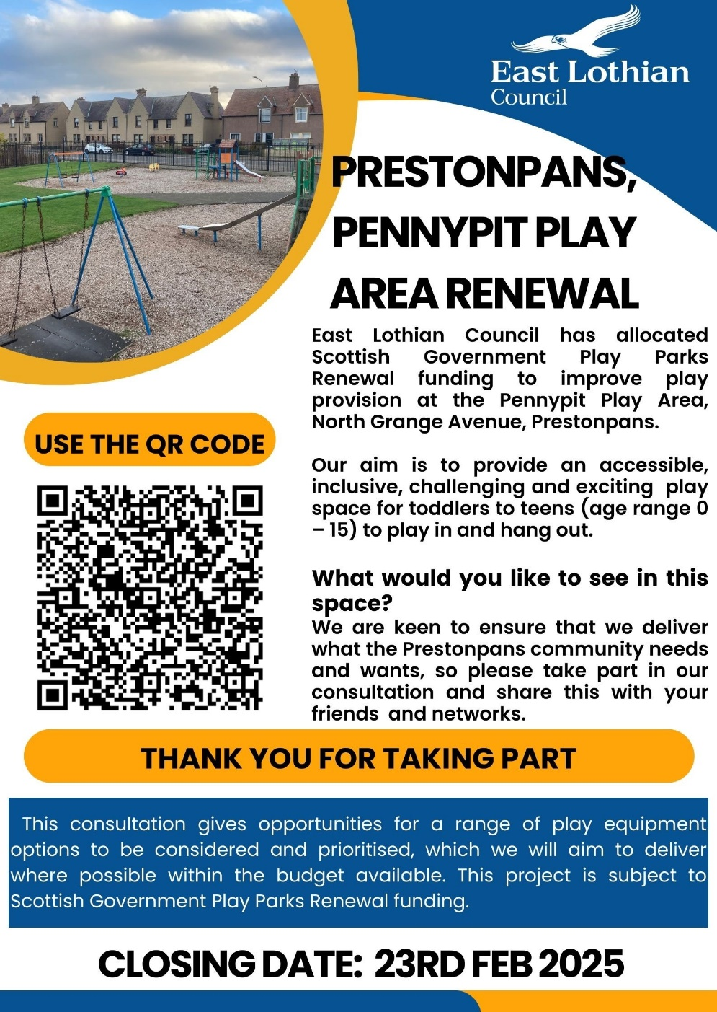

BM mentioned the Stantec consultation around the Cockenzie site which will have a 2nd event which is still to be confirmed by Graeme Marsden. There have already been suggestions made about the location of allotments, possibility of active travel connections to Prestonpans station and strong community feedback the plan to relocate the community orchard did not appear to understand the Heritage and unique trees which were planted.

BM advised it was unclear when the best battery storage sites would be represented to the Planning Committee, but ELC’s response to C&PSCC indicated 04 February was likely.

CA highlighted The Third Sector Funding and Finance Workshop for Commissioners and Grant-Makers. Volunteer Centre East Lothian (VCEL) in partnership with the East Lothian Children, Young People’s and Families Forum are delighted to invite you to their Third Sector Funding and Finance Workshop for Commissioners and Grant-Makers at the Fisherrow Centre, Musselburgh on Thursday, 6 February 2025 from 09:30am to 12.30pm. There will be a light lunch and networking opportunity at the end of the morning’s session.

BM highlighted the free Conference at Dynamic Earth on Flood Resilience on 28/29th January 2025.
BM will be attending the next EL Energy Forum and planning to raise questions around the process for Community Benefits.
- Area Partnership Meetings Dates for 2025
 |  |  |  |  | 12th March 2025  14th May 2025 APM  11th June 2025  10th September 2025  22nd October 2025  26th November 2025 | Apologies to be sent to - psg-ap@eastlothian.gov.uk

