
Minutes of Musselburgh Area Partnership Meeting
Monday 10th June 2024, 7pm – 9pm
Musselburgh East Community Learning Centre

Members (and substitute members) present:
Gaynor Allen, Chair (GA)
Alister Hadden, Vice Chair (AH)
Barry Turner, Musselburgh Conservation Society (BT)
Irene Tait, Musselburgh & Inveresk CC (IT)
Janice MacLeod, Support from the Start (JM)
Cathie McArthur, Vice Chair, Health & Wellbeing Network (CMc)
Margaret Stewart, Musselburgh & Inveresk CC (MS)
Tanya Morrison, Whitecraig Community Council (TM)
Shona Blakeley, Musselburgh Grammar School Parent Council (SB)
Natasha McInninie, Bridges Project (NM)
Christine Shaffer, Levenhall TRA (CS)
Pauline Crerar, Sustainability sub group (PC)
Rachael Wales, First Step (RW)
Laura Munro, Campie Primary School (LM)
Mandy Harrington, Volunteer Centre East Lothian (MH)
Beryl Stevenson, Wallyford Community Council (BS)
Emma Stewart, Musselburgh Churches Together (ES)

Others in attendance:
Shirley Gillie, ELC (SG)
Scott McKail, ELC Connected Communities Manager (SMK)
Laura Chant, NHS (LC)
Marilyn McNeil, IHB (MM)
Jane Ogden-Smith, Volunteer Centre East Lothian (JOS)

Apologies:
Cllr. Andy Forrest, Elected Member (AF)
Cllr. Ruairh Bennett, Elected Member (RB)
Cllr. Cher Cassini, Elected Member (CC)
Cllr. Shona McIntosh, Elected Member (SM)
Linda Finlayson, Beach Lane TRA (LF)
Tina Pollock, First Step (TP)
Callum Maguire, Queen Margaret University (CM)
Fiona Barrett, Dementia Meeting Centre (FB)
Lorraine Congalton, ELC Community Development Officer (LC)

AGENDA ITEM | KEY DISCUSSION POINTS |  |  |  | ACTION
- Welcome , Introductions and Apologies
 | GA welcomed everyone to the meeting. Introductions were made and apologies noted.
- Conflict of Interest
This is a standing item on the agenda. GA asked members to declare any conflict of interest when projects are being discussed or when voting on funding applications.
Conflict of interests were declared.
- Approval of Minutes
Minutes from meeting 5.2.24 were discussed. CS mentioned some of the items in the CC Managers report had not been discussed at the meeting and agreed what reflected the discussion.

Minutes from our 10th anniversary celebrating on 25.3.24 were approved by CS/ES/PC
- Matters Arising
 | GA confirmed there were none.
- Connected Communities Manager Report
SMK confirmed the budgets for year 2024/2025
Amenity Services £100,000 – Staff time and Machines
Roads £50,000 – Limited influence on projects
General £90,000 – no spend at the moment. 2 applications to be discussed tonight.

GA sked if members were still happy to allocate £50,000 of the budget to tackle poverty and inequalities? Everyone happy to keep it at £50,000. Very important.

SMK explained the Child Planning Framework – Locality Team (CPF-LT)
CPF-LTs are an integral part of East Lothian Council’s approach to Getting it Right for Every Child through the Child Planning Framework.
- The remit of CPF-LTs is to provide a multi-agency, solutions orientated forum to share expertise on meeting unmet wellbeing needs for identified children and young people.
- The CPF-LTs will work in partnership with children and young people and their parents / carers to ensure that their views are actively sought and form an integral part of all discussions.

Child Planning Framework – Locality Team (CPF-LT)
Criteria
- As a continuum of GIRFEC support, the CPF-LT will only consider referrals for children / young people who have an active Child / Young Person’s Plan and for whom there have been a minimum of two child planning meetings.
- Children / young people at the targeted level of the Child Planning Framework with a Lead Professional should not be referred to the CPF-LT as there will be other, more appropriate GIRFEC forums.

Key Milestones in Musselburgh
Initial orientation meeting held, 9th May & 20th June
First CPF-LT Musselburgh meeting held – 9th May
Six referrals were reviewed
Next meeting 20th June
Members discussion.

SMK shared the Summer Programme
- Venturing Out – water activities Levenhall Links
- Graffiti Workshops
- Foxlake trip – end summer on a high
- Play Days in partnership with ELPA, Whitecraig, Wallyford, MECLC, Lewsivale Park
- Using a new Musselburgh wide online booking system – liberty create.
- Summer safety briefings – Fire Service coming to youth clubs

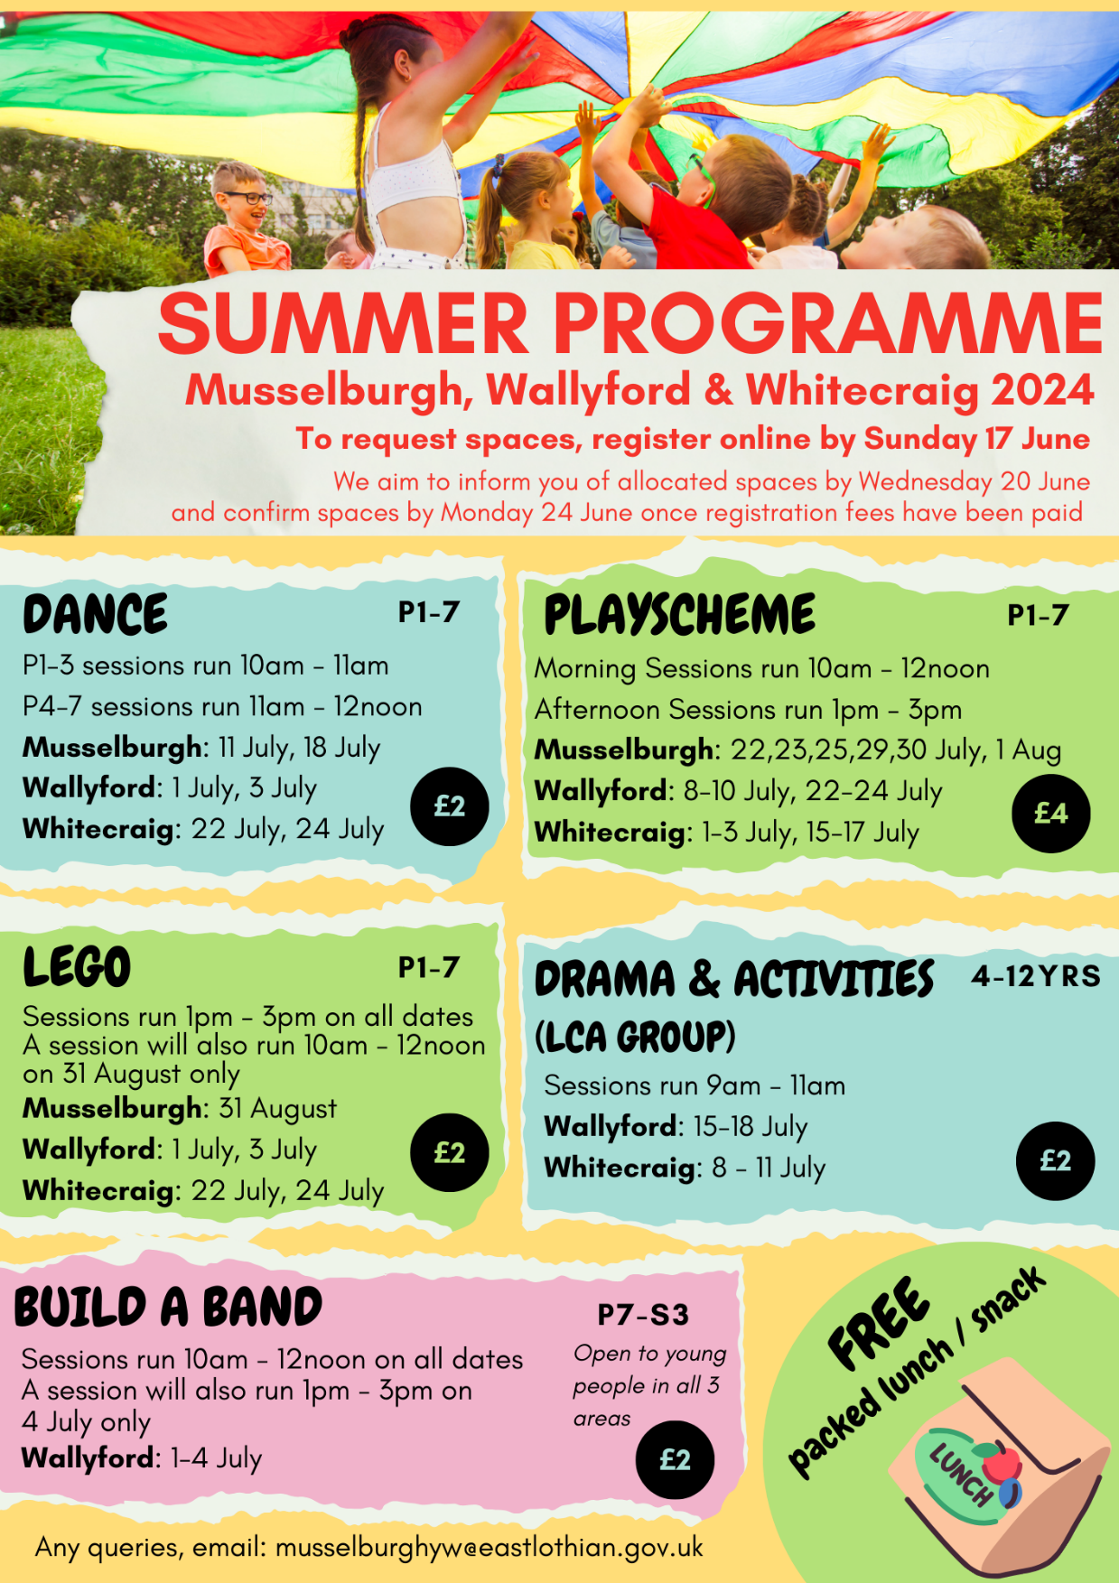

A good discussion took place about how this was targeted as well as a discussion about how accessible this would be for children and young people with a disability.

SMK highlighted Vanda Dow the Specialist youth worker who was nominated and shortlisted for the Environment & Education award through VCEL on Friday night. SMK shared words from Vandas nominator. MH added Vanda was a winner in her own right. These volunteers do so much for their community.

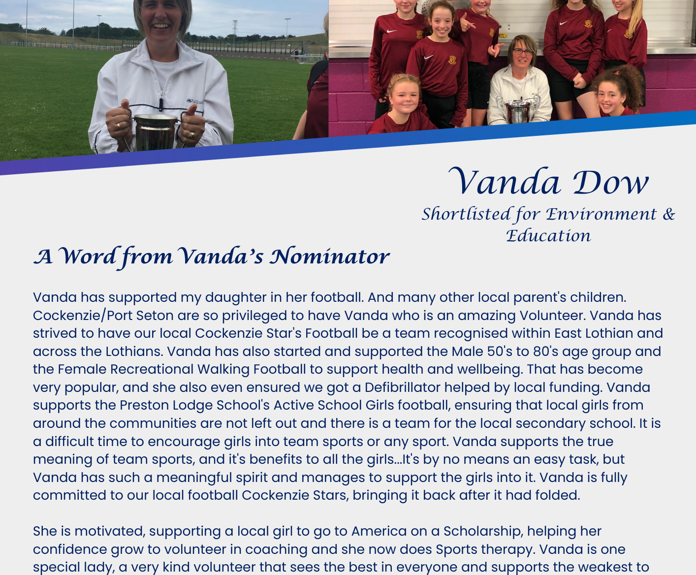

- Funding Applications for decisions
Funding applications being discussed tonight:
- First Step – Wellbeing Hub - £6,383
CS shared recommendations from sub group. LM asked for clarification on the creche money.
All members happy to support.
(NB First Step clarified on this point)

- Musselburgh Pantry – Summer Provision - £5,880
YES 13 Against/abstain 0 (votes counted in the meeting)
A condition was applied in the meeting after discussion. (subsequently members agreed to remove the condition via email vote.)

GA explained the other applications received are not progressing at this time:-
- Pennypit Development Trust – Festive Provision - £5,615
- Pennypit Development Trust – Nutrition Project - £12,300

- Sub Group Reports
Ending Poverty Subgroup
CS advised they have had 3 meetings since February. Looking at the Plan and the challenges people face regarding funding. Work in progress. Agree to partner with Sustaining Musselburgh and the pantry to look at fuel poverty. Thermal imagine cameras can be used to see where homes are losing energy. Working with Energy Scotland also.
Looking at the cost of a school day and addressing the cost of living. Trying to look at small things to help. GA/CS have a meeting with the churches together to see what should go into the plan. CS asked JOS if she would like to join the sub group. JOS happy to be involved. CS asked if anyone had any comments to please let her know.

Health & Well-being Subgroup
JM advised the group that on going discussions with the meeting centre are planned to see how the Area Partnership can support the on-going work of the MC. The H&W group and Maria Burton ( health and Social Care ) are planning to meet with the new manager of the Hollies in the near future.
H&W are really good at sharing information but would also like to do something tangible to make a difference. If any one has any suggestions please get in touch.

Children & Youth Network
JM advised they have been looking at the membership of the sub group and finally feel they have the right people around the table. A very good feeling about this sub group. Looking at breakfast clubs, cost of school day and signing up for clothing grants as this has a knock on effect for the school being able to apply for PEF funding. The meeting was 21/5/24 and action points from the meeting will be available soon. JM felt there was a lot of energy for this group and will speak to JOS about possible becoming involved too.

Active Travel Subgroup
BT provided the following update:-
ACTIVE TRAVEL SUB GROUP MEETING, 5th JUNE (11 people attended)
- Update of the projects list was circulated by Liz Hunter
Much activity and more potential identified in Wallyford and Old Craighall.
- Active Toun update
Noted that planning applications will now be needed for those parts of the project associated with the Flood Prevention Scheme. Also that there is to be a behaviour change programme as part of the Active Toun project for the benefit of all road users.
- Possible new projects
Cyclist Hamish McClean made the case for a dedicated cycle circuit in Musselburgh able to be shared by a range of different groups. He stressed the dangers presented by too much traffic and poor road surfaces to sporting and club cyclists. This may be a subject for the Area/Place Plan to consider.
- Pavement parking ban
Exemptions have been investigated but must satisfy government guidelines and this could give rise to issues in some locations. Enforcement will begin at the end of July/beginning of August.
- Work of the Sub Group
Disappointment was expressed that many of the ideas identified to make Musselburgh more pedestrian friendly had not been taken forward. The Sub Group will be looking at them again and seeking to promote them. It was agreed that there should be a special meeting on the role and importance of active travel as part of the Area/Place Plan process.

Next meeting: 4th September. 6pm, MECA building.

BT added the previous meeting was the best attended yet with a diverse range of interest represented and hopes this will continue. Active Travel is also looking for ideas to take forward for the Roads budget.
GA added it would be good for Sustaining Musselburgh and Active Travel to get together and share information.

Communities Day Subgroup
AH provided the following update prior to the meeting.
Communities Day 2024
Is booked for within the Fisherrow Centre on Saturday 28th September 2024 between 11am & 3pm.
We have prepared Posters for approval and distribution along with 4 Banners to be located around the town at the Caprice, Brunton Hall & South Street
Also Leaflets to go into welcome packs with floor layouts and information on what is on in each room within the Fisherrow centre.
The possibility of a treasure hunt for the youngsters
The possibility of a financial reward of for winners who have completed an appraisal form of £25.00p 1^{st,} £15.00p& £10.00p 3rd.
We estimate that a Budget of around £2.500 for Communities Day 2024 to cover costs.
Christine has contacted those who have received funding from the MAP 2023/2024 to ask them to have representation at Communities Day either with a table or Posters.
Christine has also been contacting entertainers for our entertainments on the day.
Shirley has been contacting other groups clubs and organisations inviting them to Communities Day 2024
Food supplies
(MS) Confirmed Nairns Biscuits would support Communities Day 2024 with their produce
(GA) has confirmed the Cook Club, also will attend with their soup pots on the day.
(GA) & (CS) will make approach local bakers & Fruit Shops nearer the time of Communities Day 2024 asking for support with gifts of their produce.
Janice has left the Communities Day Sub Group due to other commitments but will assist on Communities day, we just wish to thank Janice for all her contribution to the group during her time with us.
Sustaining Musselburgh Subgroup
GA provided this report:-
We have been very busy working on our event Warmer Homes and Cheaper Bills event at St Andrew’s High Church on June 1. This event was very well attended by a variety of different groups and included 17 organisations to help residents make three homes warmer and cheaper in the winter. It included lots of information on retrofitting, which is basically adding insulation, cavity wall filling and making any minor or major changes to the fabric of the building.
The team continues to work with Home Energy Scotland and the West Linton Community Heat Project to launch our own Community Heat Team and which will survey homes in our area for heat loss and how to deal with it to make homes warmer and cheaper to run and help cut residents carbon footprints.

Governance Scrutiny Subgroup
CS advised there should have been a meeting to look at evaluations but this is on going and will be arranged soon.
- Chair’s Report
 | GA advised everything had been discussed during the meeting.
- Consultations
GA encouraged members to look at East Lothian Councils Consultations Hub for information. The link is below:-

East Lothian Council - Citizen Space (eastlothianconsultations.co.uk)
- A.O.C.B.
GA advised we need to spend time looking at the Area Plan.

GA advised Emma Stewart was stepping down from the Area Partnership and this was her last meeting tonight. GA presented ES with a gift and the MAP wanted to thank her for help and support over the 10 years.

BT advised that the Musselburgh Conservation Society is struggling just now and looking for new members. Please spread the word and get in touch if you know anyone who may be interested in the heritage of the town. It would be a great shame if we lost this organisation.
SB advised the Musselburgh Conservation Society face book page has been shared through the schools/parent council.

GA thanked everyone for coming along tonight,

CM asked if the High Street could be put on the agenda for a future meeting as it is a disgrace and need to look at how it can be cleaned up.
- 2024 Meeting Dates
26/08/2024  30/09/2024 funding  25/11/2024 - AGM |  |  |  |  | Apologies to be sent to Musselburgh-ap@eastlothian.gov.uk

