

Minutes of the North Berwick Coastal Area Partnership
Tuesday 24th February 2026, 7-9 pm
North Berwick Community Centre

Voting Members present: | Substitute members present:
Zena Trendell, Chair (ZT)
Cllr Carol McFarlane (CM)
Frank Neate, Gullane Area Community Council (FN)
Fiona Constable, Dunpender Community Council (FC)
Alan Fraser, Gullane Area Community Council (AF)
Kenny Miller, North Berwick Community Council (KM)
John Wellwood, North Berwick Community Council (JW)
Liz Forsyth, Aberlady Community Association (LF)
Fred McClintock, Dirleton Community Association (FM)
Krish Bissoonauth, Gullane Village Association (KB)
Brett Walker, Chair On The Move (BW)
Carole Glover, North Berwick Coastal Community Connections (CG)
Sharon Young, VCEL (SY) | Mandy Harrington, VCEL (MH)
Glyn Taylor, Gullane School Parent Carer Partnership Comm (GT)
Janice MacLeod, Chair Children & Youth Network (JM)
Robin Grant, North Berwick Coastal Area Health & Social Care Charity (RG)
Craig Sneddon, NB Community First Responders (CS)
Alex Hutchison, NBC Bloom Groups (AH)
Katie Reid, Support from The Start (KR)

Others in attendance:
Doug Haig, Connected Communities Manager (DH)
Shirley Gillie, Unified Business Support – ELC (SG)
Lorna Raeburn, representing Glorious Gullane Bloomers (LR)

Apologies:
Tim Harding, Lime Grove TRA (TH)
Sally Egan, North Berwick Community Council (SE)
Sadia Ward, Aberlady Community Association (SWard)
Kathy Duncan, Sustaining North Berwick (KD)
Lauren Cowie, Children & Youth Network (LC)

AGENDA ITEM |  |  |  |  | KEY DISCUSSION POINTS, DECISIONS  Actions |  |  | FAO
- Welcome, Introductions and Apologies
 |  |  |  |  | ZT welcomed everyone to the meeting including new Member JW. Introductions were made and apologies noted.
- Minutes Previous Meeting 20.01.2026
 |  |  |  |  | Minutes from 20.01.2026 were accepted and approved.
- Declaration of Interest
 |  |  |  | ZT asked if anyone had any conflicts of interest. AH/KM/KB declared a conflict of interest with the ‘Bloom’ application tonight as all are involved in either North Berwick In Bloom or Glorious Gullane Bloomers.
- Matters Arising
Place Making
DH advised Members that the timescales are a little longer than anticipated. Still waiting on 1st draft of potential lease and still waiting on the recruitment of 2 new members of staff to support Place Making. A monthly update will be circulated by email.
ZT added this will give anyone who is interested in buildings a further few weeks. ZT/DH The team are happy to come and meet with anyone interested in taking on the long-term lease or Asset Transfer of community buildings.
AF asked if the new lease excludes the purchase of buildings.
DH confirmed that there is still going to be an opportunity for asset transfer and direct buy. The potential for community groups to take on buildings will be looked at on an asset-by-asset basis to hopefully meet individual need and aspirations.

NBC Roads’ Budget Influence
DH explained the historic pre 2024 Roads Budget Influence process and how it had changed in 2024 due to a change in Council Policy. The Roads Department will identify priorities from their annual Impact Assessment and Area Partnerships will decide from that list which projects they would like to see taken forward.
BW advised that the On the Move Group and the Area Partnership will continue to highlight priorities identified within the Charette and by the communities surrounding North Berwick. He Highlighted that the current practice in identifying priorities didn’t align with the Community Empowerment Act, or with the Council’s pledge to devolve 2% of its budget to communities.
BW respectfully asked Members to vote on the 4 projects, identified and agreed by the On the Move Group, to be taken forward to Roads Services in respect of the 2026-2027 Roads Budget Influence:-
2026-2027 PROPOSED NBC AP ROADS BUDGET INFLUENCE PRIORITIES
- Pavement widening Law Road between St Margarets Road and St Andrew Street. NB
- Crossing point - Church Road/ Forth Street/Beach. NB.
- Crossing Point - Gusset Westgate/ Abbey Road, NB.
- Various Works discussed, Aberlady.
BW proposed the four priorities for 2026-2027 Roads Budget Influence.
Members voted
13:YES 0:NO 0:ABSTAIN 1:CONFLICT
Members asked DH if he could provide information on how the Roads Impact Assessment was conducted. DH agreed to follow up.
- NBC AP Area Plan 2025-2030
ZT advised there had been a delay in working up a first draft of the Plan but had identified 7 key themes from the information gathered to date. She thanked everyone for their responses to the email questionnaire. ZT will re-circulate the questionnaire to give a further chance to feedback. She went on to advise that the Partnership had been invited to present its 2025-2030 Plan to the Council on the 25th of August and hoped to have a first draft available at the April meeting of the Partnership. ZT added she would like to use locally sourced photos within the Plan and urged everyone to submit any good ones they have.

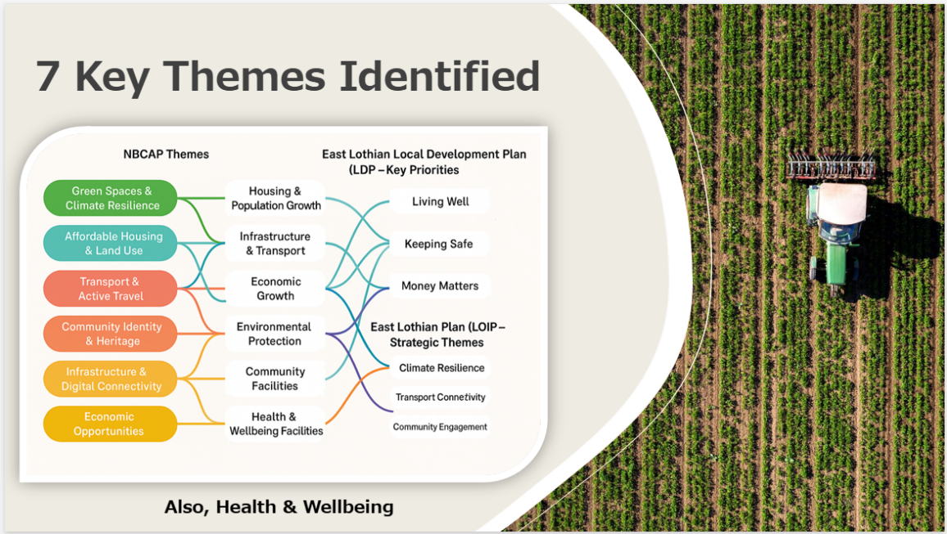

- Subgroup Updates
On The Move
BW advised he will have been Chair of OTM for 5 years come May. He is now involved with several other projects and initiatives and feels it is now time for someone else to take over as Chair. ZT thanked BW for all his hard work and congratulated him on his promotion, as she believed he was now getting involved in projects that were not just of benefit to the Coastal ward, but all East Lothian. Members showed their appreciation and thanks with a round of applause.
LF added BW had done a great job. He was and is a great listener, always willing to help and support communities.
Health & Wellbeing Association
Unfortunately, there was no one at tonight’s meeting to provide an update. Members advised however that there was a Health & Wellbeing meeting scheduled for the 31st of March.

Children & Youth Network
JM advised that the Children’s Activity Fund (CAF) is going from strength to strength and thanked those that had assisted with promoting awareness of the initiative. The application and administration process now easier. More than 30 families have benefitted from the scheme in the past year. ZT thanked JM and others involved for delivering such a beneficial initiative to support low income families in the ward.
- Community Councils updates
Gullane Area Community Council
AF advised there is some progress on the Gullane to Drem path. A meeting has been arranged for ELC Chief Executive Laurence Rockey to talk to the landowner. This last piece of land is key to the path’s viability.
FN provide a detailed update on the ongoing discharge of untreated sewage in Aberlady Bay. ZT advised that SG will circulate the information that FN has from Scottish Water.
Dunpender Community Council
FC advised that Whitekirk street lighting has now been fixed and the Whitekirk defibrillator should be fitted on Friday. Training for this will be this Saturday, the 28th February. FC advised that Whitekirk notice board has had a makeover but would ideally benefit with being replaced in the future.
FC added that the play park in East Linton had received £67,000 funding for upgrading.
East Linton has entered a national competition “Plant Life” for best garden for wildlife.
Regarding the excessive number of roads signs in the area, Keith Scott from Road Services has been out to assess them and some have been cut down in size and a few have been removed entirely. The community are frustrated by these signs. FC thanked KS for his help.
North Berwick Community Council
KM advised that the town had put its hat in the ring to be included in the ‘Town of Culture’ competition. This is a tough process and a lot of work has already been done. The organisers are meeting ELC Chief Executive Laurence Rockey next week to discuss further. £3 million in prize money for the town is up for grabs. More information will be available soon.
Picnic In The Park is happening again on 31.5.26 where you can bring your own food, seat or rug and enjoy this free event which will have lots of activities and entertainment for everyone. Two Charities will be supported: Brain Tumour and St Columbus Hospice.
Parking is still an issue. JW updated Members. The community attempted to put in a legal challenge. 100s of residents are supportive but the community needed an advocate or lawyer to take the work on pro bono. Every firm approached had a conflict of interest with ELC.
KM highlighted that parking meters in North Berwick had been vandalised. Members acknowledged the frustration of community, but did not condoned the vandalism, stating that there is no excuse for criminal acts.
ZT thanked KM/JW for their update and wished them good luck with the Town of Culture competition and the parking challenges.

- Village & Community Associations updates
Aberlady Update (Pre Meeting Note provided by LF)
LF added at the meeting that about Aberlady Flock meat boxes now available for sale £150 for a small box and £300 for a family size box. All information is available on the website.
Aberlady in Bloom
A meeting of AiB was held last week in the Old Aberlady Inn where the responsibilities for boxes and planted areas were allocated and plans for the year explored. Forward planning for the Memorial Garden was decided on.
The boxes in the Community Garden are currently being reallocated for Spring vegetable planting.
Liaising with Aberlady Community Association
The planned More to Life Festival will be discussed at the next ACA meeting. Four groups have indicated that they would like to be included in the event.
Aberlady Community Association
A committee meeting will take place next week. The seasonal newsletter is currently being planned for the next publication.
Aberlady Parish Church
The Church magazine has been published and delivered to all Church members. Douglas McMillan has taken over as the new editor.
Flower arrangers are desperately needed in Aberlady Church to join a dwindling number of volunteers.
The annual Aberlady Plant Sale will take place in the Village Hall on Saturday 9th May
Aberlady Primary School
A Scottish themed concert given by P2 and P3 was enjoyed by a large group of elderly residents last week.
Aberlady History and Conservation Society
The recent talk on the islands in the Firth of Forth which included some tales of local history especially of Dunbar was enjoyed by a large group of local people.
The society has applied to the Community Council for funding to restore the information boards behind the Church.

Gullane Village Association Report February 2026 (Post Meeting Note by KB)
- The trustees continue to engage with the ELC Place Making (PMP) team regarding the future of the Recreation Hall and are keen to help shape the Community Benefit Lease policy being developed by the PMP and be an early adopter of a lease based on that policy
- The trustees are working towards putting together a programme of events for the year focussing on Health and Well- Being. We held our first Members evening of 2026 where our members were invited to a Paint and Sip event lead by the artist Kat Healy of Shorelark art, everyone was encouraged to relax, be mindful and enjoy the moment.
- We have spoken to Graham Cross with a view to a Sporting Memories group being established this year at Gullane Recreation Hall. Others that we have engaged with recently to either deliver sessions or give talks regarding our focus are Highland Broadband regarding Digital Inclusion session, Dr Bike regarding bike maintenance and Angie Garton regarding a discussion around menopause.
- We are busy putting together a week of H&WB events for the More to Life festival (27th April- 2nd May and have asked East Lothian Care to run an event at the Recreation Hall on the 2nd May).
- 1,850 newsletters were delivered at the beginning of the month with a focus on H&WB and included a cut out of where all the local defibrillators with 24 hr access are located, thanks to the Together In Health team for their input in this.
- Our chair yoga classes with refreshments are going well with over 40 attendees each week between both classes.
- We are holding our Easter family event on the 28th March and will be using some funds to pay for the Easter treats.

ZT thanked KB for his update and wished the GVA good luck with all the forthcoming activities and events.
Dirleton
FM advised it had been discussed earlier that the road improvements pavements in the centre of Dirleton by Castle Park had now started which will make pavements and roads much safer. ZT thanked FM for his update.
- Key Partner Organisations updates
Together in Health (RG)
- Tyne & Esk funding has enabled the purchase of 12 cabinets and 10 defibrillators.
- Training in the ward continues to progress.
- Partnership working with Napier University and East Lothian Works to highlight opportunities in nursing now confirmed.

VCEL
SY introduced MH to the Members. SY had brought along some helpful leaflets and information to remind everyone how VCEL can help and offer support. This information can be shared digitally with everyone. VCEL also offers lots of training opportunities which is advertised on their website. This training is free. Sessions are available during the day and some in the evenings. These link will also be shared.
MH added that the Introduction to Fundraising course has now been split into 3 modules. These will provide information to help community groups complete funding applications. They don’t have capacity to complete funding forms but can support and read through any completed applications and make recommendations. Webinars with funders are also sometimes available.
VCEL recently held a successful networking breakfast event and another one is being looked at. They can provide support with governance, policies and procedures and offer training courses to assist. MH advised they are keen to link up volunteers, or if individuals are looking to volunteer, please get in touch.
ZT thanked VCEL for their update.

NB In Bloom
AH advised they are in the Britain in Bloom competition along with 6 or 7 other Coastal towns. The group are always working away, but don’t do it for the competition. They do it for community and everyone’s health & wellbeing. The judging takes place in August with results in October.
ZT thanked AH for the update and everyone’s hard work and wished them good luck with the competition.

1st Responders
CS advised they are always on the lookout for more people joining. If anyone is interested, please get in touch. There are 4 new responders from the NBC area and training will be held in June, in North Berwick. As always, trying to get as many of the public trained as possible on defibrillators.

- Budget Report
 | DH updated Members on the current budget allocation for 2025-2026. He confirmed the funding already allocated/spent and money remaining.
- Applications
North Berwick In Bloom – Glorious Gullane Bloomers – Traffic Light Project Upgrade- £2,180. DH highlighted that there was not enough money left in the budget to fund this project fully. If agreed, could only be part funded.
LR advised the amount requested was now £1,250. The project will be split into 2 phases and £1,250 will be required for phase 1.
Members voted to fund the revised amount of £1,250
YES:13 NO:0 ABSTAIN:2 CONFLICT:4
DH advised that this would leave just under £350 in the General Budget.
It was proposed that the remaining amount of £343.81 be awarded to North Berwick Coastal Health & Wellbeing Association – Children’s Activity Fund (CAF).
Members voted unanimously to award the remaining funds to the Children’s Activity Fund.
- A.O.C.B.
 |  |  |  |  | LR asked if they aren’t successful in applying for funding from other organisations would they be ok to come back to NBC AP for phase two funding. Members however, had already started to leave as the meeting had overrun.
Meeting dates for 2026 |  |  |  |  | 28/04/2026, 23/06/2026, 29/09/2026, 10/11/2026 |  | Apologies to  nbc-ap@eastlothian.gov.uk

