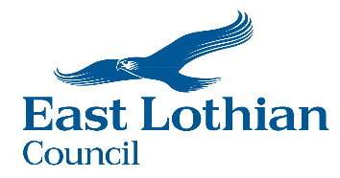

East Lothian Council’s
Local Heat and Energy Efficiency Strategy (LHEES)
21
years to Net Zero

October 2024
Executive Summary
This Local Heat and Energy Efficiency Strategy (LHEES) sets out East Lothian Council’s long-term vision for improving energy efficiency and decarbonising heat in both domestic and non-domestic buildings. This vision is shaped by Scotland’s statutory targets to address fuel poverty and for the reduction in greenhouse gas emissions:
- In 2040, as far as reasonably possible, no household in Scotland is in fuel poverty
- Net zero emissions by 2045 and 90% reduction by 2040
Our aim is for properties in East Lothian to have access to affordable, reliable and low carbon heat. This in an ambitious objective with numerous technical, financial and capacity challenges to overcome. A 5-year LHEES Delivery Plan accompanies this report. Together these two documents focus on delivering five main outcomes:
- Property owners are engaged with the need to reduce carbon emissions and empowered to make decisions on energy efficiency and heating solutions.
- East Lothian's homes and buildings are as energy efficient as possible.
- Heat solutions are delivered to tackle fuel poverty and meet the 2045 net zero target.
- Investment and grant funding is secured to deliver net zero projects.
- A significant proportion of the benefits of net zero investment remain within the East Lothian economy.
These outcomes support all three overarching objectives in the Council Plan 2022-2027– recovering with future sustainability, reducing fuel poverty and delivering the actions and change that will help East Lothian meet the net zero and climate resilience targets. It impacts on the future direction of a wide range of activities and organisations. Its preparation has involved significant internal and external stakeholder engagement.
87% of homes across East Lothian are currently heated by fossil fuels – mains gas, oil or LPG. These will all ultimately need a net zero heat solution.
The Council will continue to prioritise a ‘fabric first’ approach for its assets and will encourage all other property owners to take similar action. For homes, this approach would reduce the risk of fuel poverty, and bring social, economic and public health benefits.
Analysis of data on properties, energy use and waste heat opportunities has resulted in the broad designation of three main approaches to provide heat for the majority of buildings. There will always be exceptions due to owner preference or specific circumstances of individual properties. The strategy provides an analysis of the evidence and what support would be needed to consider and realise these opportunities:
- Individual Heat Solutions – the would be the default approach for properties that are a significant distance from neighbours or the street. These may require a property specific solution, with the majority opting for an electric powered solution including air source or ground source heat pumps.
- Local Heat Network Solutions – heat supplied using a central heat pump that then supplies multiple properties. This would mainly be suitable for communities where a connection to any District Heat Network is not viable but may have enough other properties nearby for a collective approach to be the most cost-effective option.
- District Heat Network Connection – potentially the option for larger on-gas communities where hot water would be provided by one or more heat centres and piped via insulated pipes to connected homes and business.
There could be opportunities within East Lothian that have the potential to support district heat network opportunities, which may reduce capital costs and potentially provide access to low-cost heat for a significant number of domestic and non-domestic properties. These opportunities include significant sources of industrial waste heat, potential for large scale heat storage, potentially using part of the Council owned site at Cockenzie and combining the laying of heat pipes with planned infrastructure projects to reduce construction costs.
Funding sources will be sought to allow feasibility work to be carried out to assess the potential for communal and district heat network development in East Lothian. Based on the outcome of feasibility studies, any delivery of heat network infrastructure will follow the process recommended by the Scottish Government’s Heat Network Support Unit.
Increasing energy efficiency and the development of heat network infrastructure have the potential to deliver significant long-term benefits to East Lothian’s communities. It brings the opportunity for community wealth building, creating jobs and business growth opportunities linked with energy efficiency retrofit work and heat network supply chains. Detailed collaboration with other agencies including Scottish Enterprise, universities and colleges, existing employers and community partners will be needed to ensure as much of the investment as possible remains within East Lothian’s economy.
Contents
 | Page
Executive Summary | 1
- Introduction | 4
- Policy and Strategy Review | 6
- Stakeholders, Advisors and LHEES Consultation | 8
- Data and Preparatory Studies | 12
- Helping Tackle Fuel Poverty | 17
- The Starting Point – Baseline Statistics | 20
- Energy Efficiency Priorities | 28
- Individual Heat Pumps | 36
- Local Heat Networks and Communal Heat Pumps | 39
- District Heat Network | 41
- Other Heating Solutions | 56
- Community Wealth Building | 57
- Investment and Funding | 59
- Delivery Plan | 61
Appendix 1 | 63
Appendix 2 | 65

- Introduction
1.1 Background
Local Heat and Energy Efficiency Strategies (LHEES) and Delivery Plans are at the heart of a place based, locally led and tailored approach to the heat transition. These documents set out the long-term plan for decarbonising heat in both domestic and non-domestic buildings and improving their energy efficiency. This aligns with Scotland’s statutory targets to tackle fuel poverty and for greenhouse gas emissions reduction:
- In 2040, as far as reasonably possible, no household in Scotland is in fuel poverty.
- Net zero emissions by 2045 and 90% reduction by 2040.
To achieve this would require reducing the demand for heat by ensuring properties are as energy efficient as possible and systematically replacing fossil fuels as a primary source of heat.
The East Lothian LHEES sets out the pathways to lower greenhouse gas emissions for heating buildings, and the removal of poor energy efficiency as a driver of fuel poverty. It identifies the range of property owners associated with homes, workplaces and community buildings. It explains the range of energy efficiency and decarbonisation opportunities and technologies available to reduce building emissions and ultimately reach a position of net zero.
1.2 Vision
Our vision is for every property in East Lothian to have access to affordable, reliable and net zero heat. To achieve this vision the following priority outcomes have been identified:
- Property owners are engaged with the need to reduce carbon emissions and empowered to make decisions on energy efficiency and heating solutions.
- East Lothian's homes and buildings are as energy efficient as possible.
- Heat solutions are delivered to tackle fuel poverty and meet the 2045 net zero target.
- Investment and grant funding is secured to deliver net zero projects.
- A significant proportion of the benefits of net zero investment remain within the East Lothian economy.
1.3 East Lothian Council’s LHEES journey
East Lothian Council participated in the second round of LHEES pilot projects in 2019. Changeworks were commissioned to carry out this work and produced a shortlist of potentially suitable energy efficiency and heat decarbonisation measures based on the baseline data analysis. More detailed investigation of the implications on the private rental sector was undertaken in recognition that this sector represents 10% of the domestic housing stock. This was completed in October 2019.
In 2021 Changeworks were commissioned to undertake additional work to apply Stages 1-4 of the Scottish Government’s LHEES Methodology. The results were presented to East Lothian Council in February 2023 and provide the groundwork research for this document.
In May 2023 East Lothian Council appointed an LHEES Project Officer to undertake stakeholder engagement and produce the LHEES Strategy and Delivery Plan. A draft strategy was published in October 2023 and shared with stakeholders.
Consultancy firm Arup provided feedback on the draft document on behalf of the Scottish Government. This highlighted areas where the draft strategy did not adhere to the guidance provided. Further work was undertaken with support from Zero Waste Scotland to address these areas of concern.
This document brings together this and all the stakeholder feedback into the final Strategy and Delivery Plan. As a result, there are considerable changes in the content and layout between the draft and this final version.
1.4 LHEES Delivery Plan
The LHEES Delivery Plan forms part of this document and prioritises areas for delivery over the next 5 years, against national and local priorities. This was developed in partnership with key stakeholders and provides a basis for action for East Lothian Council, local communities, government, investors and developers.

- Policy and Strategy Review
East Lothian Council has completed a review of the national and local policies, targets and strategies that are linked to, impact, or could be impacted by LHEES. This provided an opportunity to consider how the national policy landscape can be linked to local drivers, where LHEES is concerned, as well as setting out what the Council should prioritise strategically.
2.1 National Policy Context
The Heat in Buildings Strategy 2021 outlines the targets that the Scottish Government has set to reduce greenhouse gas emissions from Scotland’s homes, workplaces and community buildings and to ensure that poor energy performance is removed as a driver of fuel poverty. The focus of the Strategy is on energy demand for space and water heating in homes, workplaces and community buildings. This Strategy is focused on a series of time-limited national targets that are outlined below:
- By 2025 all private rented sector homes to reach a minimum standard equivalent to EPC C, where technically feasible and cost-effective, at change of tenancy, with a backstop of 2028 for all remaining existing properties.
- By 2030 the large majority of buildings achieve a good standard of energy efficiency.
- By 2030 emissions from buildings have to be 68% lower than 2020 levels
- By 2032 the Social Housing Sector must meet the standard of EPC B
- By 2033 all homes have the equivalent of EPC C where technically and legally feasible and cost effective.
- By 2040 all fuel poor homes to be EPC B
By 2045 our homes and buildings are no longer contributing to climate change, as part of the wider just transition to net zero.
The other national and regional strategies taken into consideration are:
- Climate Change Plan 2018-2032 - Update
- Heat Networks (Scotland) Act / Heat Networks Delivery Plan
- The Fuel Poverty (Targets, Definition and Strategy) (Scotland) Act 2019
- Programme for Government
- The National Planning Framework (NPF4)
- Hydrogen Policy Statement 2020
- Housing to 2040 (2021)
- Tenements (Scotland) Act 2004
- Historic Environment Policy for Scotland 2019
- The Edinburgh and South East City Region Deal and Regional Prosperity Framework
2.2 East Lothian Policy Context
The specific strategies that have shaped this document include:
- East Lothian Council Plan 2022-2027
- Climate Change Strategy and Action Plan 2020-2025

This document has provided emerging context for the following strategies that are under development:
- Update to Local Housing Strategy 2024-29
- Local Development Plan
- East Lothian Poverty Plan 2024-2028
  - East Lothian Council Plan 2022-2027
The Council Plan 2022-2027 is based around three overarching objectives that have been set in response to the three fundamental challenges faced in East Lothian.
- Recovery and Renewal – recovering from the COVID pandemic by investing in regeneration and a sustainable future
- Reduce poverty and Inequality – supporting our communities to deal with the growing levels of poverty and inequality
- Respond to the Climate Emergency – meeting our net zero climate change targets
The LHEES outcomes will impact on all three challenges – recovering with future sustainability, reducing fuel poverty and most significantly delivering the actions and change that will help East Lothian meet the net zero climate change targets.
  - Climate Change Strategy and Action Plan – 2020-2025
East Lothian Council declared a climate emergency in 2019. This core strategy brings together elements of a wide range of Council strategies that were live in 2020 in relation to climate change, that impact on heat and energy efficiency. This Strategy has been updated as new priorities have been agreed by the Council.
The LHEES brief directly impacts on 4 Outcomes, 10 Key Priority Areas and a total of the 36 Actions from the Climate Change Strategy.
Each of these Actions were reviewed in consultation with the relevant internal teams, to assess whether the actions proposed in relation to heat and energy efficiency were robust enough to achieve the changes required to meet net zero targets.
  - Tackling Fuel Poverty
The Scottish Government set a target that, as far as is reasonably possible, no household is in fuel poverty by 2040. This target underpins many of the actions that stem from East Lothian’s LHEES as both the cost of fuel and the energy efficiency of homes are significant factors.
The recent rapid increase in energy costs has pushed many more households into fuel poverty. Despite modest decreases in energy prices from the peaks of the start of 2023, the problem remains severe. Current industry projections indicate that energy prices are expected to remain high for some considerable time.
- Stakeholders, Advisors and LHEES Consultation
A heat and energy efficiency strategy impacts on a wide range of activities and organisations. The preparation of East Lothian’s LHEES has involved significant stakeholder engagement.
3.1 Internal Engagement
The internal engagement during the preparatory work on the LHEES has focused on regular reporting to the Council’s Energy Transformation Board. This group has been overseeing the Council’s energy strategy since 2016 and brings together senior officers from the following areas of operation:
- Sustainability and Climate Change
- Planning
- Housing Strategy
- Property Maintenance
- New Build Housing
- Housing Energy Efficiency
- Infrastructure
- Engineering Building Services
- Energy Services
- Connected Communities
- Economic Development
- Legal Services
- Financial Services
- Procurement Services
Regular meetings have taken place with the relevant officers and detailed feedback was provided on the appropriate sections of the draft strategy document.
3.2 Elected Representatives
Engagement with Councillors has been via the Cross-Party Climate Change and Sustainability Forum with additional briefings provided to Members on a collective and individual basis.
Briefings and meetings have been held with local MSPs during the LHEES preparation.
3.3 External Engagement
Heat and energy efficiency cut across so many aspects of society, business and our communities. The following organisations have been involved in the preparatory work, supplying data, providing advice and presenting opportunities:
- Delivery Partners - Scottish Government, Energy Saving Trust, Zero Waste Scotland, Home Energy Scotland and Changeworks
- Utilities - Scottish Power Energy Networks (SPEN), Scotland Gas Networks (SGN), Scottish Water Horizons
- Waste heat providers
- Public Sector Estates – NHS Lothian, Enjoy Leisure
- Registered Social Landlords – East Lothian Housing Association
- Landowners
- Energy Suppliers
- Technology providers
- Historic Buildings – Historic Environment Scotland
- Community Groups – a wide range of groups across all communities via the East Lothian Climate Action Network (ELCAN), plus those met via public consultation events
- Cross-boundary Local Authorities – Midlothian Council, City of Edinburgh Council and members of the City Region Deal
- Non-Domestic Anchor Loads – Education and business
- Investors / Finance Institutions

  - Advisors
East Lothian Council has benefited from a range of external advice during the preparation of this report. There are two specific sources that need to be acknowledged.
    - Community Steering Group
This is an informal group made up of volunteers from across East Lothian with a personal interest in developing heat solutions. Their expertise covers relevant topics such as finance, investment, governance, heat networks, community engagement, communication, community interest companies, GIS, community wealth building, civil engineering and supply chain development. This includes representatives from Community Councils, Area Partnerships and East Lothian Climate Action Network. Together, they have provided valued guidance throughout the LHEES preparation process and will continue to assist in the development of any potential solutions.
    - Danish Mentoring Programme
In October 2023 East Lothian Council was given the opportunity to be part of a mentoring programme established by the Scottish Government in partnership with the Danish Board of District Heating. This is sharing knowledge and learning about district heating
In December 2023 the Council’s Provost and LHEES Officer visited a range of district heating projects in Denmark with other local authorities from across the UK. This provided a far greater understanding of the range of technologies that can be combined to deliver the cheapest possible heat for customers. It also helped develop an understanding of the delivery and governance models that have been involved in successful Danish heat networks. It highlighted the benefits of community involvement and ownership of district heat infrastructure.
  - Consultation and Feedback
The process of preparing the LHEES reports has involved several phases of community and stakeholder consultation.
    - Early Community Consultation
In June 2023 the Council held a series of joint community consultation events. These events provided residents with the opportunity to view plans on the Local Development Plan, Economic Strategy, LHEES and Poverty Strategy. A total of six events were held, one in each Council ward, and approximately 140 members of the public sought information on proposals for energy efficiency or heat networks. This also led to invitations to speak to community groups to reach a wider audience.
    - Presentations to Community Groups
The LHEES Officer presented the draft Strategy at several community events organised by groups within the ELCAN network or Community Councils. These events provided the opportunity for detailed discussion with community activists and members of the public. They enabled the views of individual customers to be considered. The main issues that were consistently raised were:
- The potentially high cost of all homes needing to convert to individual heat pumps, outlining numerous examples where this technology would not be practical.
- Concerns relating to the cost of heat from a heat network and how it might compare with the price for gas and other fossil fuels. There was considerable concern over the risk of making fuel poverty worse or customers might refuse to connect if they were going to have to pay more.
- The risk that heat network connection costs might discourage connection and would certainly disadvantage those least able to afford up-front costs.
- The lower the internal impact within homes for any heating solution, the greater the chance of acceptance by homeowners. A big concern of individual heat pumps is the possible need to replace radiators and pipes.
- The overall feasibility of delivering ambitious heat network projects. There was a consistent concern that projects on this scale would never happen.
- The timing of delivery and guidance on what individuals should do in preparation. Property owners felt they need clear advice on what they can do now and when changes will reach them.
- The level of understanding and engagement from the majority of the population was raised consistently. Community groups expressed real concern that most people would just continue using gas and were not even exploring alternative options. A huge public awareness drive would be required both locally and nationally.
    - Stakeholder Feedback on Draft LHEES
The draft LHEES was circulated to all stakeholder groups and made available on the Council’s website. Comments were received in writing and via a series of group and one-to-one meetings. This resulted in a wide range of improvements to the initial draft.
The urgent need to focus on measures that will help tackle fuel poverty in the short and long-term were highlighted. As a result, greater emphasis has been placed on energy efficiency measures in areas with a higher risk of fuel poverty and on the overall search for the cheapest possible domestic heating solutions. A specific section relating to the issues around fuel poverty was added to the final report – see section 5.
To help readers understand the complex issues discussed, an increase in maps and diagrams was recommended. As a result, additional figures have been added to the final document to provide improved spatial representation of the data and concepts being discussed.
Elements of the heat mapping in the draft report were based on estimated data that has subsequently been shown to be inaccurate. This work was repeated using revised data, with support from Zero Waste Scotland. As a result, the maps presented in Section 4 of this report are more representative of actual heat demands.
The feedback from social housing providers was particularly relevant. They are facing pressure to replace gas boilers without being confident on the alternatives. They are unable to fund new developments where gas heating is proposed. For vulnerable tenants who are already struggling with heating costs, the prospect of making that worse through the installation of individual heat pumps was not an option that they were prepared to consider. The nature of their properties and the complication of mixed-tenure sites made finding a way forward even more challenging. Heat network solutions that are capable of delivering cheap, reliable heat would be an attractive prospect. They stressed that connection costs would need to be low or non-existent and that the overall heat costs would also need to be lower than current gas prices or risk forcing tenants into greater financial difficulty.
The most consistent feedback from members of the public related to the inconsistency between the message to encourage energy efficiency improvements and the fact that many of the choices, such as replacing single glazing can be restricted in historic buildings.
    - Finance and Investment Event
A one-day event, focused on finance and investment was hosted by Paul McLennan MSP in November 2023. This was attended by representatives from major banks and other potential investors. It was held to discuss opportunities for district solutions with potential investors and to explore options relating to the role of the community in delivering heat networks. This demonstrated that there would be market interest in heat network plans providing that they were delivered at scale and with growth potential.

- Data and Preparatory Studies
In the preparation of this report a range of data sources were used. In addition, early reports that were commissioned prior to 2023 have been reviewed and the data, analyses and outcomes from these have been used to support the strategy development process.
4.1 Core Datasets
The following form the main sources for the modelling and analysis that underpins this LHEES:
- Home Analytics – including locations of 30 conservation areas
- Non-domestic Analytics
- Scotland Heat Map
- EPC register for domestic and non-domestic properties
- SIMD data zones
4.2 Supplementary Datasets
- East Lothian Council housing database
- Register of Social Landlords property data
- Council owned assets – non-domestic properties
- Private landlords register data for private tenure data
- District Heating Scotland database
- Non-domestic heat demand – provided by Scotland Gas Networks
4.3 Preliminary Reports
4.3.1. Local Heat and Energy Efficiency Strategy (LHEES): Technical Report – completed out by Changeworks and concluded in October 2019.
This report identified the tools, data, skills and resources required to develop and deliver an LHEES for East Lothian. It involved baseline data analysis on the domestic housing stock, their energy efficiency and insulation status, fuel types, present renewable heating used and the heat demand of the area. The report produced a shortlist of potentially suitable energy efficiency and heat decarbonisation measures that could feed into the later LHEES development.
It also identified that the Private Rental sector makes up nearly 10% of East Lothian’s housing stock. Thus, engagement with both landlords and tenants are vital to understand their challenges and prepare a successful LHEES that takes all relevant perspectives into account, including short-term lets.
4.3.2. The First National Assessment of Potential Heat Network Zones – published by the Scottish Government in April 2022
The Assessment carried out an analysis to identify and characterise potential zones for heat networks in Scotland. The potential zones were identified through assessing heat demand density, providing an initial, automated assessment using national datasets of the areas that are most suited to heat networks from a demand density perspective.
The Baseline screening criteria (a linear heat density of 4,000 kWh/m/yr and at least two anchor loads) identified a small number of heat network opportunities that aligned with the modelling carried out by Changeworks in the Methodology Evaluation as outlined below.
The subsequent Stringent screening criteria (a linear heat density of 8,000 kWh/m/yr and at least five anchor loads) resulted in all of these earlier options being filtered out. This was due to a limited number of anchor loads in any of East Lothian’s towns.
Closer examination of the data used for this study identified that a number of key public and private sector heat loads across East Lothian were not included or had inaccurate values. This was corrected in later modelling work which allowed a more detail assessment of the opportunities to be carried out.
4.3.3. Local Heat and Energy Efficiency Strategy (LHEES): Methodology evaluation - carried out by Changeworks and concluded in May 2022.
The full LHEES methodology involves eight stages. This report involved completing the first four of these stages relating to East Lothian.
Stage 1: Policy and strategy review – This stage set out the national and local policies relevant to LHEES, providing an opportunity to consider how the national policy landscape can be linked to local drivers. For each priority it set out indicators and weightings that underpin analysis across the other stages. It enabled the mapping of key internal and external stakeholders, as well as funding resources that could support future Delivery Plan actions.
Stage 2: Data and tools library – This stage identified the most appropriate data and information needed to support analysis in subsequent stages. The library captured data requirements for the priorities, acting as a record of data sets used and capturing associated detail on ownership, data sharing, key contacts etc.
Stage 3: Baseline strategic zoning and pathways – This stage involved analysis and understanding of the current energy efficiency and heat decarbonisation performance of the building stock at a local authority wide level. This performance was based on assessing the building stock against the indicators from Stages 1- 2.
Stage 4: Generation of initial delivery-level areas – This stage used GIS techniques to generate initial delivery-level areas for each of the priorities.
It used a linear heat density technique recommended in the LHEES methodology to generate potential heat network zones. In total, six localised heat network opportunities were identified through this process.
4.3.4 Revised Linear Heat Density Mapping
This was carried out following the publication of the draft LHEES in recognition that earlier work had not been based on a complete dataset of heat loads. This work was carried out with technical support from Zero Waste Scotland and consultants, Buro Happold. It used accurate heat demand data from public sector buildings such as East Lothian Council properties, Enjoy Leisure facilities and NHS Lothian sites. Where information has been provided by private sector sites, this has been incorporated. Estimates have been used for other sites where heat data is not currently available.
The summary maps produced by this process are included in Section 8.2.
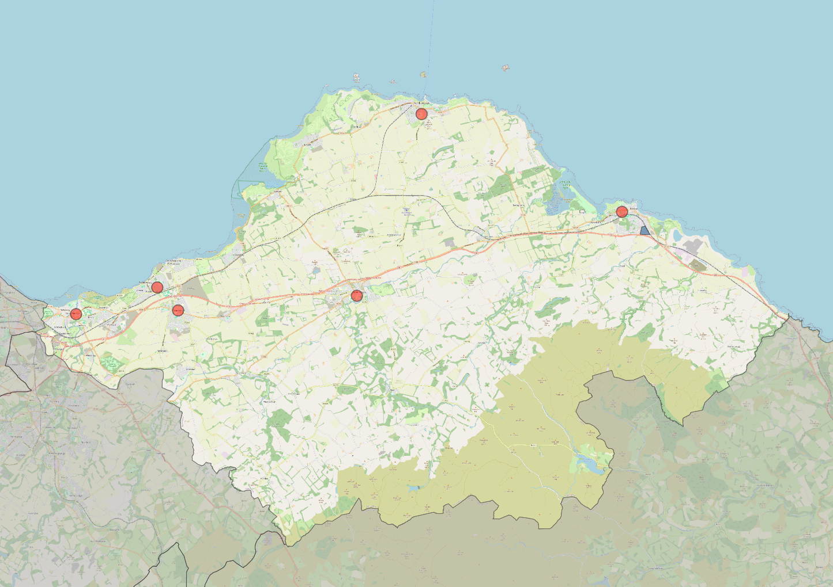
Figure 2 shows a map of East Lothian highlighting the locations of the six areas of higher heat demand in town centres that have been explored as potential locations for small heat networks.
Haddington
Prestonpans
Dunbar
North Berwick
Tranent
Musselburgh
Figure 2: East Lothian showing the locations of sites shown in more detail in Section 7.
The largest public sector heat load in East Lothian is the East Lothian Community Hospital in Haddington which has an annual demand of 4.5 GWh. The other significant NHS Lothian sites are in Musselburgh and Dunbar.
The secondary schools and leisure centres are some of the largest public sector heat loads in each town. Care facilities are also sites that have a high and consistent demand for heating. The heat demands for Belhaven Hill School in Dunbar and Loretto School in Musselburgh are estimates.
There are geographic barriers that can form a barrier to connecting areas of heat demand. These tend to be more expensive or disruptive to take heat pipes across.
- Rivers – The River Esk in Musselburgh and River Tyne in Haddington
- Railways – The East Coast Main Line impacts on Dunbar, Musselburgh/Wallyford and may also restrict pipe route options between Tranent and Prestonpans.
- Main roads – The A1 dual carriageway is a barrier through East Lothian and main roads elsewhere might also impact on transmission options.
- Existing utilities

4.4. Use of Data Zones
The LHEES guidance uses data zones for the spatial representation of modelling outputs. These zones were designated in 2006 and originally contained 300-500 properties. The significant level of new development since then makes their use for spatial representation inappropriate throughout much of East Lothian. Most of the new building has taken place on the outskirts of towns and villages, meaning that the originally rural data zones than ran up to the boundaries of settlements are now heavily skewed by new-build properties.
For example, the data zone that encompasses West Barns and rural areas to the south of Dunbar now has more than 2000 properties. Zones around Haddington, North Berwick, Longniddry, Tranent, Wallyford, Prestonpans and Musselburgh all show a similar trend with new-build significantly outnumbering the original rural property count.
When exploring issues related to energy efficiency there is a real risk that issues relating to older, rural properties could be masked by the new-build data and risk inappropriate conclusions being drawn. The following section outlines the steps taken to overcome this issue.
4.5 Data Adjustments
Figure 3. shows the average EPC ratings for properties in East Lothian based on property age. Crucially this shows properties built since 2002 have by far the highest proportion of A-C ratings, at 95%.
Closer examination of the small proportion of properties rated D-G shows that the majority have been given a lower rating because of having an air source heat pump or hybrid heating system fitted. Their low rating is a result of the outdated scoring system, not their actual energy efficiency. These homes along with most new-build properties will require few if any upgrades to meet acceptable energy efficiency standards. Their inclusion within the data for many formerly rural data zones masks the underlying issues with older properties.

Figure 3. Average Energy Performance Certificate ratings for all domestic properties in East Lothian broken down by property age. This is derived from Home Analytics, with 60% from actual surveys and 40% estimated.

To address this, the revised modelling work exploring energy efficiency factors for this final report has involved filtering out all properties built since 2002. This enables the underlying problems linked with energy efficiency measures to be examined in more detail. This applies to data represented in the following figures:
- Figure 4 on page 20
- Figure 14 on page 29
- Figure 16 on page 30
- Figure 18 on page 32
- Figure 19 on page 33
- Figure 20 on page 34
More details of the data quality challenges and steps taken to remedy these are included in Appendix 1.
- Helping Tackle Fuel Poverty
One of the key objectives of the LHEES methodology is to explore the links between poor levels of household energy efficiency and fuel poverty.
Too many households across East Lothian struggle to afford the cost of heating their homes. The rapid increase in energy costs since 2022 has made the situation far worse. The Delivery Plan includes actions that should lead to long-term improvements for households across East Lothian.
5.1 The scale of fuel poverty
The scale of the challenge is highlighted by Figure 4 below. This clearly demonstrates that fuel poverty is widely experienced across all parts of East Lothian. It is probable that between 34% to 42% of households in some areas are in fuel poverty.
This is based on data from Home Analytics that combines information on building energy efficiency, estimated heat demand with household income estimates. This has been presented by data zone. As explained in Section 4, properties built since 2002 have been removed from the data as the significant expansion of new-build houses around East Lothian can mask the underlying picture relating to older properties. Although some residents of more modern homes may experience fuel poverty, the higher energy efficiency levels that these properties have means that household income would be the main determining factor.
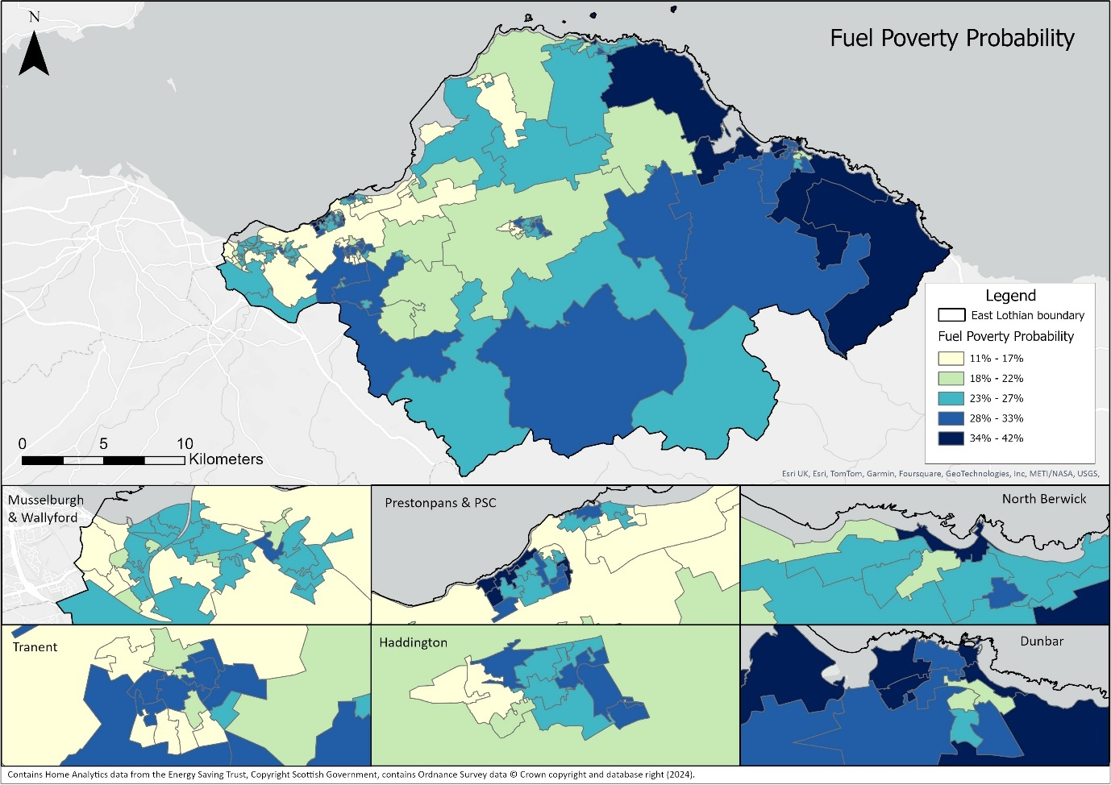
Figure 4: Map showing the probability of households being in fuel poverty. Properties built since 2002 have been excluded.

The single data zone assessed as having the highest risk of fuel poverty within East Lothian contains the rural villages of Innerwick and Oldhamstocks. Deprivation and low household income is less of a factor here. However, households in this rural area are all off-gas and properties rely heavily on oil and LPG for heating which tend to be more expensive. In addition, the majority of properties are old stone cottages which are difficult in insulate so energy inefficient buildings are certainly a significant factor. Similar circumstances can explain the clear trend for a risk of fuel poverty in most rural communities throughout East Lothian.
5.2 Underlying causes of Fuel Poverty
The nature of fuel poverty is a complicated one with multiple causes overlapping, including household income, the cost of fuel and the energy efficiency of properties. Tackling the issue of low household income is beyond the scope of this report. As fuel poverty is a measure of the proportion of household income spent on energy, clearly the lower the household income, the greater the risk that homes will spend a higher proportion on fuel bills. This is a significant factor behind the high probabilities shown in more deprived parts of East Lothian such as in Prestonpans and central Tranent. Although poor levels of energy efficiency may also be a factor in these areas and contribute to the overall level of risk. Figure 5 shows an extract of the Scottish Index of Multiple Deprivation 2020 covering these two communities. This highlights the data zones that are the most deprived based on a range of factors, including household income. There is clear correlation between the data zones in red and the darker blue areas in Figure 4.
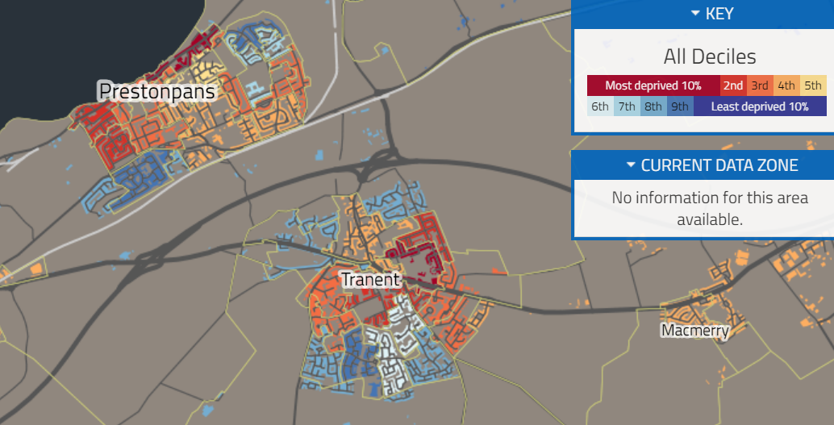
Figure 5: Extract from the Scottish Index of Multiple Deprivation 2020 showing Prestonpans and Tranent.
  - Cost of Energy
The rise in energy prices in 2022 and 2023 had a major impact on the proportion of homes experiencing fuel poverty. Figure 6 shows the price changes, based on average home use across the UK. These figures include the Energy Price Guarantee subsidy provided by the UK Government. This near doubling of energy costs has resulted in many more homes experiencing fuel poverty.
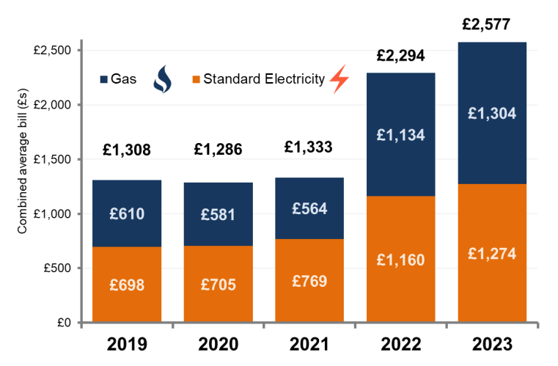
Figure 6. Changes in average household energy cost with data from the UK Government Department of Energy Security and Net Zero. Typical consumption values are based on 3,600 kWh a year for electricity and 13,600 kWh a year for gas. These figures incorporate the Energy Price Guarantee but do not reflect payments made through the Energy Bills Support Scheme
5.4 Future Heat Solutions
There is an opportunity to ensure that any changes to East Lothian’s sources of heat help tackle fuel poverty. This would help meet the strategic objectives of the Scottish Government, East Lothian Council and community organisations. Some of the ways that this could be achieved are summarised below and link to actions within Delivery Plan – see section 14:
- All property owners should be encouraged to undertake energy efficiency improvements to reduce the amount of heat wasted, with additional guidance on the sources of funding available for low-income households.
- Specific advice should be available for rural properties to help them decide whether a communal or individual heat pump might be a cost-effective long-term solution.
- If the decision is taken to develop communal or district heat networks, these should be designed with multiple heat sources to ensure that cost of heat provided can be kept as low. This should also help protect against future price fluctuations.
- If possible, there should be no financial barrier to connecting to a communal or district heat network. This would avoid creating a significant barrier to less affluent households who might otherwise be forced to opt out of connecting.
- The cost of any equipment required for individual properties, such as a heat exchanger should ideally be included within the overall cost of heating.

- The Starting Point – Baseline Data
Every property owner needs to identify the factors that are relevant to them and then consider the pathway they need to take. This is likely to be a complicated interaction of factors and they may need additional guidance to aid that decision process.
6.1 Main Heat Source
6.1.1 Domestic Properties
Figure 7 summaries the current main sources of heat for domestic properties across East Lothian.
- 43,200 properties use mains gas – almost all within towns and larger villages. The spatial distribution is shown on Figure 8.
- 3,300 using oil or LPG – almost exclusively in rural villages, farming communities and other isolated properties
- 6,200 properties already use electricity, the majority in rural areas but a reasonable number in on-gas areas
Figure 7: Main heat sources for domestic properties derived from Home Analytics
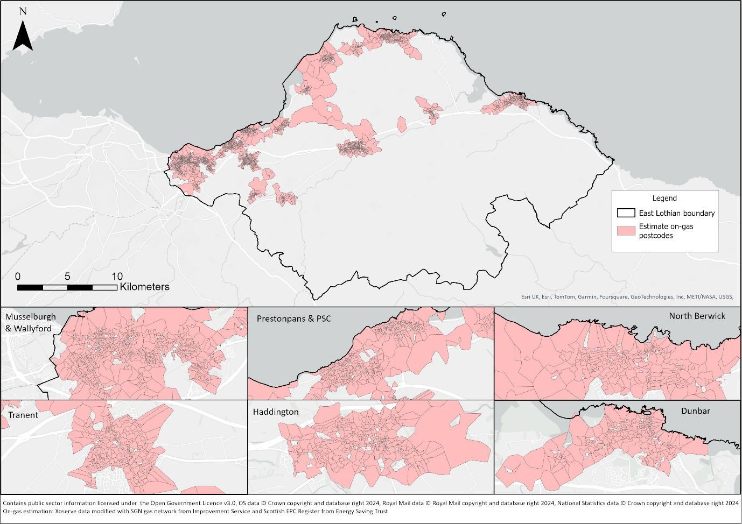
Figure 8: Distribution of properties connected to the mains gas grid, displayed by postcode area
6.1.2 Non-domestic Properties
Fossil fuels make up a smaller proportion of the primary heat source for non-domestic properties with 28% using mains gas or oil as highlighted below in Figure 9.
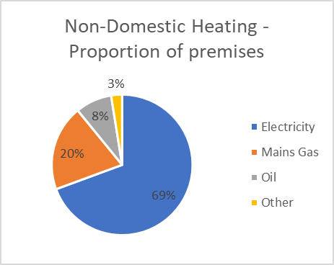
Figure 9: Primary heat sources for non-domestic properties derived from Non Domestic Analytics.
As the majority of non-domestic sites rely on electricity for their heating, for the purposes of heat decarbonisation, they are not considered an immediate priority. However, individual business could still benefit from looking to improve energy efficiency to lower their overall energy costs.
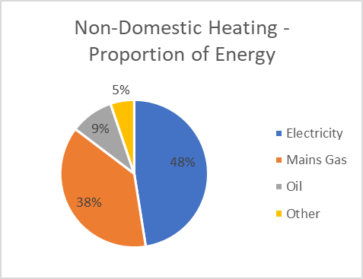
Some of these on-gas non-domestic sites are also some of the larger heat users. These include many public sector buildings, private schools, care facilities, hospitality venues and offices. Mains gas accounts for 38% of the overall energy use for non-domestic heating as shown in Figure 10. These sites are all located in the shaded areas on Figure 8.
Figure 10. Proportion of the overall heating need provided by each source derived from Non-Domestic Analytics
6.2 Current Energy Performance Certificate (EPC) rating
The percentage of domestic properties in each of the EPC categories are provided in Figure 11. This data is derived from Home Analytics and combines the results from the most recent EPC survey, which may be well over 10 years ago. As explained in section 4.4, 40% of the ratings are based on estimates as these properties have never had a survey carried out. The margin of error in these figures may be quite significant.
The top performing properties, those rated A or B are grouped together. Similarly, the worst performing, those rated F or G are combined.
An estimated 50% of properties across East Lothian are rated poor – D to G. This is in line with the national average where it is 51%.
Although there are numerous factors that impact on the overall rating, the owners of properties with poor scores need to consider taking action to improve energy efficiency alongside any decision on a suitable net zero heat solution.

Figure 11: EPC rating for all domestic properties in East Lothian using data from Home Analytics
6.3 Property Age
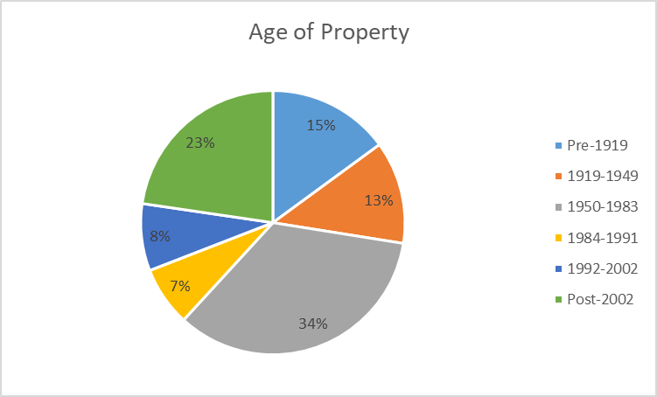
The age of the property is an important factor to consider in relation to energy efficiency. A summary of the age range of domestic properties in East Lothian is shown in Figure 12.
Figure 12: A break-down of domestic properties by age using data from Home Analytics
Older properties, such as many of the 15% that were built pre-1919, are often stone built. These do not have wall cavities and are far harder to insulate. External or internal cladding may not be an option due to the visual impact or the need to ensure adequate air circulation. Many are in rural locations.

6.4 Historic Properties
18% of all domestic properties are within the 30 Conservation Areas across East Lothian. The spatial distribution of these is shown on Figure 13. These are split between on-gas and off-gas areas as is shown. 5% of all domestic properties are listed buildings, categories A, B or C. The distribution of these is also plotted on Figure 13. These show a far wider geographic spread.
On average, these properties perform worst when it comes to energy efficiency. For example, 11% of all domestic properties in East Lothian are estimated to have single or be partially single glazing. That proportion rises to 31% in Conservation Areas. 57% of Listed buildings have single glazed windows. These figures highlight some of the very significant challenge in ensuring historic buildings are as energy efficient as possible.
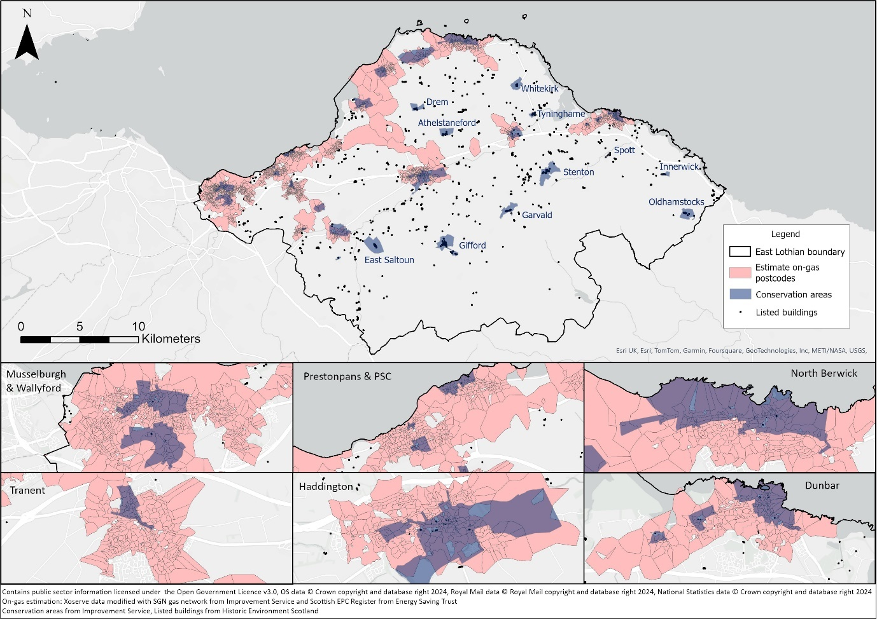
Figure 13: The locations of Conservation Areas, distribution of Listed Buildings also showing the on-gas communities

6.5 Property Tenure
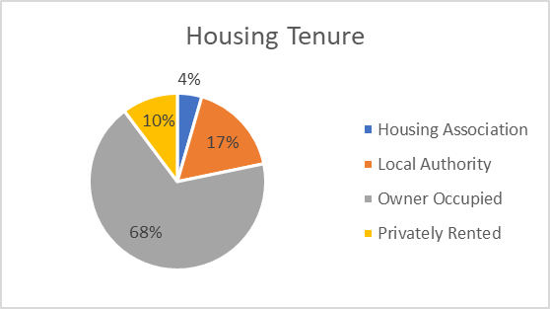
Property ownership has a direct impact on decision making and who is ultimately responsible for making those crucial decisions. The break-down for domestic properties is shown on Figure 14.
Figure 14: Tenure type for domestic properties across East Lothian
With 21% of properties classed as social rented, these are owned by just 5 landlords, East Lothian Council and four housing associations. When this is focused on just on-gas properties in the larger settlements, the proportion rises to nearly 25%.
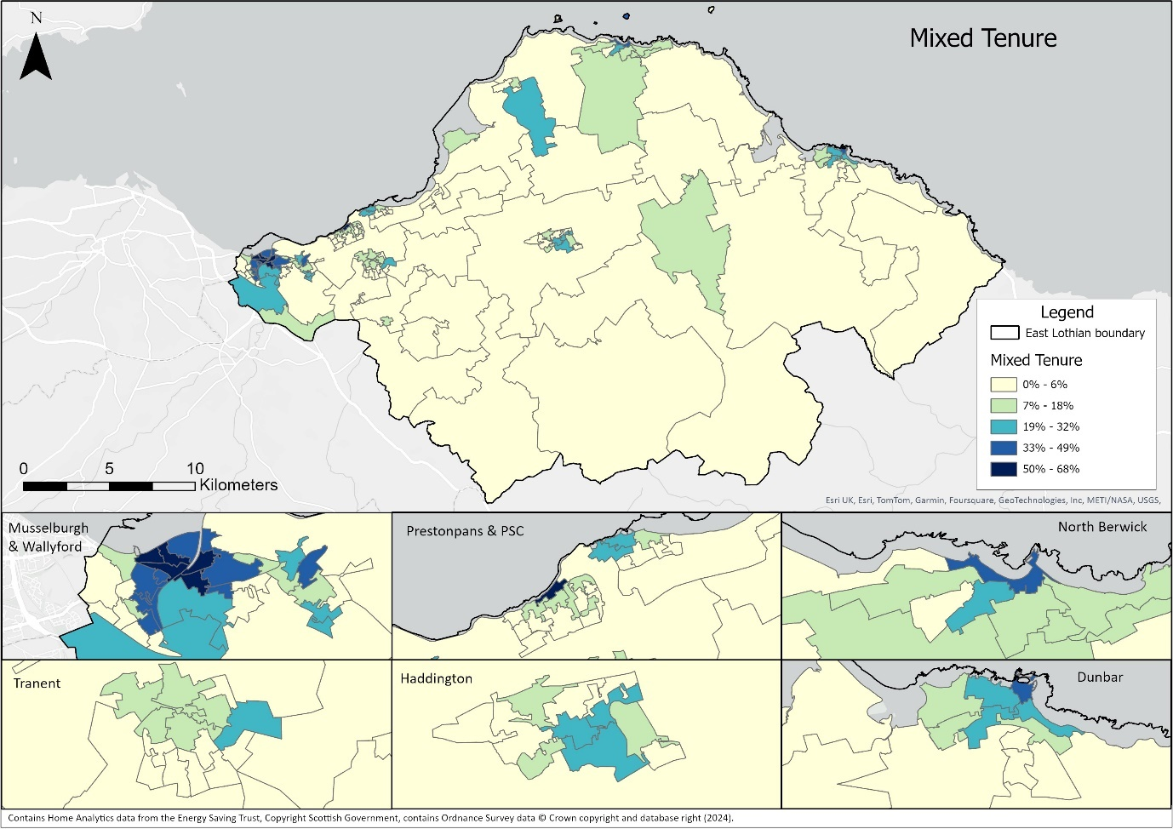 Figure 15: Distribution of mixed tenure properties displayed by data zone. Properties built since 2002 have been excluded.
15% of domestic properties are classed as mixed tenure. The spatial distribution of these is shown on Figure 15. These are mainly flats within the towns and villages with much smaller proportions in rural areas. These are concentrated in town centres with the highest in Musselburgh and Prestonpans. There is close corelation between mixed-tenure properties and the distribution of flatted properties as shown in Figure 17.
Mixed tenure blocks are characterised by a combination of rented and owner-occupied properties or domestic residences in flats above non-domestic properties. Those with multiple owners will always complicate the decision-making process, especially where consent of all owners is required for property improvements.
6.6 Property Type
Figure 16 shows the breakdown of property types within the domestic housing stock. 31% of properties are flats with 69% as houses. Figure 17 shows the distribution of flatted properties. These are highest in the town centres, rising to over 90% in the data zones covering the centres of Musselburgh and North Berwick.
Within the housing there is a reasonable balanced picture with 26% terraced, 20% semi-detached and 23% detached.
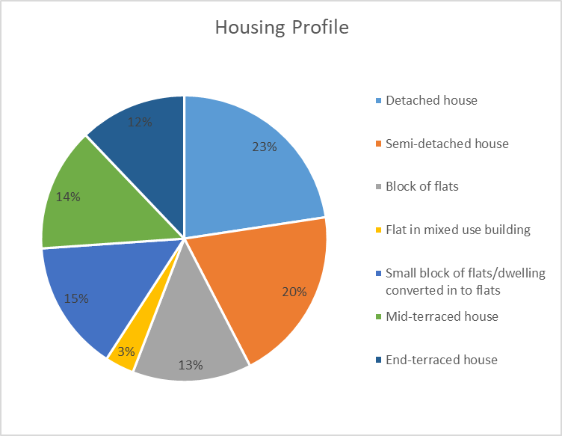
Figure 16: Breakdown of housing types for domestic properties
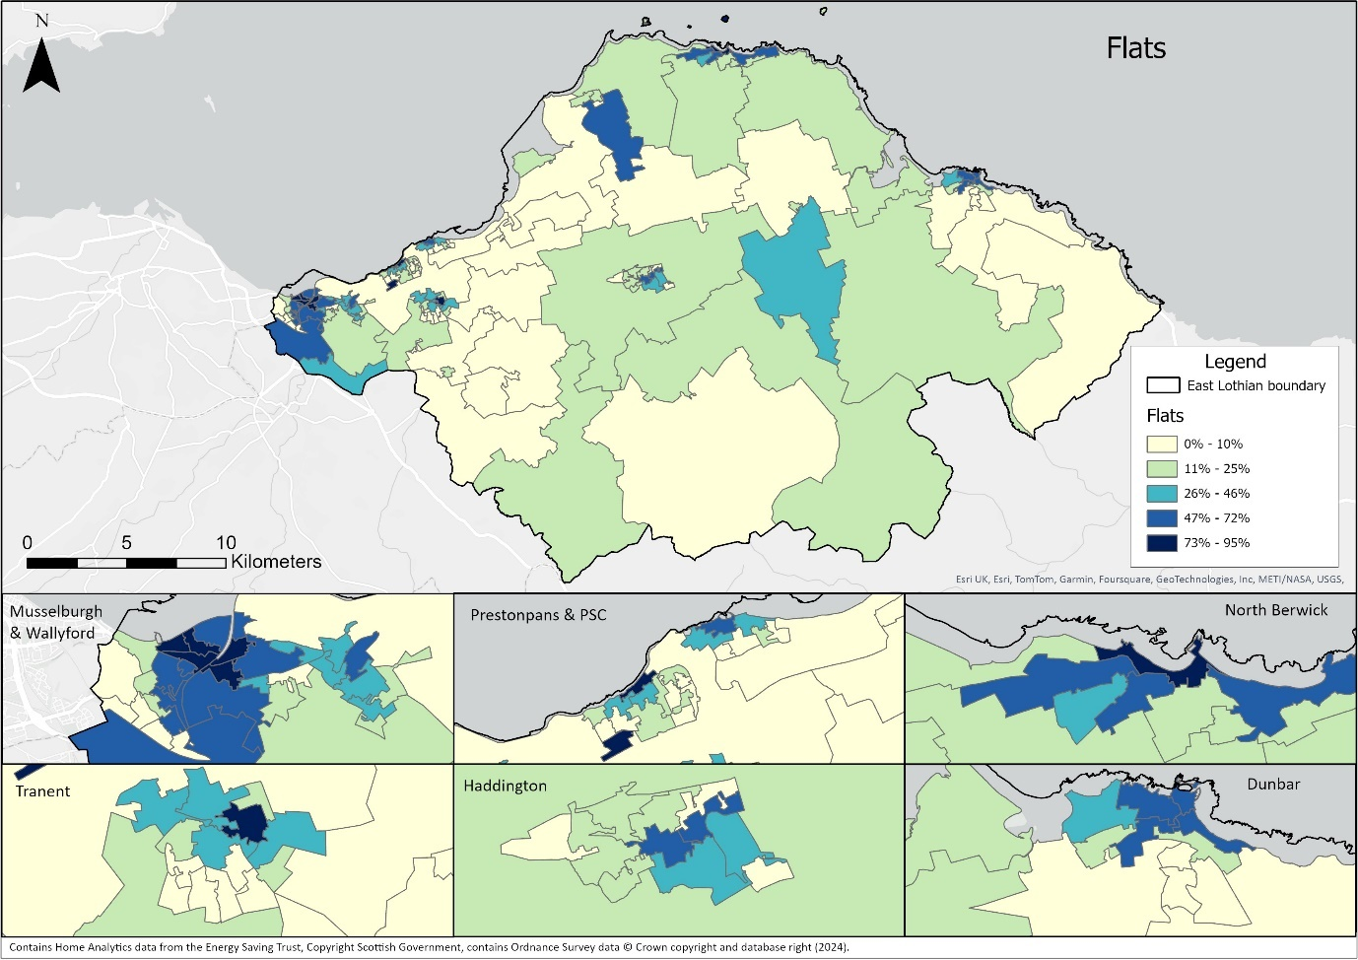
Figure 17: Distribution of flatted domestic properties.
7. Energy Efficiency Priorities
All building owners, public and private, are encouraged to significantly invest in energy and waste reduction. This section explains the targets that have been set, summarises the main options available to improve energy efficiency, explains some of the challenges involved and ultimately summarises the immediate priorities for action.
7.1 Targets
Figure 18 below summarises the energy efficiency targets that have been set by the Scottish Government. It highlights the scale of the challenge involved in meeting these within East Lothian.
Scottish Government Target | East Lothian implications
Private rented homes to be EPC C by 2028 | 3,000 across East Lothian not currently meeting this standard
All social housing to be EPC B by 2032 | 10,000 local authority and housing association properties rated C or lower
All other homes to be EPC C by 2033 | 19,000 will need to be improved
All fuel poor homes to be EPC B by 2040 | Excluding social housing, around 34,000 homes could fall into this category
Figure 18: Summary of Scottish Government energy efficiency targets and the number of properties each of these impacts across East Lothian.
Overall, an estimated 65% of domestic properties are likely to need some level of energy efficiency retrofit to meet Scottish Government targets.
It is not yet clear what impact a change in primary heat supply to a low-carbon or net zero source might have on the assessed EPC rating for properties. Connecting to a district, communal heat network or a heat pump could bring significant improvements in the overall rating. This will be tested as soon as the new standards are announced and may have an impact on the decisions property owners make in relation to potentially expensive energy efficiency improvements.
7.2 Improving Insulation
The most effective way to reduce energy consumption in a property is to reduce heat loss through the roof, walls, windows and floor. The nature of a building’s construction has to be taken into consideration when planning changes improvements to insulation. Maintaining adequate ventilation is essential to prevent a build-up of moisture which can lead to damp and mould.
7.2.1 Roof insulation
This is one of the cheapest and easiest installed interventions that can bring the most immediate improvement in energy efficiency.
The first thing for any property owner to check is the depth of insultation in any areas of roof space that they can access. Scottish Government guidance states that this should be at least 250mm. Figure 19 highlights the areas of East Lothian where loft insulation is estimated as being below the 250mm target. As previously outlined, this map excludes data from properties built since 2004. This demonstrates that a significant proportion of properties could still benefit from increasing levels of roof insulation. These figures do need to be treated with caution and ultimately roof insulation requirements need to be addressed on a property-by-property basis.
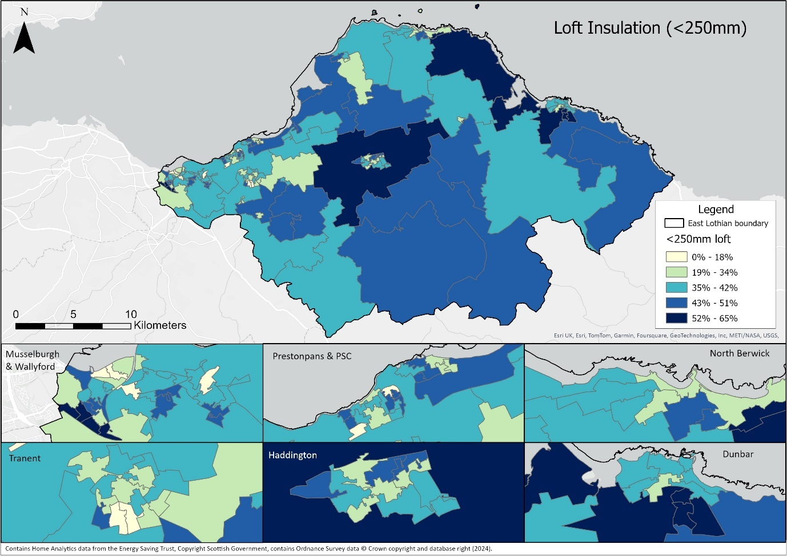
Figure 19: An estimate of the distribution of properties with less than 250mm of roof insulation fitted.
Homes that had insulation fitted many years ago often have considerably less than 250mm which reduces the overall effectiveness. Adding additional insulation on top is a relatively cheap solution and would bring immediate benefits in reducing heat loss. It is essential that insulation coverage does not leave gaps as this will allow heat to escape.
Where rooms are built into the roof of a property, it is also important to recognise that vertical surfaces should be insulated as well. This includes around dormer windows or on sloping surfaces. These are often overlooked due to being inaccessible and can lead to considerable loss of heat.
For many properties, especially those with rooms in an attic or with dormer windows, there may be areas of roof space that have limited or no access. It is difficult to tell whether these have effective insultation or not. A simple test is how quickly the temperature of the room drops on a cold night when the heating is turned off. If a room quickly feels cold, then the insulation levels should be checked. Although getting access to these areas may be disruptive, the result in terms of reducing heat loss could be very dramatic.
The use of thermal imaging cameras may help identify areas of heat loss or poor insulation coverage. Community groups in East Lothian are currently testing the use of thermal imaging to help homeowners understand heat loss in properties. If this proves successful, then it is a voluntary-run service that could be provided in other communities across East Lothian
It should be a priority for all landlords to ensure that every step has been taken to insulate roof spaces to appropriate standards.

7.2.2 Wall Insulation
Figure 20 shows the estimate of where the highest proportion on uninsulated cavities might be.
At data zone scale it is difficult to identify consistent trends that could help shape targeted actions. EPC surveys tend to rely on information that homeowners provide or even assumptions made by the assessor, rather than bore-scoping or the use of thermal imaging cameras. The most accurate data is held on properties owned by East Lothian Council and other social landlords. They have carried out detailed surveying and, in many cases, have already undertaken remedial work.
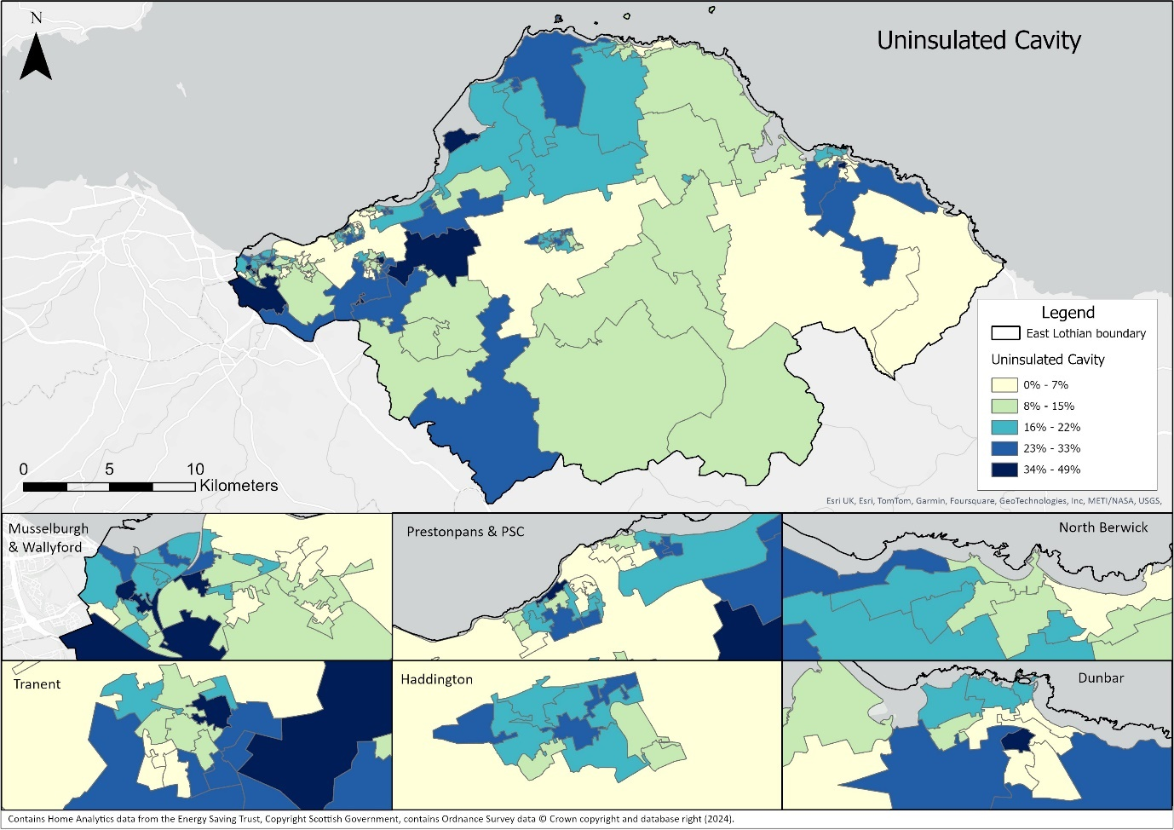
Figure 20: Estimated distribution of uninsulated cavities.
Thermal imaging cameras are very effective during cold spells when the heating is on at identifying properties where there is no cavity wall insulation installed or where an installation may be defective. As explained in 7.2.1, the systematic surveying of properties by community groups will provide clear evidence to support appropriate property-level decisions.
If a property has uninsulated cavities, then this should be a priority for action. An element of grant funding is available for most properties though there may be difficulties finding a contractor able to undertake the work.
Internal or external wall cladding may be a consideration for some properties that do not have cavities. This is an expensive intervention and likely to be only financially possible on a small number of properties. It may remain an option for Council owned properties, especially where multiple homes can be upgraded as part of a wider renovation programme. This is an example of where mixed tenure properties can restrict improvements due to the need to get all owners to agree to works being undertaken. Collaboration with the EES/ABS team can sometimes unlock grant funding to help private homeowners within a predominantly social housing block afford to participate. That will continue to be reviewed on a case-by-case basis.

7.2.3 Draft proofing and ventilation
At the most basic, this involves ensuring that there are no gaps around doors and windows where heat can escape. The use of community-led thermal imaging will help identify areas of greatest hear loss than might be resolved with minor changes such as insulation strips.
However, in older properties that were never intended to be air-tight, blocking all ventilation can also create additional problems. With low air flow there is a risk of moisture build-up that can lead to mould and unhealthy conditions. This is of particular concern in properties that are not adequately heated, potentially due to the cost of energy, and as a result internal walls get cold. The balancing of sufficient levels of ventilation with adequate internal heating is an area of concern for any property where there is a risk of fuel poverty.
Home Energy Scotland or a technical survey should be able to advise on what measures would be suitable for any property.
7.2.4 Replacing single glazing
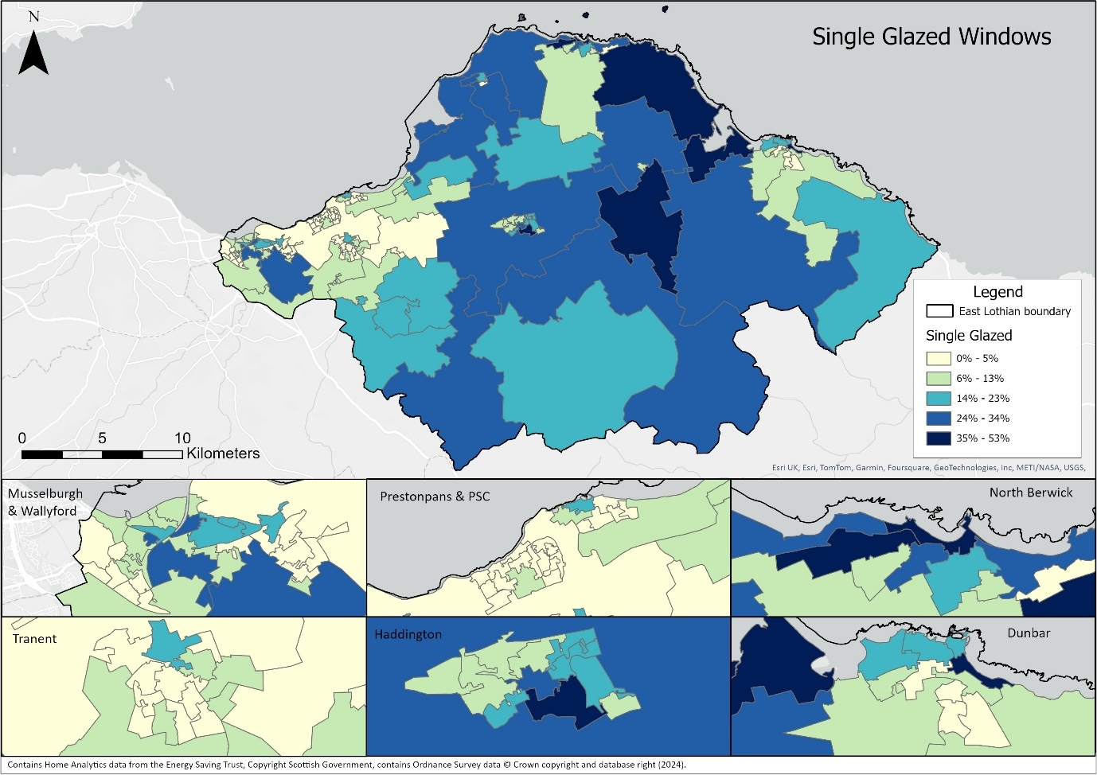
Based on data from Home Analytics, an estimated 5800 domestic properties in East Lothian are entirely or partially single glazed. The spatial distribution is shown in Figure 21. As a result, for these properties a significant proportion of heat is being lost through windows and without investment in double glazing these properties are unlikely to ever meet the increasingly stringent energy efficiency targets set by the Scottish Government.

Figure 21: Distribution of properties estimated to be partially or wholly single glazed.
As previously discussed, 2900 of these properties are in Conservation Areas and a further 460 are Listed Buildings outside Conservation Areas. The additional costs linked with fitting double glazing that meets planning conditions may be discouraging property owners from making the investment that would bring energy efficiency saving.

Private rental properties out with conservation areas are nearly three times as likely to have single glazing compared with owner occupied properties. To date there has been little incentive for landlords to invest in property improvements. However, the pending changes to EPC rules may encourage more to upgrade glazing.
Of the 2440 other properties listed in Home Analytics as having single glazing, 1030 do not have an EPC certificate so these should be treated as unreliable. In a further 350 cases the EPC certificate is over 10 years old. It is quite likely that a proportion of these properties will already have fitted double glazing.
The community-led surveying work will gather more accurate information on scale of the glazing challenge and help shape future actions.
7.3 Energy Efficiency across Tenure Types
Although the energy efficiency of domestic properties varies considerably depending on a wide range of factors, it is noticeable that there are trends across tenure types.
7.3.1 Social Housing
The best performing type are the social rented properties owned by housing associations. Less than 5% have EPC ratings of D or lower. All properties have a current EPC certificate, and these tend to be more up to date, so contain more reliable information. These properties tend to be well maintained by the social landlords and have benefited from more consistent investment to ensure tenants are protected from rising bill and the risk of fuel poverty.
The Council’s own property database has up to date information on all its social housing properties. This has been used to supplement the data from Home Analytics. The Council has an ongoing programme of property upgrades, many involving energy efficiency improvements. These are funded from the Housing budget and also supported by government grants.
7.3.2 Private Rented
The private rented sector is consistently the worst performing with nearly 60% of properties rated at D or lower on EPC certificate. This has huge implications for increased living costs for tenants and significantly increases the likelihood that tenants will experience fuel poverty. This is why the Scottish Government has focused early statutory targets on this sector.
East Lothian Council may use the approaching deadlines for energy efficiency improvements to encourage private landlords to improve their properties.
7.3.3 Owner Occupied
This tenure category shows the greatest variability in energy efficiency performance. Some property owners have already invested heavily to improve energy efficiency of their homes. For example, in the year to end June 2024 a total of 565 owner occupiers had an EPC survey carried out linked with a range of energy efficiency upgrade schemes.
However, others have not. This may be down to the cost of these measures or that they are not aware of the range of measures that could be relevant for them. Direct experience from the Council’s ABS programme regularly identifies former council houses that have not been upgraded to the same standard that properties that remain under council control.
For example, many homeowners may not know if their property has had cavity wall insulation installed in the past. It can be difficult to tell without technical knowledge. In some cases, badly installed insulation may have only a limited benefit and without a detailed thermographic survey it is difficult to diagnose specific problems.
The immediate priority at community level is to help homeowners make decision about their properties. The proposed use of resident surveys and thermal imaging to gather accurate information will support initial engagement and then enable more appropriate advice to be provided, including highlighting the availability of grant funding.
7.3.4 Mixed Tenure
Mixed tenure properties can be the most difficult to deliver major improvements. This can be due to difficulties getting all owners to agree, especially when considerable costs are involved, even when there is grant funding available that can also support owner occupiers. It may be impossible to progress any energy efficiency measures such as external wall insultation in a whole block if one property owner opts not to sign up. These issues will continue to restrict progress on installing energy efficiency measures.

7.4 Energy Efficiency in Historic Buildings
East Lothian has an estimated 9,600 domestic properties within the 30 Conservation Areas. Figure 12 shows the distribution of these. Conservation Area properties are on average considerably less energy efficient compared with the other parts of East Lothian.
- Only 4% of Conservation Area Properties are rated A or B compared to 16% in other areas
- 67% are estimated to be rated D-F compared to 46% in other areas
The issue of glazing has already been covered in section 7.2.4. The underlying reason is that these properties are older and stone built. It is also impacted by the restrictions placed on these properties by planning regulations.
The Scottish Government has recently introduced changes to the planning regulations relating to energy efficiency and renewable technology for Conservation Areas. Over time, these changes should make it easier for property owners in Conservation Areas to improve the energy efficiency of their properties. It is important that we make the public aware of the changes that are applicable to East Lothian, and this will form an action for the first year of the Delivery Plan.
There are significant challenges associated with making changes to the fabric of older buildings to improve energy efficiency. These can include:
- Repair work may be needed prior to retrofit
- Ensuring air flow and water vapour dispersal are not compromised to the building’s detriment
- Consideration of using natural materials better able to buffer moisture and prevent condensation
- Preventing damage when retrofitting
- Maintaining historic character
- Use of lime render as external wall insulation
- Presence of lath and plaster potentially restricting internal wall insulation options
Some of East Lothian’s Conservation Areas may be served in time by either local or district heat solutions. In that case, it is likely that the most efficient heat solution for those properties w would be to connect to the network. For many other historic buildings, due to their location, an individual heat pump may the most cost-effective long-term solution.
Prior to those decisions being made, every effort should still be made to improve energy efficiency in the short term.
7.5 Solar PV and batteries
The combination of local electricity generation with storage has the potential of effectively reducing the cost of heating for a property that relies on electricity. This is particularly important for any property in the Heat Pump Zone and considering installing a heat pump.
East Lothian benefits from an above average level of sunshine and solar panels can be expected to deliver a good performance level through most of the year. Even in winter panels can be expected to make a small contribution to electricity demand as the coldest days tend to be sunny. The positioning of panels is important, avoiding shade or partial shade. Ideally properties should face south, southeast or southwest, but using optimisers would reduce the issue for properties that don’t face south.
Before any property fits solar PV, it is important that the capacity of the local electricity grid infrastructure is checked with the grid operator, SPEN. The local grid needs to be able to cope with any surplus electricity that is exported at periods of high sunlight and power generated exceeds the need of the property. This may result in properties that would otherwise be suitable for solar PV being ruled out.
The addition of household battery storage can significantly increase the amount of self-generated electricity that can be used. This may have an impact on the time taken to cover the cost of the installation.
There is an additional internal space requirement for the battery and control panel. Batteries can be installed in roof spaces and control panels can be fitted next to fuse boards and are relatively small. Home Energy Scotland can advise on what would be suitable for any property. Installing battery storage would also help properties be more resilient to grid disruptions.
Surplus electricity generated can be exported to the grid and a property owner will be paid a guaranteed rate for this. The rates offered by suppliers vary so it pays to look at all the options as there will almost certainly be periods over the summer when panels will generate more than is required.

8. Individual Heat Pumps
Individual heat pumps are expected to be the main route to deliver net zero heat for a significant proportion of properties that currently use fossil fuels. These heat pumps would normally be either air source, using an external fan box fitted to the outside of the property or ground source, using either a vertical borehole or a horizontal closed loop laid in trenches adjacent to the property.
8.1 Baseline Installations
As of the end of September 2024 there were a total of 552 air source heat pumps and 55 ground source heat pumps installed across East Lothian, with 107 and 3 respectively fitted in the last 12 months. Together this amounts to just 1.2% of properties.
Most recent air source installations have been on new build properties.
A significant proportion of the retrofitted heat pumps were installed as part of the UK Government’s Electrification of Heat trial project in 2021/22 which selected SE Scotland as one of the pilot areas.
8.2 Heat Pump running costs
The relative price of electricity is the most important factor determining the economic competitiveness of heat pump running costs in the United Kingdom. Nesta - the UK's innovation agency for social good - published “How the UK compares to the rest of Europe on heat pump uptake | Nesta” in August 2023. It cited the UK Climate Change Committee report to Parliament that stated “... out of 17 European countries examined in 2021, the UK had the slowest rate of heat pump installation.” Figure 22 below is from this report and highlights the relative rates of heat pump installation across Europe.
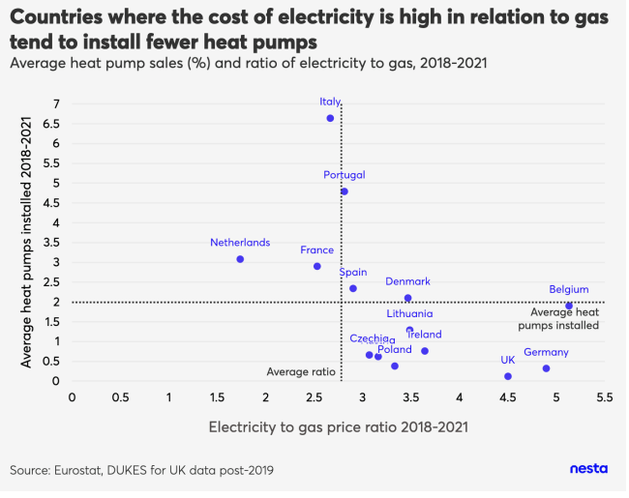
Figure 22: NESTA chart of heat pump sales versus the electricity-gas ratio for European countries.
In the UK, between 2011 and 2021, electricity was on average 3.8 times more expensive than gas. It is also alarming that the trend in the UK is heading in the wrong direction; between 2018 and 2022 electricity was on average 4.4 times more expensive than gas. The latest prices announced by OFGEM from October 2024 show a small improvement to a ratio of close to 4. That is unlikely to be enough to make heat pumps an attractive proposition for many on-gas properties unless the tax regime changes to reduce the ratio.
Where properties are not connected to mains gas and are instead reliant on LPG or oil for heating then the relatively higher prices for these fuels may make converting to a heat pump an attractive option.
8.3 Heat Pump Benefits
The benefits of installing a heat pump are:
- The heat pump technology generates between 2.5 and 4 units of heat for every unit of electricity used, depending on the internal temperature required and the ability of the property to retain heat.
- Disconnecting from mains gas, LPG or oil reduces the exposure to future price fluctuations linked with global markets and could be considerable cheaper.
- Using electricity will mean that the heating will progress towards net zero as the electricity grid reduces exposure to gas in coming years.
8.4 Heat Pump Disadvantages
The disadvantages of installing a heat pump may vary considerably depending on the characteristics of each property and can include:
- As outlined in 8.1 above, the unit cost of electricity remains high compared with mains gas so even with the multiplier effect of a heat pump, the financial incentives to switch fuel source are marginal at best.
- A property may not have the physical space externally for a fan box or for ground source bore holes.
- The flow temperature of the new heating may be lower than provided by an existing fossil fuel boiler. This may require radiators to be replaced with larger units and the connecting pipework to be replaced, especially if this is microbore pipes of 9mm diameter.
- The lower flow temperatures are more efficient in well insulated properties where heat loss can be kept to a minimum. For many properties, such as older stone-built homes, achieving this level of heat retention will either be impossible, or very expensive.
- Many modern properties were designed for combi boilers and do not have the physical space for a hot water tank that is normally required alongside a heat pump. Heat batteries may be a partial solution as they require an average a third of the space of a traditional hot water tank.
8.5 Efficient Heat Pump Operation
The cheapest heat pump solutions involve local electricity generation and storage to help reduce reliance on grid power supplies. There may be significant long-term cost benefits to households in installing solar panels and battery storage alongside a heat pump. This adds significantly to the overall capital cost and additional levels of decision making. However, it may produce the most cost-effective solution that protects against changes in electricity prices.

8.6 Electricity Grid Capacity
If there is a large-scale roll out of heat pump technology, this will result in a major increase in electricity demand. East Lothian Council has engaged with SPEN throughout the preparation of the LHEES and will continues to liaise over the requirements to upgrade capacity to support the widespread installation of heat pumps.
As it stands, the local electricity grid may require upgrading to support the additional power load. Before any heat pump installation can be considered, SPEN would need to confirm that the existing grid supply is sufficient to provide the additional supply. Where it cannot, system upgrades may be required which could delay or prevent a heat pump installation.
8.6 Increasing Public Awareness
There are a growing number of properties that have already made the decision to instal heat pumps. Their experience may be useful in helping others understand the issues involved in fitting and efficiently operating a heat pump. A concerted effort will be made to build on the existing Green Homes Network to identify volunteers who are prepared to share their experience with others and provide reassurance on decisions being taken. This will provide another level of valuable information to aid complex decision making. This will be coordinated by community groups that form the East Lothian Climate Action Network. Developing this support network will be an action for the first year of the Delivery Plan.
Property owners will be encouraged to seek advice from Home Energy Scotland suitable for their circumstances.
8.7 Further Advice
Homeowners can access free advice on heat pump options along with a wide range of other energy efficiency issues via Home Energy Scotland - Home Energy Scotland. This also contains links to the most up to date information on funding support available.
8.8 Future Heat Pump Installations
The areas of East Lothian to be targeted for conversion to heat pumps will ultimately be impacted by the scale of heat network development – see sections 9 and 10. If these are not deemed technically or financially viable then East Lothian will need to plan for the installation of tens of thousands of individual heat pumps across all communities and rural areas. It is expected that the strategic decisions relating to this will need to be taken during the period covered by this report.

9. Communal Heat Pumps and Local Heat Networks
This section describes the potential for a single heat source or heat pump to supply heat to multiple properties. The term ‘communal heat network’ is used when these properties are within a single building, such as in a block of flats. The term ‘local heat network’ is used to describe the situation where multiple buildings are heated from a single source, such as for a steading development. The key factor is that the properties are close enough together to make a single heat pump more cost effective than multiple heat pumps on individual properties, but not in areas where a connection to a district heat network is possible – see section 10.
9.1 Shared Heat Pump options
There may be opportunities for smaller scale heat network solutions and communal heat pumps alongside individual properties having their own net zero solutions. This could help address the lack of external space for certain properties. It may also be a more long-term cost-effective solution. Again, decisions on this may be supported by Home Energy Scotland.
Shared heat solutions also bring issues about the share of capital costs, billing and ongoing maintenance. They will require cooperation between neighbours, which may not always be possible to achieve. No proposals on how schemes like this might operate have been developed.
An assessment of rural communities will be carried out to try and identify those areas where shared heat pumps might be appropriate. This work would need to be carried out promptly to reduce the risk of some property owners taking individual action without considering the wider community possibilities. Early community driven initiatives in Pencaitland, Innerwick and Tyninghame are helping develop the approach to this. It will be up to those communities to determine the most appropriate governance and commercial arrangement.
A communal ground source heat network is being proposed as part of a new development in Dunbar. This type of initiative may be part of the solution for other new developments.
If a shared heat pump proposal is not deemed the best heat solution, then the fall-back position will always be individual heat pumps.
9.2 Target Communities
Initially, research will focus on properties that are very unlikely to be served by district heat network proposals. The target communities for shared heat pumps cover all the rural areas of East Lothian that are currently not served by the gas grid where a significant proportion of the households are reliant on oil or LPG for their heating. This will include the following villages and the rural areas around them:
- Drem
- East Saltoun
- Garvald
- Gifford
- Humbie
- Innerwick
- Oldhamstocks
- Spott
- Stenton
- Tynninghame
- West Saltoun
- Whitekirk
Most of these villages include Conservation Areas with older, stone-built properties.
Other steadings and smaller settlements may also be considered and will need to be assessed on an individual basis, drawing on support from Local Energy Scotland, to see if a shared solution is technically feasible and the financially viable.
The village of Pencaitland is perhaps a special case. It is currently served by mains gas. However, the distance from other larger settlements or possible pipeline routes under consideration for district heat development and the modest scale of demand, with only around 600 potential customers may make a local heat network solution more cost-effective approach than a connection to the district pipe network. The potential availability of waste heat from the Glenkinchie Distillery and Bairds Maltings will also be a factor.
9.3 Further Advice
Further information and free advice is available from Local Energy Scotland - We are Local Energy Scotland · Local Energy Scotland. They manage the Scottish Government’s Community and Renewables Energy Scheme which offers financial support to local energy projects.
10. District Heat Networks
This section aims to provide the Council and the wider community with a logical framework for identifying and prioritising the opportunities for district heat network solutions. It highlights the existing small heat networks, explores the main areas of heat demand, examines available sources of heat, including storage, and reviews a range of opportunities that might impact on delivery that relate specifically to East Lothian.
The development of heat networks should be aiming to deliver the following:
- Provide long-term and cost-efficient solutions to mass decarbonisation of both domestic and non-domestic properties
- Directly addressing the challenges of fuel poverty by ensuring the most vulnerable households benefit from lower energy costs and can be protected from future price spikes
- Ensuring that the operation of heat networks brings significant investment into our communities, supporting sustainable jobs and reinvesting future profits into ongoing retrofit and energy efficiency programmes.
10.1 Existing Heat Networks
East Lothian currently has 26 existing heat networks.
The only modest-scale heat network is operated at Queen Margaret University’s campus and serves the university buildings and halls of residence. This was originally designed to use a biomass boiler as its heat source, but for operational reasons it now uses mains gas powered boilers. The University is already actively exploring options to connect to alternative heat sources to help reach net zero.
The remainder of the heat networks are small in scale and fall into two categories:
- 15 are based at social housing or care settings. These are owned by Housing Associations or East Lothian Council. These involve multiple properties serviced by a central mains gas boiler. In total they provide heat for just 391 properties, which is less than 0.1% of East Lothian’s properties. To decarbonise, all these sites will need to convert to a net zero option. They could be considered as single point anchor loads for potential heat networks.
- 10 are rural heat networks based around farms that have installed biomass boilers, providing heat to multiple properties. Many will have benefited from previous grant schemes to cover the installation costs. Though biomass boilers are no longer encouraged, for the purpose of LHEES these are considered already net zero.
In addition, just beyond the western boundary of East Lothian there is a district heat network under development by Midlothian Energy Ltd. This is a joint venture between Midlothian Council and Vattenfall, the energy company owned by the Swedish state. The heat source is the energy from waste facility at Millerhill, operated by FCC Environment. The initial target for development is to provide heat to the new Shawfair town. Negotiations are underway to expand their pipe network to provide a district heating supply into the south-east of the City of Edinburgh.
As an early phase of development, there may be an opportunity to bring a supply from this heat centre into East Lothian, potentially providing heat to Queen Margaret University and parts of Musselburgh. The construction of the new A1 junction at Queen Margaret University included ducting for heat pipes within the design.

10.2 Heat Demand.
In exploring heat demand across East Lothian, it is useful to start from a regional perspective. Figure 23 shows the heat demand derived from the Scottish Heat Map across Edinburgh, Midlothian and East Lothian. By far the highest concentration of demand for heat is across the City of Edinburgh. Both East Lothian and Midlothian have a far more dispersed heat demand which focuses on the main centres of population. The heat demand averaged across rural areas is very dispersed and low by comparison.
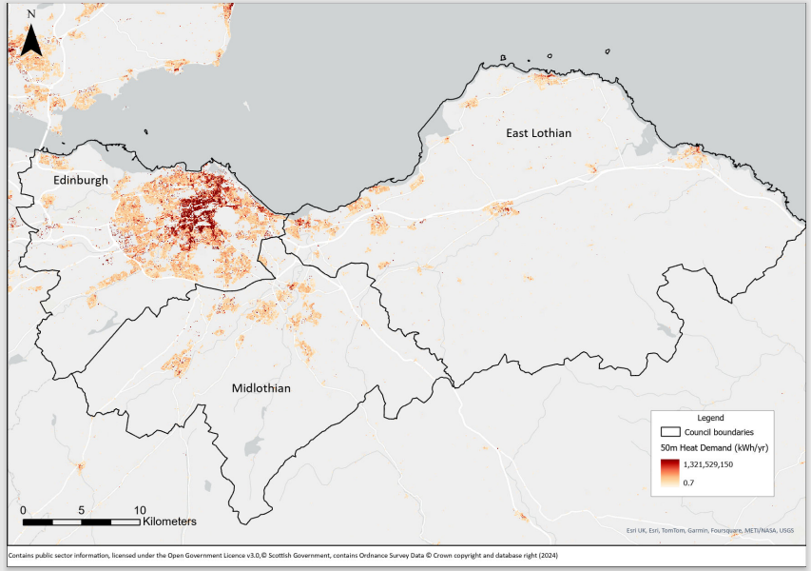
Figure 23: Regional Heat Map showing the heat demand from domestic and non-domestic properties across Edinburgh, Mid and East Lothian.
This dispersal explains much of the distribution of properties connected to mains gas across East Lothian. As shown in Figure 8 on page 24, the gas supply network focuses on the main population centres that have been cost effective to connect to the pipe network.
Utilising data from known gas usage from public sector buildings, data supplied by Scotland Gas Networks for non-domestic demand and domestic estimates from Home Analytics, it has been possible to bring an estimate of heat demand for the areas currently connected to the gas grid. This is shown in Figure 24 and includes notes on the confidence of the underlying data.

Property category | Heat demand (GWh / year) | Source of data | Confidence
43,000 on-gas domestic properties | 540 | From Home Analytics – EPC surveys and estimates | EPC figure is an estimate based on survey results, not an actual use. The margin of error will be higher for properties without a valid EPC.
East Lothian Council Assets | 28.8 | Accurate historic readings | 100%
Enjoy Leisure Assets | 10.1 | Accurate historic readings | 100%
NHS Lothian | 7.1 | Accurate historic readings | 100%
Other non-domestic | 74 | Historic data on overall gas use provided by SGN | This will be an over-estimate as it will include some high temperature industrial use.
Total estimated heat demand | 660
Figure 24: Estimated heat demand based on current gas use
There are non-domestic properties, particularly industrial units within geographic areas served by the gas grid that use either oil or LPG for heating and may have operational wet heating systems in place. There is insufficient data available on these sites at this stage to estimate the additional heat demand. This will be investigated on a case-by-case basis if any district heat network plans progress beyond the feasibility stage.
A more detailed examination of the concentrated heat demand in six town centre locations follows. Detailed heat demand figures are provided for each community broken down by domestic and non-domestic properties. These are based on actual gas use figures so are robust and include all properties that are currently heating by mains gas within those communities. Totals are also provided for public sector buildings, based on actual heat use and for social housing which is estimated. The local opportunities for low carbon or net zero heat sources are also explored.

10.2.1 Musselburgh Town Centre
Figure 25 shows the scale and distribution of the main centres of heat demand in Musselburgh town centre. This shows two main areas of demand on either side of the River Esk. To the east of the river, the main heat loads are the Health Centre, Grammar School, Leisure Centre and the senior campus of Loretto School. To the west of the river the largest heat demands are the Brunton Theatre (currently closed), Fisherrow Community Centre and Loretto’s junior campus.
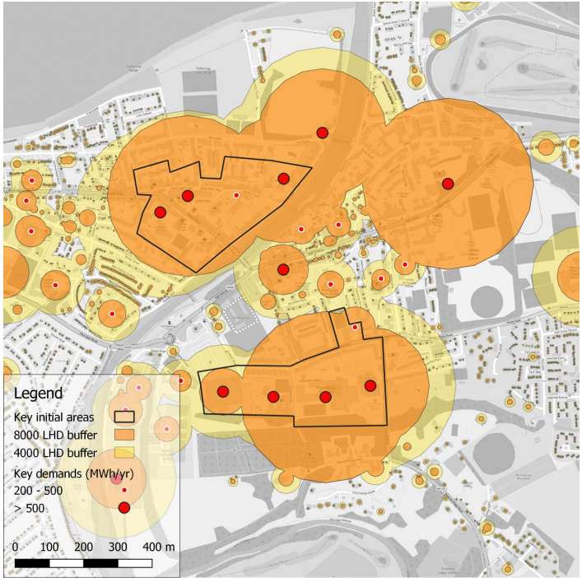
Figure 25 Linear Heat Densities in central Musselburgh
Annual Heat Demand Summary
Total Demand (GWh) | Number of Domestic Connections | Demand (GWh) | Non-domestic Connections | Demand (GWh) | Social Housing (GWh) | Public Sector (GWh)
157.1 | 9475 | 124.8 | Not avail. | 32.3 | 19.9 | 10.6
Possible local heat sources that could be considered to supply this cluster include:
- Heat supplied by Midlothian Energy via the A1 underpass and Queen Margaret University. Any pipe connection also needs to find a route to cross the East Coast Main Line railway.
- Water source heat pump using the River Esk
- Sea source heat pump with a facility on the sea wall
- Sewer source heat linked with the coastal main sewer that runs parallel to the coast.
10.2.2 Tranent Town Centre
Figure 26 below shows the scale and distribution of anchor loads in the centre of Tranent. The largest demand is from Ross High School, the Loch Centre and Tranent Medical Practice to the south of the High Street and with the Day Centre, Crookston Care Home and Sanderson’s Wynd Primary school site to the north of the High Street. This shows that there are multiple heat demands in the centre of Tranent that could be a possible core for a heat network.
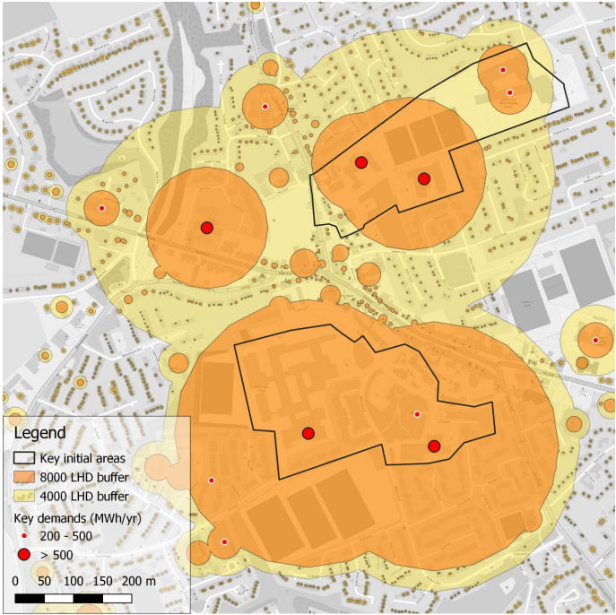
Figure 26: Linear Heat Densities in the centre of Tranent
Annual Heat Demand Summary (includes Tranent and Macmerry)
Total Demand (GWh) | Number of Domestic Connections | Demand (GWh) | Non-domestic Connections | Demand (GWh) | Social Housing (GWh) | Public Sector (GWh)
79.3 | 6389 | 68.1 | 61 | 11.2 | 18.3 | 6.0
The heat supply options in Tranent are significantly more limited. The ParkPower study (Section 8.3.2) suggested that there might be sufficient heat available via a ground source array using the school playing fields. However, this would have limited capacity to extend heat supply to domestic properties beyond these anchor loads.
10.2.3 Prestonpans Cluster
Figure 27 shows the main buildings with a high heat demand in Prestonpans. This cluster contains Preton Lodge High Scool, the Mercat Gait Centre (leisure centre) and Prestonpans Primary School. The heat load showing at the bottom left of the image is linked with an industrial site and is highly uncertain.
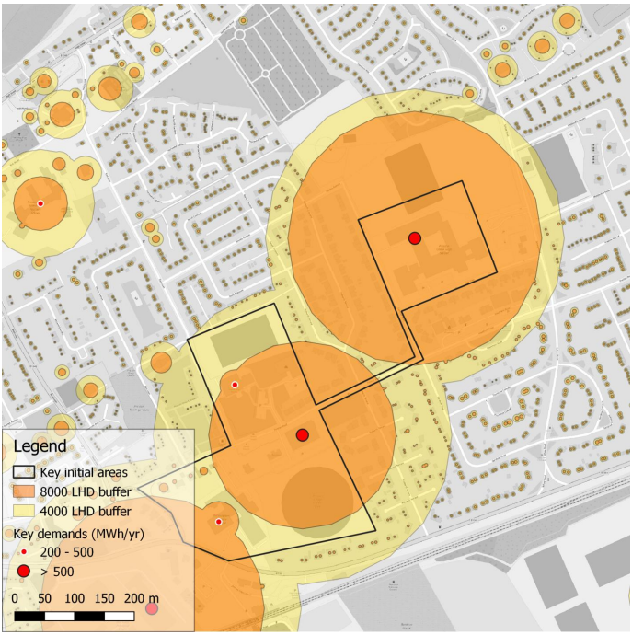
Figure 27: Linear Heat Densities in Prestonpans
Annual Heat Demand Summary (covers Prestonpans, Port Seton and Cockenzie)
Total Demand (GWh) | Number of Domestic Connections | Demand (GWh) | Non-domestic Connections | Demand (GWh) | Social Housing (GWh) | Public Sector (GWh)
102.5 | 7300 | 92.1 | 80 | 10.4 | 15.5 | 8.8
The nearest potential heat source for this small cluster, potentially including nearby domestic properties would be the mine water source heat pump solution that was investigated by Synergie Environ and Townrock Energy.

10.2.4 Haddington Town Centre
Figure 28 shows the main sites and scale of heat demand in Haddington town centre. This cluster is based around Knox Academy, the two sites of Haddington Primary School and the Aubigny Sports Centre. The proximity of additional heat demand from East Lothian Council’s headquarters, John Muir House, a care home and a hotel could justify connection.
The two large heat loads to the northwest of the town centre are the East Lothian Community Hospital and the neighbouring industrial site. NHS Lothian has expressed an interest in connecting to a heat network if a suitable supply can be provided.
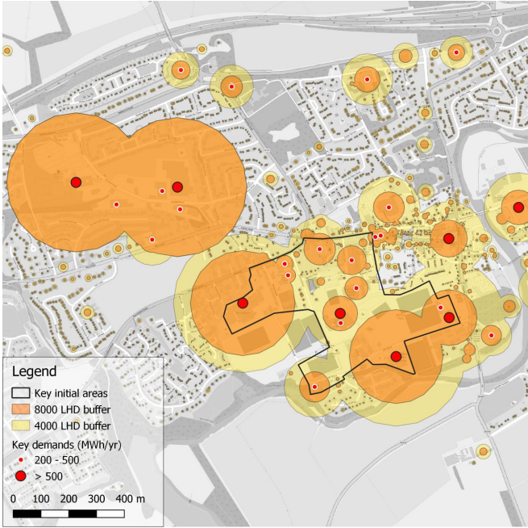
Figure 28: Linear Heat Densities in central Haddington
Annual Heat Demand Summary
Total Demand (GWh) | Number of Domestic Connections | Demand (GWh) | Non-domestic Connections | Demand (GWh) | Social Housing (GWh) | Public Sector (GWh)
90.3 | 5353 | 70.2 | 112 | 20.1 | 10.5 | 9.8
There are two potential local heat sources that might have the capacity to supply this cluster. These would be a ground source heat pump linked to a pipe array utilising the green space and sports fields from Knox Academy playing fields to Neilson Park. Alternatively, a water source heat pump utilising the River Tyne might be considered.

10.2.5 North Berwick Cluster
As shown on Figure 29 below, this cluster is based around three public sector sites on the southern edge of the town, North Berwick High School, Law Primary School and North Berwick Sports Centre. The combined heat demand might make this a possible local heat network opportunity. The community immediately to the east of the cluster includes a considerable proportion of social housing and might make an extension possible to supply some existing domestic properties.
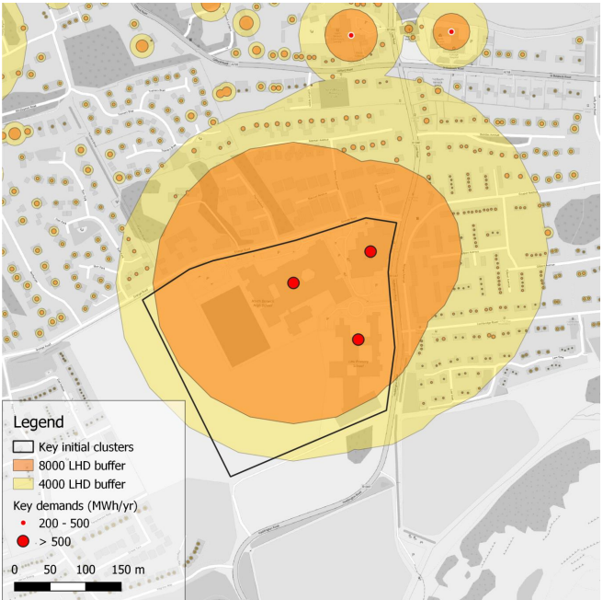
Figure 29: Linear Heat Densities in North Berwick
There are other significant heat loads in North Berwick associated with a major hotel, and with care homes. These are located at the western edge of the town and are too far from the cluster above to justify connection for a small-scale network.
Annual Heat Demand Summary
Total Demand (GWh) | Number of Domestic Connections | Demand (GWh) | Non-domestic Connections | Demand (GWh) | Social Housing (GWh) | Public Sector (GWh)
89.8 | 4217 | 71.6 | 86 | 18.2 | 4.7 | 4.0

There may be an opportunity for either a ground source or air source heat pump given the modest heat requirements of these three sites.

10.2.6 Dunbar Town Centre
Figure 30 below shows the main heat loads in Dunbar. The biggest single demand is the Dunbar Leisure Pool. The other main sites in relatively close proximity are Dunbar Grammar School, Belhaven Hill School and Dunbar Primary School. Belhaven Hospital is also nearby. All these have known heat demands and could form the basis of a heat network.
The smaller cluster of heat loads at the lower right of the map are retail and industrial units along Spott Road. These are only estimates so there is less certainty about whether these sites would be keen to connect to a heat network. The development site marked in blue is earmarked for employment use. The developer suggests that the early phases of development are unlikely to have considerable heat demand. They may connect to a heat network but should not be considered a primary target for early connection.
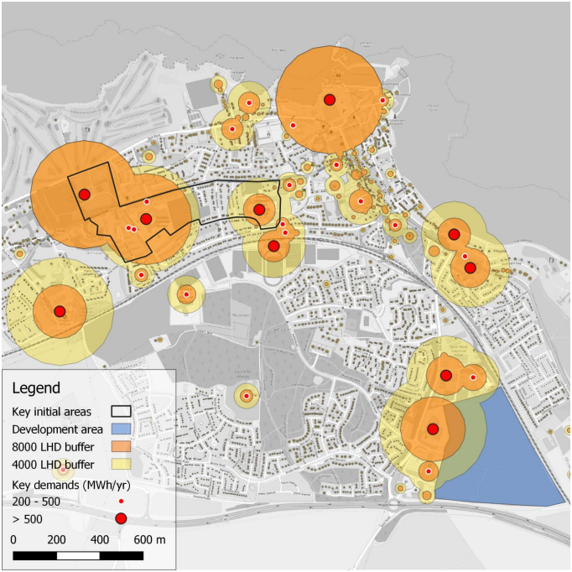
Figure 30: Linear Heat Densities in Dunbar
Annual Heat Demand Summary (Dunbar and West Barns)
Total Demand (GWh) | Number of Domestic Connections | Demand (GWh) | Non-domestic Connections | Demand (GWh) | Social Housing (GWh) | Public Sector (GWh)
61.7 | 3725 | 47.5 | 94 | 14.2 | 7.3 | 7.4

The potential heat source for a heat network in Dunbar could involve connection to the energy from waste facility. However, a limited demand based on mainly public sector buildings is unlikely to have sufficient demand to justify the investment needed to access this heat source. A more ambitious scheme to provide heat to more domestic properties throughout Dunbar might provide a large enough demand to interest the operator of the energy from waste facility.
10.2.7 Blindwells
Blindwells is the new settlement underway on the former open cast coal mine site between Tranent and Port Seton. This is the largest single new-build site in East Lothian. The developer has already carried out a feasibility study in association with the Heat Network Support Unit and their own technical advisors to explore options to develop a local heat network.
The developer will be responsible for progressing with any heat network development and are currently seeking expressions of interest from commercial partners. This would involve a mine water source developed in partnership with the Coal Authority to connect to future new-build domestic and non-domestic properties on the site.
Their current preferred heat network model is for an ambient system that would involve the distribution of water in uninsulated pipes to all properties. Each property would then require a water source heat pump to provide the increased temperature needed for heating and hot water. Each property would also require a hot water tank.
10.2.8 Limitations of Linear Heat Density Assessments
The modelling of linear heat densities within the LHEES guidance has its limitations. The following is an extract from the Heat Network Zone Guidance, prepared for the Scottish Government by Buro Happold and Zero Waste Scotland and published in April 2023.
“Note that the linear heat density approach used to identify potential zones within LHEES provides a very coarse strategic steer regarding viable connection distances and could be used to inform consideration of cross-boundary opportunities in terms of the likely viability of connecting demands that lie across a boundary.
No numbers have been suggested for proximity as the consideration of viable connection distance is complex and depends on many factors – 2 important variables are the ground conditions (soft dig is more affordable and suggests longer connection distances will be viable) and the cost of heat available (particularly so where relatively low-cost excess or waste heat is available). The latter may also present opportunity to take heat over considerable distance to connect supply sources with demand concentrations, potentially offering up connection opportunities to demands on route.”
As a result, this strategy explores beyond the initial scope of the LHEES guidance to assess the wider potential for heat network development relating to East Lothian’s specific geography and opportunities.

10.3 Heat Sources
This section takes a wider look at possible sources of heat that might be used to support any potential heat networks. A crucial element is the likely cost of that heat. The priority should be to secure the cheapest possible sources to ensure customers ultimately benefit from lower energy costs.
10.3.1 Capturing and Using Waste Heat
In searching for the cheapest sources of heat, the starting point should be locations where significant quantities of heat are currently being wasted. In most cases, waste heat is simply vented into the air. There are a number of sources of waste heat that could potentially be accessed to supply district and local heat networks.
- Energy from Waste Facility, Dunbar.
This Energy Recovery Facility began operation in 2019. The facility has a commitment to make up to 10 MW of heat available for local use. To date this has not been accessed. There is also potential to capture significantly more waste heat with the operator indicating that the plant could satisfy the heating needs of 71,000 homes. The challenge for this opportunity is having a demand sufficient to justify the considerable expense of developing the pipe network required to deliver that heat to customers.
The plant shuts down for roughly 3 weeks every 24 months for maintenance. This is normally in May/June when electricity prices are low and conveniently when heat demand is also low. Any heat network infrastructure needs to be able to plan for this scheduled break in supply.
- Cement Plant, Dunbar
This is the only cement manufacturing facility in Scotland. It is the single largest source of CO₂ in East Lothian and one of the largest in Scotland. Its kiln requires a temperature of 1400C, which is achieved through burning coal and other waste materials. Although the plant is quite efficient at utilising most of the heat generated, there remains the possibility of capturing waste heat at a temperature that would be suitable to feed a heat network. Tarmac are in the process of calculating how much waste heat could be supplies.
One additional factor is that the facility shuts down for annual maintenance in January or February. This coincides with when the construction industry has less demand. However, it is when heat demand is at its highest. This would not be an easy process and, as with the example above, would probably not be viable without a considerable connected market for the heat that links multiple heat sources.
- Wastewater Sewers
Heat networks utilising heat from wastewater are operational at other locations in Scotland and a major project is being considered at the Seafield Water Treatment site in Edinburgh. This treats a significant proportion of East Lothian’s waste via the coastal sewer.
In addition, the sewer that transports most of Midlothian’s waste runs to a pumping station outside Wallyford and from there towards Seafield. There may be opportunities to access waste heat from this pipe as well.
Any decision to use sewers as a heat source in East Lothian would have an impact on the ability to extract heat at Seafield as is being considered by City of Edinburgh Council’s LHEES.
- Whisky Distillery
East Lothian has one distillery site, outside Pencaitland. This generates heat during whisky production. Currently hot water is cooled in external ponds on site prior to release into the Kinchie Burn. There may be an opportunity to utilise this heat. The distance from the distillery to the village of Pencaitland might make utilising this heat impractical, but this could be fully explored.
- The Maltings
This site is also outside Pencaitland and generates low level waste heat from a number of processes. The site owner is keen to explore whether this heat could be used to provide heat to the local community via a heat network.
- Green Hydrogen
Although there are no confirmed plans for green hydrogen production in East Lothian, there may be opportunities for future production at both Cockenzie and Torness. These locations are where offshore power cables are coming ashore and are close to major electricity grid infrastructure. Green hydrogen production involves the generation of considerable quantities of waste heat so having heat network infrastructure planned at either or both sites would unlock a very significant additional source of net zero heat.
10.3.2 Zero Emissions Heat Sources
The preparation of this LHEES has involved bringing together information on a range of other potential sources of net zero heat linked with the use of predominantly renewably generated electricity. The potential for each to play a role in East Lothian’s future heat solutions is being considered and could be further investigated as feasibility work progresses. In summary, these opportunities are:
- Mine Water Source. A series of reports have been commissioned by East Lothian Council to explore the potential of utilising mine water. The most recent was completed by Synergie Environ and Townrock Energy in August 2023. This study explored various options for mine water district heating networks at the former Cockenzie power station site, and the benefits that such a heat network could bring for the council and the local area.
It identified that a maximum output of 9.7MW could be delivered at the Coal Authority’s treatment site at Blindwells. This is viewed as a viable source of heat for a district heat network and development of that project is being taken forward by the developer as outlined above in section 10.2.7.
This report also suggests that mine water has the potential to support a viable district heat network from two separate borehole extraction sites linked with former collieries near Prestonpans. The report informs that this could support a water sourced heat network with the capacity to supply council-owned assets in Prestonpans plus several hundred domestic properties.
- Sea Source. East Lothian’s coastal location makes utilising the sea as a source of heat promising. It offers a limitless supply so can be readily scaled up to meet any need. At scale, it can achieve a coefficient of performance of 3, i.e. delivering three units of heat for everyone one unit of electricity required. The ultimate cost of the heat produced is therefore directly linked to the cost of the input electricity.
A significant challenge for sea source heat is identifying appropriate locations for heat infrastructure that have development land on the coast and suitable access to the sea. East Lothian has one potential location, the site of the former Cockenzie Power Station. This is owned by East Lothian Council and is close to the site where two offshore wind cables will be coming ashore. This brings the potential for a cheap source of electricity to power any heat pump.
- Ground Source and Water Source. In March 2021, Greenspaces Scotland and ParkPower produced a report, Green Heat in Greenspaces, examining the potential to utilise parks and other green spaces within urban settlements across Scotland to support low carbon heat solutions. It also explored the potential to extract useable heat from local rivers.
This study found that those public buildings with the highest heat demand, such as leisure centres, particularly those with swimming pools, hospitals, schools and care homes and offices are often closely located to urban greenspaces. Large greenspaces have the potential to supply 100% of the heat demand for a nearby public building with high heat demand and provide potential for supply to other buildings via district heating networks. Over time, the heat network might then be expanded to supply additional heat demand in the locality.
It concluded that there are promising options in Dunbar, Haddington and Tranent for ground source heat pumps, all of which ranked within the top 2% of most suitable sites across Scotland. However, the maximum scale of any one of these developments was limited by the available green space and would not be able to expand to heat many neighbouring sites. The cost-effectiveness of any project is also closely linked with the price of electricity and with significant price rises since 2021, and any future feasibility work would need to establish whether these options would be viable.
The results for water source heat pump solutions highlight promising options for some settlements within the East Lothian area. The most promising settlement is Whitecraig, utilising the River Esk as its heat source.
- Electric Boilers linked to Thermal Storage. On a national scale, the UK’s grid manages periods of oversupply of electricity by turning off wind farms, a process known as curtailment. During periods of oversupply excess electricity could be used to power electric boilers to produce heat. This heat is stored in thermal stores (large tanks of water) which can then be used as a cheap heat supply for heat networks. The electric boilers can be controlled by the grid and switched on remotely, providing a near instant outlet for excess power. This can mean delivering free heat or in some cases, being paid to generate heat.
Tarmac have confirmed that there would be physical space within the restored section of their limestone quarry at Dunbar for the large scale storage that this would require.
10.4 Additional Infrastructure Opportunities
There are a number of potential infrastructure projects across East Lothian that could facilitate the more cost-effective delivery of heat network solutions. These include:
- Cockenzie Power Station site. East Lothian Council owns this large site and is currently preparing a masterplan for its redevelopment for both energy and employment opportunities. This work is already underway, with major decisions being made over the next two years. The coastal location could provide access to sea water for a possible sea source heat pump or alternative heat solutions.
- Offshore Wind connections. East Lothian is the landing site for a number of cables from offshore wind farms. Considerations should be given to opportunities that might enable a long term deal to electricity supply to heat infrastructure. This might reduce the risk of energy price fluctuations and help secure long-term capital investment.
- Musselburgh Flood Protection Scheme. Design work on this scheme has already been taking place for a number of years, aiming to reduce the flood risk from the River Esk. There may be an opportunity to include heat network infrastructure within he proposed construction should the timelines align.
- Active Travel Corridor. In line with Scottish Government policies to promote active travel, East Lothian Council is preparing plans for an Active Travel Corridor, a combined cycle path and walkway along the route of the A199 (old A1) from Dunbar to Tranent, a distance of around 24km. Again, there may be an opportunity to combine this with heat network infrastructure.
10.6 A District Heat Network Opportunity
Much of the research undertaken for this report, when combined with the advice provided via the Scottish Government’s Danish Heat Network Mentoring Programme has encouraged East Lothian Council explore the wider opportunities for heat network development. This could involve connecting multiple heat sources and involve thermal storage. This approach could potentially provide the sustainability of supply to ensure the cheapest heat can be delivered to both domestic and non-domestic customers.
A significant transmission network of insulated pipes would be required to move the heat to customers across East Lothian and might eventually provide the opportunity to supply surplus heat to other heat network operators in Midlothian and Edinburgh. This could take 15-20 years or longer to roll out. Significant feasibility work will be required to assess the technical and financial viability of any proposals.
10.6.1 Benefits of a District Heat Solution
Developing a district heat network might bring significant benefits for individual bill payers. These needs to be compared with the costs and technical challenges linked with solutions described in sections 8 and 9. The potential benefits might include:
- The system would be designed to consistently deliver the cheapest possible heat to customers and provide protection from short-term price fluctuation.
- The water supplied by the district heat network would be at roughly the same temperature as produced by most existing gas boilers, so this would simply involve replacing one source of heat for another with minimal internal changes required.
- In most cases the heat exchanger can fit in the space that is currently occupied by a gas boiler and might even require less space.
- There could be no need to replace internal pipework or radiators so minimising internal disruption. It may help the level of overall energy efficiency to do this, but it would not be a requirement.
- Properties without existing hot water tanks would not need to get one fitted. The heat exchanger would provide instant hot water in the same way that a combi boiler. Those wishing to retain a hot water tank could do so.
10.6.2 Down-sides of a District Heat Solution
The disadvantages of developing a district heat network include:
- Connection can only take place when the pipe network reaches your property. This may take several years, which could take longer than some property owners are prepared to wait.
- Some replacement of internal radiators or microbore pipes may be required where the existing heating uses flow temperatures above 65°C, such as in non-domestic properties.
- There would certainly be an element of external disruption as heat pipes need to be laid from the street to individual homes.
- There will be no choice of supplier as a single heat provider will operate the network. This will mean that there is no opportunity to shop around for a cheaper deal.
- To enable properties to disconnect from the gas supply, saving on the standing charge, any cookers using gas would need to be replaced. Knowing the timeline for connection should make planning for this easier and can be done at any time ahead of connection.
- The delay in getting heat network infrastructure developed and the pipe network constructed may result in difficult short-term decisions on heating systems, especially where an existing gas boiler breaks down or come to the end of its safe operational life.
10.7 Feasibility Studies
Should the decision be to continue exploring the potential for a district heat network in East Lothian, then the next step would be to undertake a detailed feasibility study. This would be carried out in conjunction with the Scottish Governments’ Heat Network Support Unit and draw on advice and support from a wide range of local and national sector exprts.
10.8 Electricity Grid implications
Developing individual heat pumps to supply the majority of on-gas properties would have major implications for the electricity grid infrastructure. However, the development of district heat networks should significantly reduce the scale of local electricity grid upgrades in many towns across East Lothian. SPEN will be reviewing the LHEES report to assess any other implications for their grid supply.

11. Other Heating Solutions
11.1 Electric heating
Around 10% of East Lothian’s homes already use other electric heating systems. These can be expensive to operate, especially as a result of recent price rises. The priority for properties that already have electric heating, or where heat pump options are not feasible, is to ensure that the chosen heating system is as energy efficient as possible. This will provide an element of protection against the risk of fuel poverty if electricity prices remain high.
Free advice should be sought from Home Energy Scotland before deciding on the most appropriate electric heating solution. The following electric solutions may be suitable:
- Storage heating (Quantum Heaters) and high heat retention storage heaters. These benefit from using cheaper overnight tariffs to charge the heaters.
- Electric Wet Central Heating (Combi Boiler). These are probably the easiest to fit into a property that already has a wet heating system. However, when the unit cost of electricity is considerably higher than the fossil fuel it replaces, the running costs may be unaffordable and bring a risk of fuel poverty to the household.
- Infra-red Heating. This system relies on panels to heat spaces that are being occupied, rather than whole properties. There may be circumstances where this is an efficient option, especially when only part of a property is regularly in use.
11.2 Hydrogen
The Scottish Government do not envisage hydrogen having a role in domestic heating. The UK Government is scheduled to make a final decision on this in 2026. This timeline brings uncertainty and may undermine the ability to make firm decisions. Considerable uncertainties remain on the safety and economic viability of hydrogen in a domestic setting. The proposed strategy put forward by SGN shows a continuing reliance beyond 2045 on blue hydrogen, sourced from natural gas. This could make it very challenging to meet net zero emissions targets as the required technology for large scale carbon capture remains unproven. As a result, hydrogen is not considered as a heat source in this strategy. It will almost certainly have a role in high temperature industrial processes and therefore its production may become a source of waste heat that could be captured for use in heat networks.
The production of green hydrogen, using surplus renewable electricity to electrolyse water into hydrogen and oxygen produces a very significant level of waste heat. Around 25% of the input energy is lost as heat. If East Lothian is viewed as a future location for this industrial process, then it would be essential that this heat is captured for use in heat networks. Both Cockenzie and Torness have been mentioned as potential locations due to the offshore wind connections at these sites.
Should hydrogen become a cheap and widely available fuel in the future, then it would also be possible to include a hydrogen powered combined heat and power plant as part of the overall energy solution in East Lothian. This could be an alternative source of peak support for the heat network.

12. Community Wealth Building
12.1 Heat Solution Delivery Models
In February 2024 the Scottish Government published a report by the Scottish Futures Trust on Heat Network Delivery Models - Heat Networks Delivery Models - gov.scot (www.gov.scot). This explores the core attributes that an effective delivery model should include. This provides a framework to assess and refine the proposed option for East Lothian. The desirable attributes identified are:
- Ease of deployment
- Potential for private sector investment
- Supports development of skills and capacity
- Simplifies delivery
- Contributes to wider policy objectives
- Reduces demand risk
- Supports transition to self-sustaining market
- Supports replicability
- Supports expansion/interconnection
- Facilitates installation of heat networks ahead of demand
- Balance Sheet Treatment
Work is underway to help determine the most appropriate organisational and governance structure for East Lothian’s future Heat Solutions that can meet as many of the attributes listed above. This will be explored during feasibility studies.
12.2 Growth opportunities for businesses
There are a range of existing local businesses with significant potential to benefit from decarbonisation, bringing growth in local employment with high paying, skilled jobs.
Other commercial partners will be encouraged to consider relocating business operations into East Lothian in support of their role in project delivery
12.3 Skills shortage
The number of homes to be retrofitted each year to meet targets is significant, requiring a substantial skilled workforce. The range of roles that will be required includes:
- Insulation fitting
- Heat pump installation/ maintenance
- Retrofit coordination
- Traditional skills for historic buildings
- Supporting roles (e.g. welders, scaffolders)
Were a heat network or communal network to be developed then this would increase the range and number of potential employment opportunities in the county. East Lothian Council has a number of programmes in place and under development that aim to help address the skills shortage. This includes a Scottish Government Demonstrator Project, based at Wallyford Learning Campus, for Modern Apprenticeships in Global Infrastructure & Built Environment. In addition, a partnership with Edinburgh College a range of relevant courses. There is also an Edinburgh College certificated construction certificate for post school.
The Integrated Regional Employability and Skills Programme that forms part of the Edinburgh and South East Scotland City Region Deal is developing a network of Recruitment and Skills Centres to act as a tangible interface between the partners and business. There is a clear opportunity for a focus on heat and energy efficiency employment as a sector of high demand.
The college sector, supported by ESP Scotland is ready to coordinate training provision to help deliver the significant increase in skilled workers that would be required to deliver this transformation in heat and energy efficiency. Some of this training could be provided in East Lothian, taking advantage of new facilities at the Wallyford Learning Campus.
12.5 Wider economic impacts
The decisions taken as a result of LHEES have the potential open up additional economic growth opportunities, helping attract businesses linked with heat infrastructure to be based in East Lothian.
12.5.1 Cockenzie site
The location of a major heat centre on the East Lothian Council owned site could make the location potentially more attractive to other businesses and job creators. A connection to a net zero heat solution may enhance marketing activities and be attractive to a range of other industries.
The infrastructure to manage waste heat may be attractive. Any business that generates heat might improve their energy efficiency by supplying that waste heat into the heat network. This could improve their overall energy efficiency performance that could enhance their ability to secure new business.
12.5.2 Green Hydrogen production
There are no known plans for green hydrogen production in East Lothian. However, were this to come forward, this is an energy intensive process that generates significant waste heat. The ability to capture that heat and distribute it within a heat network would have a positive impact on the business model of any proposed site and help diversify the heat supply.
12.5.3 Horticulture
Recent price rises have focused attention on food security, especially out of season. A major input cost into food production out of season is heat. A relatively cheap supply might open up the potential to expand East Lothian’s production utilising spare capacity within the heat network.

13. Funding and Investment
East Lothian Council does not have the capital or revenue capacity to deliver the desired outcomes of this strategy. Indeed, the Council may not be part of future heat solution delivery. It would require leadership and funding from SG to fit in with an emerging national picture. As a result, significant funding and investment will be required if the visions outline in this document are to be realised. The various options for governance for an Energy Supply Company as outline in section 9.1 may impact on the range of funding opportunities available.
13.1 Grant and loan funding
A review was carried out of the current grant and loan funding and delivery programmes that could be utilised to support LHEES Delivery actions. This is by no means a comprehensive list of all the funding opportunities available.
Consideration should be given to potential changes in the policy landscape that may involve new delivery and funding programmes. The clear designation of zones within LHEES will help property owners adapt quickly to new opportunities as they arise.
13.1.1 Potential sources for East Lothian Council
Scheme Name | Details | Status
Energy Efficient Scotland: Area Based Scheme (ABS) | Funded by Scottish Government. Targets energy efficiency measures for owner occupiers and private landlords owning 3 or less properties. This ongoing scheme is delivered by East Lothian Council and prioritises fuel poor areas (usually Council Tax Band A-C) | Scheme already operating and will continue to focus on priority retrofit aligned with LHEES outcomes
Heat Network Support Unit | Funded by Scottish Government to support and develop heat networks. Can offer 100% funding for feasibility studies and up to 50% of Outline Business Cases. | Future applications are planned to support feasibility work.
Heat Network Fund | Funded by Scottish Government with a total of £300m available before April 2026. Heat network projects must be of a large scale and demonstrate a positive social and economic benefit. | Case will be made in support of wider capital investment for heat solution priorities
Public Sector Heat Decarbonisation Fund | Funded by Scottish Government via Salix. Total of £20m to help public sector decarbonise their heating systems by replacing them with zero direct emissions systems, as well as for retrofit energy efficiency measures to support the overall decarbonisation of heat in buildings | Announced in July 2023 with more information expected soon with tight application deadline
Social Housing Net Zero Heat Fund | Funded by Scottish Government and also open to other social landlords. Total of £200m by 2026 with two themes:  1 – zero direct emissions heating systems  2 – “fabric first” energy efficiency only projects | ELC application can be prepared once net zero heat solutions are agreed via LHEES. Also encourage RSLs linked with getting heat network ready
Figure 32. Summary of the potential sources of grant funding available to East Lothian Council.
13.1.2 Potential sources for social landlords
The main opportunity currently available for social landlords is the Social Housing Net Zero Heat Fund as mentioned above. Any future confirmation of heat network plans might enable applications for with further energy efficiency measures to be directly linked with getting heat network ready, or potentially towards the capital cost of connection.
For rural, off-gas properties, proposals could be considered focused on communal heat pump solutions.
13.1.3 Potential sources for private landlords
The Private Rented Sector Landlord Loan is a Scottish Government funded loan that helps landlords improve the energy efficiency of their properties and meet minimum standards. This is administered by the Energy Savings Trust.
Up to £15,000 can be borrowed per property for insulation measures and £17,500 for up to two home renewable systems per property plus an energy storage system up to a maximum of £6,000. Landlords with five properties or fewer can borrow up to £100,000 and those with six or more can borrow up to £250,000 with the loan repayable over eight years.
13.1.4 Potential sources for homeowners
Advice on the range of grant and loan funding that is currently available to support owner occupiers with energy efficiency improvements and net zero heating solutions is available via Home Energy Scotland. More information can be found at Home Energy Scotland Grant and Loan.
In addition, Home Energy Scotland will be able to advise whether homeowners would be eligible for support under the Warmer Homes Scotland grant scheme - Warmer Homes Scotland.
As part of the investigation into the development of the capital investment model for the district heat networks, options will be explored to enable property owners to unlock additional funding for energy efficiency improvements. This may involve an increase in unit cost paid for heat by that household for a number of years. However, any increase in unit cost should be more than offset by the overall reduction in heat required to maintain a warm home due to increased energy efficiency. Any agreement of this nature would remain with the property so if a home is sold, the next owner would continue to pay the slightly increased unit rate for heat.
13.2 Capital Investment
As part of the stakeholder consultation, an engagement event for investors was held in November 2023 to showcase East Lothian’s possible heat network opportunities. The broad conclusion was that a range of financial institutions are ready to invest in suitable energy efficiency and heat network projects. However, it is important to stress that they are expecting large scale projects, based on robust business plans that have scope for expansion. Relatively small and local heat projects are unlikely to attract significant investment interest.

14. Delivery Plan
This section takes the analysis and framework explained in the Strategy and prioritises provisional areas for delivery over the next 5 years.
14.1 Plan Details
The Delivery Plan focusing on progressing five specific outcomes, as summarised below. Each outcome has two or more key priority areas outlined in the bulleted lists below. More detail on the individual actions is provided in Appendix 2.
Outcome 1: Property owners are engaged with the need to reduce carbon emissions and empowered to make decisions on energy efficiency and heating solutions.
- Raising Awareness
- Building Community Leadership
Outcome 2: East Lothian's homes and buildings are as energy efficient as possible.
- Conservation Areas
- Solar PV Installations
- Owner-occupiers
- Council Homes
- Private Rented and Short Term Lets
- Social Rented
- Council-owned Non-domestic
- Other Non-domestic
Outcome 3: Heat solutions are delivered to tackle fuel poverty and meet 2045 net zero target.
- Heat Network Opportunities
- Communal and Individual Heat Solutions
Outcome 4: Investment and grant funding is secured to deliver Net Zero projects.
- Feasibility Studies
- Infrastructure Investment
- Grant Funding from Scottish and UK Governments
- Community Funding
Outcome 5: A significant proportion of the benefits of Net Zero investment remain within the East Lothian economy.
- Community Wealth Building
- Tackling Fuel Poverty
- Developing the Local Supply Chain
14.2 Development Funding
It is important to recognise that East Lothian Council is operating within very strict financial constraints and currently does not have the resources available to play a leading role in all aspects of this Delivery Plan. It will require financial support from the Scottish Government, UK Government, or other external sources to make significant progress. All avenues to unlock funding will be explored.

14.3 Importance of Heat Network Feasibility Studies
Many elements of this Delivery Plan hinge on the technical and economic viability of a variety of options, particularly the district heat network proposals. Feasibility work for this will be prioritised in remainder of 2024 and into 2025. Upon completion of any phase of feasibility work, recommendations will be taken by the Energy Transformation Board for decisions on the way forward. As a result, actions contained within the Delivery Plan may need to be adapted or changed significantly depending on the decisions taken. The latest version of the Delivery Plan will be available via the Council’s website.
14.3 Tracking Progress
Where appropriate and feasible at this stage, targets will be set to help deliver the Actions. If these extend beyond the 5-year term of the LHEES Delivery Plan, then interim targets will be added to ensure progress continues towards the longer-term objectives.
East Lothian Council’s Energy Transformation Board will be responsible for the overall monitoring the progress of this Delivery Plan. This Board meets on a bi-monthly basis.
14.4 Delivery Plan Updates
The Council recognises that heating is an area where national policy can change rapidly and that external factors such as the market price for energy can have a significant impact on the financial viability or desirability of interventions. Elements of this Plan may have long lead in times that stretch beyond the initial 5-year window. As a result, this Delivery Plan will be reviewed regularly to ensure that it continues to meet the needs of stakeholders as circumstances change. The first review will be provisionally planned within 12 months, and then a decision taken at that stage on the required frequency thereafter.

Appendix 1 - Data Quality Challenges
The early LHEES studies all relied on Home Analytics as the primary source of household data. This remains the only comprehensive household data set. However, Home Analytics has some very significant shortcomings that need to be acknowledged. These considerably limit the value of elements of the GIS based modelling work that is recommended in the LHEES methodology. Further work has been done to reduce and mitigate these shortcomings.
Energy Performance Certificates
The primary source of data within Home Analytics comes from Energy Performance Certificate (EPC) surveys. Thes covers 58% of domestic properties in East Lothian. The data for the remaining 42% of homes are extrapolated from neighbours and subsequently given a lower confidence estimate of around 90%. Close examination of individual surveys shows inconsistencies in the surveys themselves. Of EPC surveys, 18% were carried out over 10 years ago and need to be awarded a lower level of confidence.
Rural areas tend to have lower rates of EPCs as the turnover of property sales there tends to be lower. Properties are more likely to be unique in build style and energy efficiency, so the extrapolation process is likely to result in greater errors. The confidence level of 90% that is used in the modelling seems to be too high based on the level of uncertainty.
EPC ratings for Heat Pumps
The Scottish Government is in the process of upgrading the EPC process to bring it in line with net zero ambitions. One anomaly of the current rating that directly impacts on LHEES is the fact that EPC ratings are greatly influenced by the cost of operating heating systems. Mains gas is relatively cheap whereas the use of electricity is more expensive. Properties converting to heat pumps can actually see their rating drop despite moving from a fossil fuel source. This will be corrected in the new rating system but needs to be taken into account when using data based on the current system.
Timing of Home Upgrades
Any homeowner applying for grant or loan funding for home improvements is required to get an EPC survey done before work is carried out. In many cases they then go ahead and make changes to their property but do not get a new EPC survey afterwards.
EPC surveys are required to be carried out ahead of property sales. Any changes and improvements made by the new owners, a time when most major changes are undertaken, will not be represented in the EPC rating. This again leads to an underestimate of energy efficiency.
Home Analytics (EPC) data will not necessarily reflect all energy efficiency improvements measures across all housing tenures. For example, in a social housing context, East Lothian Council have made considerable investment in recent years, which they track and calculate but do not commission a new EPC on completion of each retrofit measure.
As a result, the data shown by Home Analytics for a proportion of homes may be out of date. This has a knock-on impact on the extrapolation process as described above.

Housing Tenure
The number of properties listed on the original Home Analytics dataset as East Lothian Council owned was around 25% higher than the actual figure. This is a direct result of the extrapolation process used with Home Analytics. The data used for this final report has corrected these errors in tenure.
Similarly, there were considerable errors in properties listed as ‘Private Rental’. When cross-referenced with the private landlord register, nearly 60% of properties were incorrectly attributed. This has been corrected for the analysis included in the final report.

