

Foreword

“Planning enforcement is an essential part of the process of regulating development
and it is important that the council sets out how it will deal with unauthorised development,
for those carrying it out and especially for those affected by it. This Charter sets out the standards the public should expect of the council in dealing with enforcement complaints
and is an essential part of understanding how the planning process works”.



Norman Hampshire, Council Leader & Convener of Planning Committee

Contents

Introduction 1
Legislative Context 1
Time Limits 5
Breaches of Planning Control 1
Reporting Breaches of Planning Control 1
Monitoring of Major Developments 1
Enforcement Procedures and Service Standards 1-11
Enforcement Powers - Types of Notices 1-13
Other enforcement powers 11-15

Introduction  East Lothian Council’s (ELC) Planning Enforcement Charter 2024 outlines how the planning enforcement process operates, in addition to setting out the standards of service to which ELC strives to achieve when enforcement enquires are made.  Planning enforcement forms as one of the most complex aspects of the Planning System and often has long timescales associated with it. The enforcement procedures in which ELC has adopted are wholly in line with planning legislation and are considered to be fair, reasonable, consistent and transparent.  This Planning Enforcement Charter (2024) sets out the following:  - Legislative Context;  - Breaches of Planning Control;  - Reporting a Breach;  - Monitoring of Major Developments;  - ELC’s Enforcement Procedures and Standards of Service; and  - Enforcement Powers - Notice Types.  Taking formal enforcement action is a discretionary power issued by the Scottish Government to each respective local authority/national park in Scotland. Where a satisfactory outcome cannot be achieved through negotiation, formal enforcement action may be exercised.  A planning authority is not required to take formal enforcement action on a breach of planning control.  Legislative Context  This Charter sets out the current powers available to ELC as Planning Authority. Such powers include:  Enforcement  Enforcement powers are set out in the Town and Country Planning (Scotland) Act 1997 as amended by the Planning etc. (Scotland) Act 2006 and the Planning (Scotland) Act 2019.  Listed Building  Listed Building Enforcement Notices are covered by the Planning (Listed Buildings and Conservation Areas) (Scotland) Act 1997.  Advertisement  The display of advertisements is covered by the Town and Country Planning (Control of Advertisements) (Scotland) Regulations 1984.  Scottish Government Circular  Other relevant guidance and legislation can be found within the Scottish Government’s Planning Enforcement Circular 2009/10.    Breaches of Planning Control  What constitutes as a breach of planning control?  ELC has statutory powers to investigate:  - Unauthorised development being carried out without the grant of Planning Permission, Listed Building Consent, Advertisement Consent or any other relevant planning related consents;  - Unauthorised change(s) of use;  - A breach of condition/conditions as attached to any relevant permission or consent; and  - Development not in accordance with plans as approved as part of any permission or consent.  ELC grant a large number of permissions per year and whilst development is monitored within the county, it is not practical to monitor all development, at all times.  There is therefore an important role for the public in alerting ELC’s Planning (Enforcement) Service to any concerns (i.e. alleged unauthorised development/alleged breach of condition).  You can check if works have consent by visiting ELC’s Planning Portal.  Reporting Breaches of Planning Control  ELC recognise that members of the public have a vital role in reporting breaches of planning control. Any concerns should be raised with the ELC’s Planning (Enforcement) Service.  Preliminary enquiries can be made by telephone. Written confirmation of the alleged breach of planning control is however essential.  Any report of an alleged breach of planning control must be made to ELC in writing and must include the following:  - Address of the property to which the breach relates.  - Details of the suspected breach of planning control (i.e. times & dates, if applicable);  - Contact details of the person providing the information; and  - Details on whether the complainant wishes the matter to be treated confidentially.  Any report of an alleged breach of planning control should be sent to:  Planning Enforcement  John Muir House  Haddington  East Lothian  EH41 3HA  Email: environment@eastlothian.gov.uk  Monitoring of Major Developments  The Planning (Scotland) Act 2019 introduces the provision for planning authorities across Scotland to include a statement within their Planning Enforcement Charter which sets out how they monitor and record compliance with planning permissions for major developments.  It is primarily the responsibility of the developer to ensure strict compliance with the terms of a permission. In such cases, it is our normal practice that the planning case officer would receive, discharge and monitor conditions and would be the point of contact for the developer.  If the planning case officer is unable to resolve matters for any outstanding conditions within a reasonable timescale, the planning case officer would notify our planning enforcement officer and an enforcement case would then be created and investigated accordingly.  Information relating to the approval of conditions and any related monitoring is recorded in the application file and is available to view via the ELC’s planning portal.  Enforcement Procedures and Service Standards  Enforcement Complaint Registration  Information received by the ELC’s Planning (Enforcement) Service is checked to ensure that it involves a possible breach of control and includes the required details for a possible investigation to take place. If all details are present and correct, the complaint will be registered, and a written acknowledgement will be sent via post or email.  Service Standard  Registered complaints will receive an acknowledgement via post or email within 10 working days. This will include a complaint reference number and the investigating officer’s contact details.  Priority  Priority for enforcement investigations is based on considerations such as the effect of the breach on the public, the immediate impact of it and the significance of the site as part of the built or natural heritage.  Service Standard  Priority will be given to breaches of planning control which include:  - Breaches of condition for major developments;  - Irreversible damage to Listed Buildings;  - Unauthorised felling of trees and matters affecting  trees protected by Tree Protection Orders (TPO); and  - Significant detrimental impact on public amenity.  Service Standard  We recognise that delays can be a source of frustration to those submitting information, particularly if they consider that their amenity is affected, so we will try to keep interested parties informed of significant stages in the progress of a case but they may wish to contact the case officer for a more regular update.  Service Standard  If there has been no progress for a period of 30 working days, we will write to complainants to explain the delay.  Enforcement Action  In some cases, enforcement action may not be appropriate, even though a breach of planning control has occurred. The Planning Authority has to consider each case on its own individual merits and decide on the best solution or course of action.  ELC is unlikely to take formal action, for example, over developments which, in planning terms, are seen as acceptable. It may be more appropriate, in such cases, to seek the submission of a retrospective application.  Only a relatively small number of cases require formal enforcement action. Formal enforcement action involves the issuing of a notice to the landowner or developer. This may be an Enforcement Notice, or a Breach of Condition Notice.  Enforcement Notices and Breach of Condition Notices include the following information:  - Carrying out any work required by an Enforcement Notice and charging the person for the costs involved.  As noted above there is a separate appeals' procedure for a recipient of an Enforcement Notice.  Service Standard  Where the terms of any formal notice are not complied with, every effort will be made to resolve the case to the satisfaction of the Council.  Options include:  - In the case of an Enforcement Notice, direct action by the Council; or  - For either an Enforcement Notice or a Breach of Condition Notice, the matter being referred to the Procurator Fiscal for possible prosecution or alternatively offering the opportunity to pay a fixed penalty (issue of a Fixed Penalty Notice).  Suggestions and/or Complaints  ELC hopes the public will be satisfied with the planning enforcement service offered. If however, you have any suggestions, concerns, or difficulties, we would really like to hear from you.  We are committed to improving our service and dealing promptly with any failures. We will consider all complaints made about the way an enforcement enquiry was dealt with. Some people may disagree with the outcome of an investigation but, please note that this should not form grounds for a complaint.  Enforcement Powers - Types of Notices  Section 33A of The Town and Country Planning (General Permitted Development) (Scotland) Order 1992 (as amended)  Where there has been a breach of planning control, the council may serve a S33A Notice requiring the submission of an application for retrospective planning permission for development already carried out.  Planning Contravention Notice (PCN)  A PCN is used to obtain information about activities on land where a breach of planning control is suspected. It is served on the owner or occupier, on a person with any other interest in the land or who is carrying out operations on the land. They are required to provide information about operations being carried out on the land and any conditions or limitations applying to any planning permission already granted. Failure to comply with this notice within 21 days of it being served is an offence and can lead to a fine being issued by the Procurator Fiscal.  Breach of Condition Notice  This is used to enforce the conditions applied to any planning permission. It comes into effect immediately. It may be used as an alternative to an Enforcement Notice (see above) and is served on any person carrying out the development and/or any person having control of the land. There is no right of appeal. Contravening a Breach of Condition Notice can result in the Council deciding to prosecute, with a fine of up to £1,000.  Enforcement Notice  This is generally used to deal with unauthorised development but can also apply to a breach of planning conditions. There are similar notices  and powers to deal with Listed Buildings and Advertisements.  An Enforcement Notice will specify:  - A notification period before it comes into effect (a minimum of 28 days);  - The steps that must be taken to remedy the breach; and,  - A further period (known as the compliance period) which is set by the planning authority and gives the recipient time to carry out any work required to comply with the notice.  There is no minimum or maximum period, so long as the amount of time allowed is reasonable and reflects the amount of work that may need to be undertaken.  There are limited rights of appeal against an Enforcement Notice and, if an appeal is made, the terms of the notice are suspended until a decision is reached. Failure to comply with an Enforcement Notice within the time specified is an offence and may lead to a fine of up to £50,000 in the Sheriff Court. Failure to comply may also result in the Council taking Direct Action to correct the breach (see other powers below).  Enforcement Notice (Listed Building)  This must be served on the current owner, occupier and anyone else with an interest in the property.  The procedures are similar to those outlined within the previous section (i.e. Enforcement Notice).  The notice must specify the steps to be taken to remedy the breach and a final date for compliance. Failure to meet the terms of the notice by the date specified is an offence.  There is a right of appeal to Scottish Ministers (‘DPEA’) against the notice. A breach of listed building control is a serious matter and it is a criminal offence to undertake unauthorised works to demolish, significantly alter, or extend a listed building. In certain circumstances, this can lead either to an unlimited fine or imprisonment.  Enforcement Notice (Advertisements)  The procedures are similar to those outlined within the previous section (i.e. Enforcement Notice). The notice must specify the steps to be taken to remedy the breach and a final date for compliance. Failure to meet the terms of the notice by the date specified is an offence. There is a right of appeal to Scottish Ministers (‘DPEA’) against the notice.  Fixed Penalty Notice (FPN)  This provides planning authorities with an alternative process, in addition to the option to seek prosecution, to address situations where a person has failed to comply with the requirements of an Enforcement Notice or a Breach of Condition Notice (BCN).  By paying the penalty imposed by the FPN, the person will discharge any liability for prosecution for the offence. They will not, however, discharge the obligation to comply with the terms of the Enforcement Notice or Breach of Conditions Notice and the planning authority will retain the power to take direct action to remedy the breach and recover the costs of such work from that person. The planning authority is not required to offer the option of paying a fixed penalty. Any decision to do so would be dependent on considerations such as the scale of the breach and its impact on local amenity.  Amenity Notice  This allows planning authorities to serve a notice on the owner, lessee or occupier of land which is adversely affecting the amenity of the area, under Section 179 of the Town and Country Planning (Scotland) Act 1997. This is also known as an 'Amenity Notice' and sets out the action that needs to be taken to resolve the problem within a specified period.  Other Enforcement Powers…  Notification of Initiation and Completion of Development (NID/NCD) & Display of Notices While Development is Carried Out  While not in themselves planning enforcement powers, these notices are intended to improve delivery of planning enforcement by requiring positive confirmation that development has commenced and been completed, and, in the case of on-site notices, to raise community awareness of developments in the local area. Planning authorities will be made aware of active development in their areas, enabling them to prioritise resources with a view to monitoring development.  For any development for which permission has been granted, a NID has to be submitted to inform the planning authority of the date on which development will commence. It is to be submitted after planning permission has been granted and before development has commenced. Initiating development without submitting a NID is a breach of planning control and the planning authority may consider enforcement action.  The NCD requires a developer to submit a further notice as soon as practicable after development has been completed. Depending on the nature or scale of a development, the developer may also be required to display on-site notices while development is taking place.  These notices contain basic information about the site and the development. They also provide contact details where members of the public may find out more information or report alleged breaches of planning control. It is a breach of planning control to fail to display such a notice when required to do so.  Interdict and Interim Interdict  An interdict is imposed by the courts and is used to stop or prevent a breach of planning control. Court proceedings can prove costly. Local authorities therefore usually only seek interdicts in serious cases or where Enforcement Notices have been ignored in the past. A Planning Authority can seek an interdict in relation to any breach without having to use other powers first. Breaching an interdict is treated as a contempt of court and carries heavy penalties.  Direct Action  Failure to comply with the terms of an Enforcement Notice within the time specified can result in the Council carrying out the specified work. The Council may recover any costs it incurs from the landowner.  Notice under Section 272 of the Town and Country Planning (Scotland) Act 1997  This provides limited powers to obtain information on interests in land and the use of land. Failure to provide the information required is an offence.  Advertisements and Enforcement  The display of advertisements is covered by the Town and Country  Planning (Control of Advertisements) (Scotland) Regulations 1984. Many advertisements are displayed with what is called 'deemed consent' which means they do not require Advertisement Consent if they meet the criteria and conditions set out in the aforementioned regulations.  Displaying an advertisement in contravention of the regulations is an offence and, if convicted in court, an offender can be fined. The court can impose further fines for each day the breach of the regulations continues.  The Council also has powers to remove or destroy placards and posters that do not have Advertisement Consent. If the person who put up the poster can be identified, they have to be given at least two days' notice that the Council intends to take the poster down. If they cannot be readily identified, then the advert can be removed immediately. Council officials can enter unoccupied land, if necessary, to remove an advertisement. However they have no powers to remove advertisements displayed within a building to which there is no public access. | Where enforcement action is taken, it must be expedient to do so, having regard to the Development Plan and to any other material planning considerations. Any action taken must be reasonable and proportionate to the breach of planning control.  By publishing our standards and targets, we aim to improve our enforcement service and make it as responsive as possible to the needs of our customers.  We will monitor the contents of this Charter to ensure that standards and targets are being met. It is our hope that you will find this Charter useful and that you will let us know if you think we could improve this service in any way.  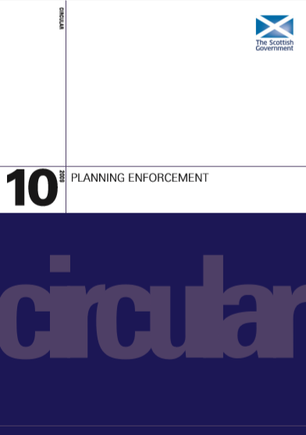  All legislation as listed above, is available online  or can be viewed in person by visiting:  The Stationery Office (TSO), located at:  26 Rutland Square, Edinburgh, EH1 2BW.  Time Limits  In line with the Town and Country Planning (Scotland) Act 1997 (as amended), enforcement action must be undertaken within strict time limits:  4-Year Limit  Applicable to: ‘Unauthorised operational development’ (i.e. the carrying out of building, engineering, mining or other operations in, on, over or under land); and  The change of use of a building, specifically to a single dwellinghouse.  After four years following the breach of planning control, the development becomes lawful and no enforcement action may be taken.  10-Year Limit  Applicable to: All other development including the changes of use (other than of buildings to a single dwellinghouse) and breaches of condition.  After ten years, development becomes lawful if no enforcement action has been undertaken within this period.  Time restrictions do not apply to unauthorised development to a listed buildings or the display of unauthorised advertisements.  It is important to remember that a breach of planning control does not constitute as a criminal offence. ELC aim to amicably resolve breaches of  planning control, rather than punish those who carried out the unauthorised breach.  What likely does not constitute as a breach of planning control?  The Planning Service can only investigate matters relating to planning enforcement. Where the complaint/enquiry falls under different legislative powers or cannot be controlled through the planning process, it will be forwarded onto the relevant local authority department to investigate (e.g. Environmental Health & Protection, Community Wardens, and Roads etc).  The following matters cannot be controlled through the planning enforcement process:  - Anti-social behavior complaints;  - Disputes over land ownership/boundaries;  - Drainage/structural issues;  - Loss of private view;  - Business competition;  - Fire hazards; and  - On-street parking / allocation of parking spaces.  Whilst ELC will do its very best to honour requests for confidentiality, this cannot be guaranteed, particularly if the case leads to court proceedings.  Please note: Repeat complaints submitted in respect of the same alleged breach of planning control will be treated as one singular complaint. Anonymous complaints will not be accepted.  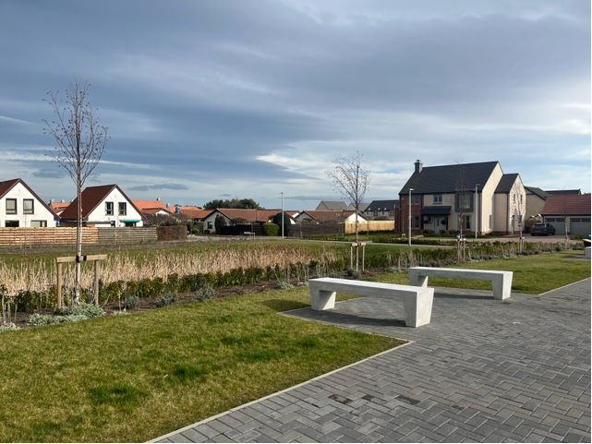    Investigation Process  Once a complaint is registered and prioritised, an Enforcement Officer will visit the site if required. Following investigation, the person(s) making the complaint will be informed of the findings and what action, if any, is proposed. In some cases, additional investigation or monitoring may be needed.  Service Standard  Person(s) making the complaint will be advised of the findings and any proposed action to be taken within 30 working days of the complaint being registered. This may include the need for additional investigation prior to deciding on a course of action. They will be advised if the matter does not involve a breach of planning control.  Resolution  The time required to resolve a case or take action can depend on a number of factors. Further evidence or monitoring may be required, negotiations may need to be made or other formal procedures concluded.  Similarly, where a householder or developer submits a retrospective application for the development which breaches planning control or submits an appeal against a decision of the planning authority, this may add to the length of time it takes to resolve any such case.  In the case of an enforcement notice, any rights of appeal recipients have and how to lodge an appeal. For more detail, see the 'Enforcement Powers – Notices Types’ section at the end of the Charter.  - A description of the breach of control that has taken place; and  - Seeking a Court interdict to stop or prevent a breach of planning controls;  - The steps that should be taken to remedy the breach;  - The timescale for taking these steps; and  - The consequences of failure to comply with the notice.  Service Standard  Where a planning breach cannot be resolved and action is required, a formal notice will be served. This will be either: a notice requiring a retrospective planning application; an Enforcement Notice; or a Breach of Condition Notice. The Council will write to the recipient of the notice to explain what is required, the timescales involved and the available options to resolve the issue.  Appeals against Enforcement Notices are considered by Scottish Ministers and dealt with, in most cases, by Reporters from the Scottish Government’s Directorate for Planning and Environmental Appeals (DPEA). Anyone who has submitted information on a breach of planning control is advised of the appeal process. There is no right of appeal against a Breach of Condition Notice.  Non-Compliance  Failure to comply with a notice may result in the Planning Authority taking further action. This can include a range of possible options including:  - Referral to the Procurator Fiscal for possible prosecution; and,  In the first instance, complaints should be discussed with the member of staff involved. If you are still dissatisfied, please contact the Planning Service Manager.  Service Standard  We will get in touch with you within 30 working days of receiving a complaint or suggestion to let you know what is happening. We will monitor all complaints and suggestions made and use them to review and improve the service we provide.  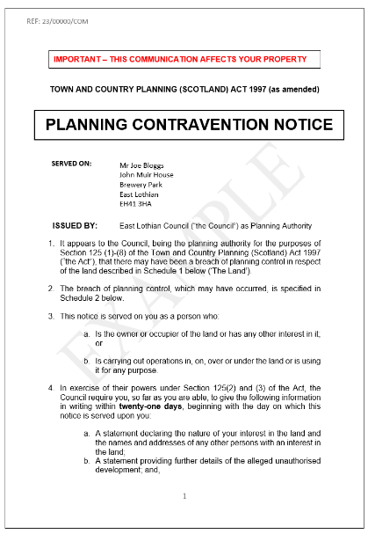  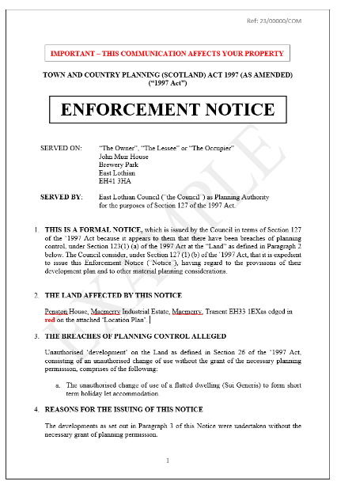  Stop Notice  This is used in urgent or serious cases where an unauthorised activity must be stopped, usually on the grounds of public safety. When a Stop Notice is served, the planning authority must also issue an Enforcement Notice. There is no right of appeal against a Stop Notice and failure to comply is an offence.  If a Stop Notice is served without due cause, or an appeal against the  Enforcement Notice is successful, the Stop Notice may be quashed and the Council may face claims for compensation. The use of Stop Notices therefore needs to be carefully assessed by the Council.  Temporary Stop Notice (TSN)  This is used to require the immediate halt of an activity which breaches planning control. The provisions make an exception in that a TSN cannot prohibit the use of a building or a caravan for residential purposes. TSNs are enforceable for 28 days, after which time they expire. They may, however, be followed by further enforcement action such as the issuing of an Enforcement Notice and Stop Notice. There is no provision to appeal against a TSN.  paying a fixed penalty. Any decision to do so would be dependent on considerations such as the scale of the breach and its impact on local amenity.    Prior to the service of an Amenity Notice and an Enforcement Notice.    After the service of an Amenity Notice and Enforcement Notice.  