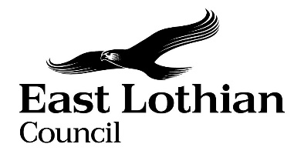

Supporting Good Decisions
Promoting Equality and Human Rights;
Reducing Poverty; and
Protecting the Environment

Integrated Impact Assessment Form

Integrated Impact Assessment Form
Promoting Equality and Human Rights;
Reducing Poverty; and Protecting the Environment

Title of Policy/ Proposal | Tree and Woodland Strategy for East Lothian (TWSEL)
Timescale for Implementation | Consultation May 2023 – August 2023  Adoption May 2024 the earliest. No end date but expected to cover a 10-year period.
IIA Completion Date | 09/05/2024
Completed by | Planning Service
Lead officer | J Squires

Section 1: Screening

1.1 Briefly describe the policy/proposal/activity you are assessing.
Set out a clear understanding of the purpose of the policy/ proposal/ activity being developed or reviewed (e.g. objectives, aims) including the context within which it will operate.

The production of the Forestry and Woodland Strategy for East Lothian is a statutory requirement under Section A159 of the Town and Country Planning (Scotland) Act 1997 as amended by the Planning Scotland Act 2019. It requires the planning authority to identify woodlands of high nature conservation value in their area, and set out its policies and proposals as to
(i) the development of forestry and woodlands,
(ii) the protection and enhancement of woodlands, in particular those mentioned in paragraph (a),
(iii) the resilience to climate change of woodlands, in particular those mentioned in paragraph (a),
(iv) the expansion of woodlands of a range of types to provide multiple benefits to the physical, cultural, economic, social and environmental characteristics of the area;
and any other matter which the planning authority consider appropriate.

  - What will change as a result of this policy?
The Council has committed to a Climate Forest of 2 million trees planted from 2021 – 2031. This Strategy will help deliver this, guiding tree planting and woodland creation considering places where it should and should not occur. The Strategy contains Targets which are:
- Creation of the East Lothian Climate Forest of at least 80-125 ha of new woodland annually across East Lothian to provide the 2 million trees in 10 years to achieve increased woodland coverage of 13.45% by 2031
- Improve resilience of East Lothian’s environment including by securing functional native woodland connections through East Lothian to support migration of species under climate change, forming a lowland corridor between the eastern boundary with Scottish Borders to the east and Midlothian to the west and corridors between lowland woodland and montane scrub/heathland in the Lammermuirs and increasing native riparian woodland by 18% to 60% of the riparian zone (with 9% implemented year 5)
- Improve biodiversity value of East Lothian’s woodland habitats in line with the Green Network strategy, including by doubling the area of native woodland; improving connectivity of the Central Scotland Green Network broadleaf and yew habitat network; increasing the total length of hedgerow by 10%, retaining ancient woodland, and restoring 30% of coniferous plantation on ancient woodland sites to native woodland
- Improve and increase access to trees and woodland for all by retaining or increasing tree canopy coverage to 30% in settlements and in the most deprived 30% SIMD areas, improving and increasing access to woodlands so that 99% of properties meet at least one of the Woodland Trusts accessibility standards, and the 80% of properties have access to a 2ha wood within 500m, developing a Tree Warden Scheme in East Lothian and recruit volunteers from each of our main settlements, and helping set up and ensure management for a community orchard in each of our main settlements
- Create 300 hectares of new small farm woodlands, shelterbelts orchards and other agroforestry which align with and support agricultural production
- Improve recognition and protection of trees with cultural heritage value by encouraging identification of Champion, Veteran and Ancient Trees through Citizen Science, and completing mapping of ancient woodland, orchards, parkland and wood pasture
- Improve landscapes through woodland creation by structural planting at Cockenzie/Blindwells and Innerwick Coast area, and developing of an ash dieback plan.
In addition Policies in the Strategy provide for protection of woodland of high nature conservation value, alongside other valued habitat.
Mapping is included which shows a strategic overview of what the Strategy intends to achieve. There is also mapping of sensitivities and opportunities, aimed at guiding woodland creation at project level. As a result of the Strategy, the woodland and trees of East Lothian would become better adapted to climate change, better able to play their part in reducing flooding, and increase shade and shelter within settlement. The biodiversity, cultural and landscape value of trees would be more widely appreciated, and further taken into account in planning decisions.

  - Deciding if a full Impact Assessment is needed.
Please answer the following questions:
 | Yes | No
- The policy/ proposal has consequences for or affects people e.g. how they can access a service? | Yes | --
- The policy/proposal has potential to make a significant impact on equality and human rights, socio-economic disadvantage, the council’s role as a corporate parent, or the council’s commitment to tackling climate change? | Yes | --
- The policy/proposal is likely to have a significant environmental impact as defined by the Environmental Impact Assessment (Scotland) Act 2005? | Yes | --
- The policy/ proposal involves a data processing activity (storage / collection of personal data) that is likely to result in a high risk to individuals as determined by Article 35 of the General Data Protection Regulation? | -- | No

- If you have answered yes to questions 1 and 2 above, please proceed to complete the Integrated Impact Assessment. If you have answered No then an IIA does not need to be completed. Please keep a copy of the screening paperwork.

- If you have answered yes to question 3, you will need to consider whether you need to complete a Strategic Environmental Assessment.

- If you have answered yes to question 4, you will need to consider whether you need to complete a Data Protection Impact Assessment. Please seek further advice from the Team Manager Information Governance.
__________________________________________________________________
Section 2: Integrated Impact Assessment

  - Have those who are directly affected by the policy had the opportunity to comment on new proposals?

Yes. Consultation took place on the draft Tree and Woodland Strategy for East Lothian, its associated draft Environment Report and on this document. The ‘Response to Consultation’ document considers the responses in detail. In summary, almost twice as many women as men responded, which is clearly out of line with the population. The quantity, type and location of woodland is likely to affect both sexes equally. However men are more likely to work in the forestry sector than women. Partly to try and address this, following the end of the consultation we wrote out to forestry/timber related business to seek their views specifically.

The consultation survey sought information on the characteristics of those responding. The findings are as follows:

Sex – 5/75 respondents skipped the question

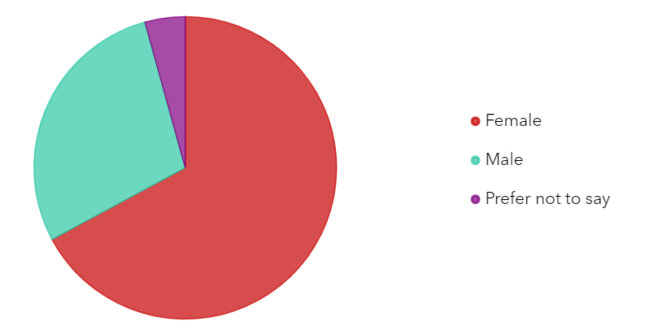

There were considerably more women than men responding to the survey. Although there are slightly more females than males in East Lothian (52%), this difference is not in proportion to population.

Trans or trans history – 8/75 respondents skipped the question

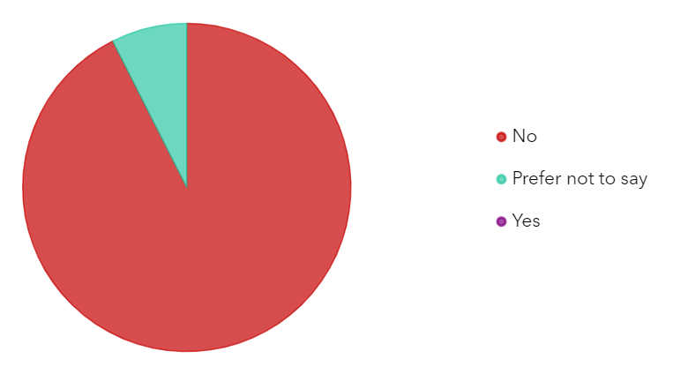

Nobody who declared they have a trans history responded, however, this is probably not out of line with the population given the number of respondents.

Physical or mental disability – 5/75 respondents skipped the question

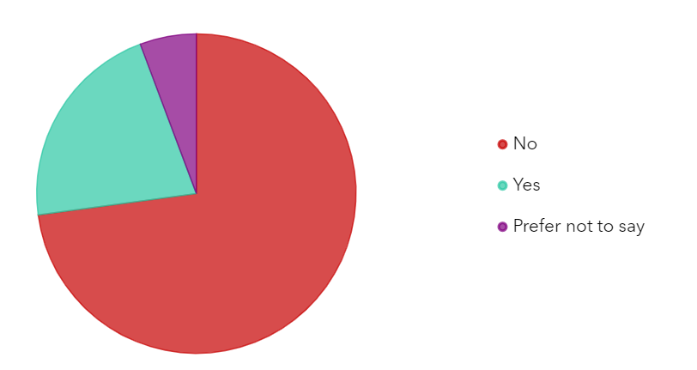

Of those that said yes, the ways in which their condition affected them were:

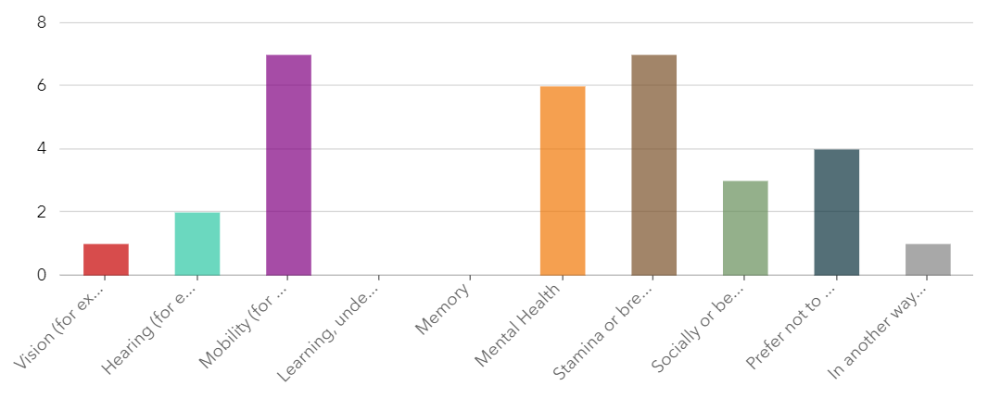

Some respondents may have more than one of the conditions. The conditions were grouped into categories that we thought might affect people’s experience of trees or woodland. Information from the 2011 census is not arranged in the same way, so it is difficult to be certain whether responses are reflective of the population overall. However, it is useful that responses were received from some people with those conditions. No responses were received from those with learning disability or memory difficulties, and this should be borne in mind.

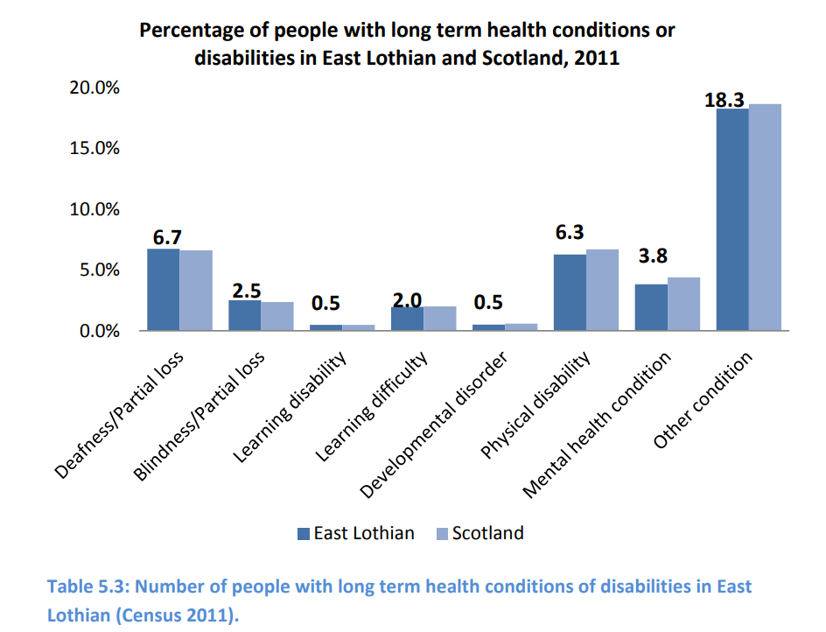

Ethnic group 4/75 respondents skipped this question
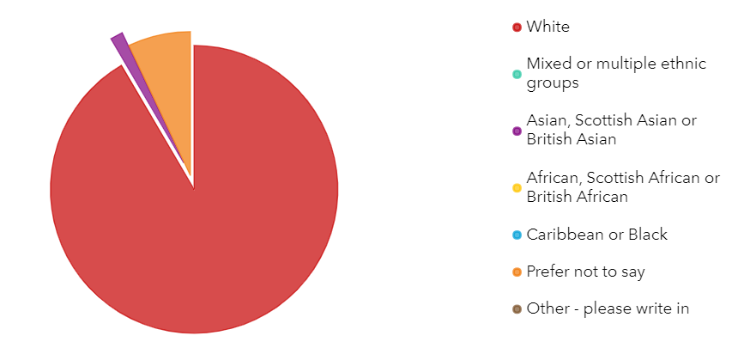
Only one respondent stated they were from an ethnic group other than white. In the 2011 census reported in East Lothian by Numbers, 98.3% of the population was found to be white, with 0.4% mixed or multiple ethnic groups, 1.0% Asian, and 0.4% Other groups. Although the number of respondents stating they were not White is low it is not significantly out of step with population.

Religion – 8/75 respondents skipped the question

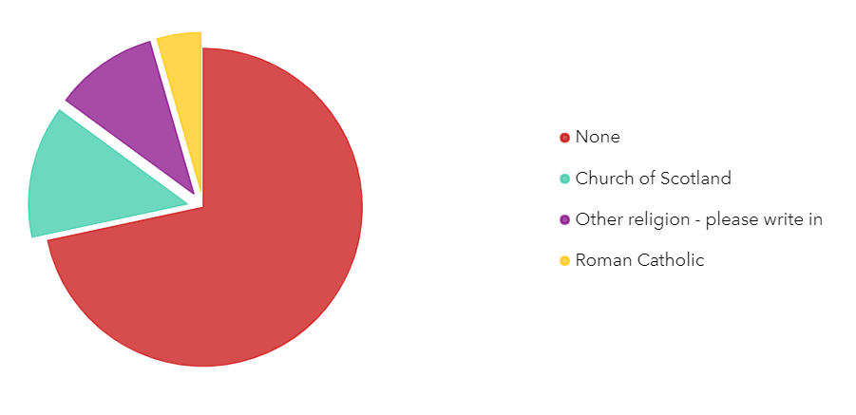

‘Other’ religions were Church of England (2); Buddhist (1) Muslim (1) and Worshipper of the Natural World (1). East Lothian by Numbers gives figures on religion from the 2011 census. This gave figures of 41% having no religion, 37% as being Church of Scotland, 10% as Roman Catholic and 3% as of other religions. Church of Scotland membership has fallen by around a third since then overall.

Age 6/75 respondents skipped the question

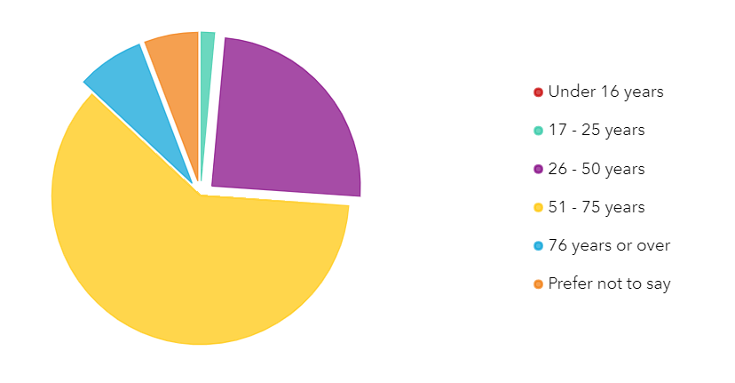

Most people who responded were in the over 51 age group. More people in the 51–75-year-old age group responded than there are in the population (around 30%). Nobody who said they were under 17 responded, and only one person between 17 and 25 years. This is out of step with the East Lothian population, which has more younger people in proportion – 18% in the 1 to 15 age group (many of which would be too young to respond) and 9% in the 16 – 24-year-old age group. The 75 years + age group was also slightly underrepresented, being 10% of the population but 6% of respondents.

Sexual orientation – 8/75 respondents skipped this question

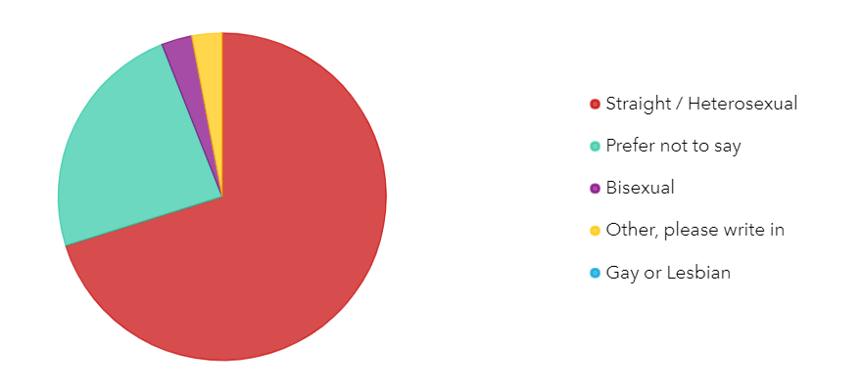

Sexual orientation is often a characteristic where people prefer not to give the information. The majority of those responded were straight/heterosexual, with two respondents stating they were bisexual. On the information given, this is probably not out of line with the population.

Social Class/income
The Tree and Woodland consultation did not ask for information about social class or income, but the fact that most respondents had access to a car, and had recently visited a woodland, may indicate fewer people from lower social classes responded. Most respondents said their household had access to a car for recreational journeys all the time. Including those who had access to a car outside work times, this makes up 92% of respondents. East Lothian by Numbers suggests 23.7% of households do not have access to a car, so access to a car was a lot higher among respondents than for East Lothian as a whole. The survey also found that more respondents than would be expected by population have visited a woodland recently (as you might expect). The Scottish People and Nature survey found that people in higher social grades are more likely to made recreational trips to outdoor sites. Taken together, this may indicate that respondents had higher incomes than average.

Engagement: Comments that were made on the IIA specifically were said that more community consultation needs to be done, with the council reaching out to groups rather than the other way round. The consultation did not specifically reach out to groups with particular characteristics. As the strategy does consider issues relevant for particular groups such as access to woodland for all, this is point is noted and something that should be considered in future.
One respondent noted they thought it was ‘good’.
We also asked respondents if the TWSEL could have any impacts which are unfair, and what these were.
Six people said ‘no’, with a further 4 saying that the strategy would benefit everybody. One respondent said that ‘any further destruction of any existing tree, woodland and wildlife is unfair’ but did not say why or who to.
Issues raised were:
- The need to ensure spaces are safe and not road runs for off-road bikers
- Unfairness arising from creating out of town woodland without public transport access
- Need to plan travel access for all
- Tree removal for Musselburgh Flood Protection Scheme is detrimental for people’s mental health
Groups that were mentioned as being disadvantaged were:
- people on low incomes (no reason was given for this),
- women in terms of safety,
- people in protected groups who will be worst affected by lack of access to biodiverse and attractive woodlands, with creating and better managing woodlands near where people live being one step to enhancing their lives;
- urban gardeners (no reason given but perhaps shading fruit and vegetable growing)

Dunpender Community Council notes that financial incentives and grants for planting and managing trees might further enhance the incomes of large landowners. This would reinforce existing inequalities.
Tillhill Forestry considered it ought not to have any impacts which are unfair if carefully considered and resourced to ensure those on the fringes of our society are included and welcomed and views included in the strategy and actions on the ground.
Gullane Eco Group noted that animals, birds and insects are the most important consideration. Although these are included in Integrated Impact Assessment and SEA as part of biodiversity, impact on individual animals, birds and insects (e.g. deer that are ‘controlled’) were not considered.
Suggestions to combat unfairness included:
- planting trees that give products to forage (nut and fruit trees and berry shrubs)
- planning travel access for all
- making sure planting is equitable across the county taking into account accessibility, socio-economic factors, and safety for women
- avoid looking to protect the vested interests of landowners and instead by wholly focussed on the greater good
- focus on areas with low tree canopy percentage and places where there’s a threat of losing trees
- Creating and better managing woodlands near where people live is one step to enhancing the lives of people in protected groups

  - What information/data have you used to inform the development of the policy to date?
The draft Environment Report related to this Strategy has a list of documents consulted and background information sought. The most relevant to this assessment is that for impacts on human health and population. Other information includes
- Scotland’s Forestry Strategy 2019-2029 Equality Impact Assessment (Scottish Government, 2019) available at https://www.gov.scot/publications/equality-impact-assessment-eqia-scotlands-forestry-strategy-2019-2029/
- Active Scotland outcomes indicator Equality Analysis (Scottish Government, 2015) here: https://www.gov.scot/publications/active-scotland-outcomes-indicator-equality-analysis/
- Disability Access All Areas (ESSS Outline, Annelies Allcock, 2018), here: https://www.iriss.org.uk/resources/esss-outlines/disability-access-leisure
- Forestry Commission (2006) “Race Equality and the Forestry Commission” https://www.forestresearch.gov.uk/research/accessibility-and-racial-equality-in-the-forestry-commission/
- NHS ‘Heatwave: how to cope in hot weather’ https://www.nhs.uk/live-well/seasonal-health/heatwave-how-to-cope-in-hot-weather/
- NHS ‘Vitamin D’ https://www.nhs.uk/conditions/vitamins-and-minerals/vitamin-d/
- Office of National Statistics – access to private outdoor space https://www.ons.gov.uk/economy/environmentalaccounts/articles/oneineightbritishhouseholdshasnogarden/2020-05-14#:~:text=The%20median%20garden%20size%20for,in%20Scotland%20(the%20largest).
- Scottish Census – Datashine https://scotland.datashine.org.uk/
- Scottish People and Nature Survey, NatureScot
- Scottish Government Equality Evidence Finder, at http://www.equalityevidence.scot/
- Scottish Household Survey data explorer, available here: https://scotland.shinyapps.io/sg-scottish-household-survey-data-explorer/
- Scottish Public Health Observatory https://www.scotpho.org.uk/life-circumstances/homelessness/data/demographics/

  - What does the evidence/ research suggest about the policy’s actual or likely impact on equality groups and those vulnerable/ or experiencing socio-economic disadvantage?
Evidence | Comment
Which groups are in particular need of this service? | This is not a service but a Strategy. Its main benefits will be to tackle climate change, change air quality, improve townscape and increase woodland recreational opportunities close to where people live. People overall will benefit from this.  Groups most in need:  - All groups  - Young people and those vulnerable to poverty; Young people need this service more as they are more likely to be alive to experience future climatic and biodiversity conditions. Ecosystem service of avoiding flooding is more needed by those least able to recover from the effects of flooding. Positive impacts are contribution to climate change mitigation, adaptation and reduce biodiversity loss.  - Those living in poor physical environments. This is likely to include groups with less access to income, which may include single parents who are mostly women, disabled people, older people for example  - Those who do not get the recommended levels of physical activity. For example Active Scotland evidence shows that many disabled people fall into this category. Therefore those who currently do not have good access to opportunities to exercise outdoors may benefit from improved accessibility to woodland. The positive outcome is easier access to a quality, free, accessible outdoor activity by providing an accessible environment for activity.  - People with specific health conditions may experience worse health because of poor air quality. The Strategy aims to improve air quality by providing a tree or hedge buffer between people and the source of pollution. There is a risk that some trees may increase ground level ozone, which is an air pollutant which exacerbates some health problems.  - Allergies: As more trees are planted especially in urban areas, tree pollen is likely to increase. This could create or exacerbate allergies, including to food. For example Birch pollen can lead to cross-sensitivity to some foods. The Strategy tries to steer planting of birch trees away from concentrations of potentially vulnerable people by identifying places where there are large numbers of young and older people (schools and residential care homes) as evidence indicates that these groups can be more susceptible.  - Those with some mental health conditions may also benefit from having more accessible natural places in which to spend time.  - Groups vulnerable to being or falling into poverty may benefit from access to a quality, free outdoor recreational experience.  What level of service uptake/ access is there from protected and vulnerable groups? What is the service user experience of those from protected or vulnerable groups?  All groups experience a daily living environment. There is likely to be both landscape and townscape change. The Strategy aims to increase urban tree canopy cover, which is generally seen as beneficial to townscape and living places. However, some people may not experience this as a benefit. This could be firstly where people experience the change to their own home as negative. For example, if it becomes more shaded or there are issues with leaves &c. Secondly, people may experience the change to the public realm as adverse, for example if they experience it as dark and/or dangerous rather than shady and pleasant. The first is likely to affect those in social housing and the lower end of private ownership more than others as they have less choice over their location. The second is most likely to affect those with concerns over their personal safety. This can include some women, transwomen and transmen, disabled people, those from an ethnic minority.  Scotland’s People and Nature Survey looked at adults accessing the outdoors for recreation and found the of adults who rarely or never visited the outdoors for recreation, the main barriers were lack of time (36%), poor health (23%), old age (8%), and affordability (4%), though these last were below no particular reason (8%) and last was below lack of interest (5%).  People who are likely to be time poor, such as single parents or carers, may therefore not use existing woodland. Increasing woodland near where people live may benefit these groups most as visiting woodland would become easier and cheaper for them. However, some groups may not benefit in the same way as others from an increase in woodland as a recreational resource.  For outdoor visits altogether, 82% of adults visit the outdoors at least once a year, and 57% at least once a week. Those aged under 55 visit slightly more than this, those older, slightly less. 90% of those in social grades AB visit at all, and 67% at least once a week. This falls through the grades, with only 68% those in social grade DE visiting at all, and 44% visiting each week. Rural dwellers are more likely to visit but not by all that much. People not in employment are less likely to visit, as are disabled people or those with poor health. Forestry Commission, 2006 and Nature Scot research shows that there is some evidence that people from Black and Minority ethnic groups are under-represented in visitors to woodland. They found financial reasons, lack of awareness, cultural attitudes and not feeling welcome being reported.  Positive outcomes for services users  - All people will benefit from the contribution of the Strategy to mitigating and adapting to climate change and addressing biodiversity loss (though the effect is tiny compared to the scale of both issues)  - Generally, an improvement in air quality  - Improvement to amenity in urban areas including in lower SIMD areas  - Increased access to woodland  In terms of physical activity, walking is an important ‘leveller’. For most protected characteristics, where walking is not included in assessment of levels of physical activity, inequality between groups in the amount of physical activity undertaken are wider. Increasing opportunities for walking should particularly benefit those groups that engage less in other forms of active recreation and who are therefore most at risk of being physically inactive. The differences in physical activity levels between different groups overall would therefore reduce.  These are: those with disability or longstanding poor health, older age groups, women, teenage girls and ethnic minorities (especially south Asian). Active Scotland found that people from lower socio-economic groups are more likely to become significantly less active as they enter adulthood. The strategy supports increased levels of walking for recreation and active travel by promoting improvements to townscape and accessibility of woodland and therefore continued physical activity in these groups. There are likely to be positive effects on health and well-being.  Climate change is likely to have severe impacts on all groups. The impacts are likely to be felt most by the poor, who may not be able to afford to take measures that would protect themselves from some impacts. There are also likely to be greater impacts on the old and very young from more extreme weather such as heat or cold, and their carers, likely often to be women. People who are young now are likely to experience more adverse effects of climate change and biodiversity loss over their lifetimes than those who are old. The strategy, cumulatively with other similarly focussed actions, projects and strategies will benefit these groups.  - Greenspaces: Nationally, people from minority ethnic backgrounds are less likely to live in areas within a 5 minute walk of a greenspace. Urban greenspaces and nature are less accessible to people with disabilities. People from low-income households are also less likely to have good access to greenspaces across the UK as a whole. These groups may therefore benefit most from an increase in accessible woodland (Groundwork, Out of Bounds)  What opportunity have those from protected groups had to co-produce or comment on the service/ plans?  The Strategy and IIA were consulted on giving everybody the chance to comment. Comments on the Integrated Impact Assessment are shown above, while comments on the Strategy are shown in the accompanying Response to Consultation’ document. We did not specifically seek the views of particular groups. However, engagement with children was carried out for the Evidence Report of the Local Development Plan, and this material was referred to in finalising the strategy.  At project level community involvement is encouraged. However, this Strategy has been developed by council officials in partnership with other agencies. There has been no co-design at this strategic level. Those producing Local Place Plans are encouraged to include policy for trees in their plans, and this Strategy gives the background to allow them to do this in an informed way. Through this, at project level there is opportunity for co-design locally.
What level of service uptake/ access is there from protected and vulnerable groups?
Can you identify positive outcomes for service users
What is the service user experience of those from protected or vulnerable groups?
What opportunity have those from protected groups had to co-produce or comment on the service/ plans?

  - How does the policy meet the different needs of groups in the community?

 | Comments
Equality Groups  Older people, people in the middle years  Children and young people children  - Women, men and transgender people (includes issues relating to pregnancy and maternity)  - Disabled people (includes physical disability, learning disability, sensory impairment, long-term medical conditions, mental health problems)  - Minority ethnic people (includes Gypsy/Travellers, migrant workers)  - Refugees and asylum seekers  - People with different religions or beliefs (includes people with no religion or belief)  Lesbian, gay, bisexual and heterosexual people  - People who are unmarried, married or in a civil partnership | The Strategy will meet the needs of the protected characteristic groups through improved townscape and landscape, biodiversity and climate change related benefits. Such as:  - increased access to woodland for recreation. The intention is that the plans, policies and projects that stem from the strategy will have a positive (or at worst a neutral) impact on individuals with protected characteristics. Projects which come forward under the strategy may, depending on their scale and location, benefit from being subject to separate equality impacts assessment.  - a safe, attractive environment, accessible woodland, and respect for cultural heritage. What is a safe environment may be different for different people and groups. Children and young people need opportunity to play in nature and as they will live longer (on average) into the future, have more need for solutions to climate change and a habitable planet to spend their future in.  Specific potential effects on the needs of different groups are identified as follows:  Older People:  Safety issues and anti-social behaviour - increased woodland, and tree planting in urban areas, could lead to real and perceived safety issues. This could come from an increase in potential hiding places for attackers or those indulging in anti-social behaviour to lurk, arising from an increase in trees and woodland in urban areas. This disproportionately affects some groups, in particular older people, women, some disabled people, some ethnic minorities, and some Lesbian, Gay, Bisexual or Trans people. Vulnerability can be increased by a person having more than one protected characteristic, for example disabled women may feel particularly vulnerable. It is not the intention of the Tree and Woodland Strategy that this effect occurs. The effects of trees are generally positive. However this must be carefully considered at implementation stage and safety considered. .  The effects of more trees in the urban area may lead to damage to footways which could increase the risks of injury.  More trees may also be associated with nuisance from leaves, sap, aphid drop &c which people with often age-related conditions such as arthritis may have more difficulty dealing with.  More trees in urban areas will reduce the heat island effect, predicted to be greater with climatic change. Older people are more vulnerable to heatwaves as their bodies are not as good at regulating temperature. The NHS notes those especially vulnerable to heat include:  ⦁ older people – especially those over 75 and female  ⦁ those who live on their own or in a care home  ⦁ people who have a serious or long-term illness including heart or lung conditions, diabetes, kidney disease, Parkinson's disease or some mental health conditions  ⦁ people who are on multiple medicines that may make them more likely to be badly affected by hot weather  ⦁ those who may find it hard to keep cool – babies and the very young, the bed bound, those with drug or alcohol addictions or with Alzheimer's disease  ⦁ people who spend a lot of time outside or in hot places – those who live in a top-floor flat, the homeless or those whose jobs are outside  The reduction of this impact is therefore of more benefit to them than other groups.  Children and younger people: effects should be positive through improvements to townscape and accessible woodland which increase opportunities for play. Air quality changes (positive and negative) are likely to affect children more as they are particularly vulnerable to both poor air quality and allergens. Schools are identified in the strategy so at project level designs can avoid placing trees with highly allergenic pollen close by. Young people are more likely to benefit from townscape/landscape changes as trees take time to reach maturity so the full effect will not be felt for some time.  Younger people are more likely to live to have to cope with the predicted effects of climate change and biodiversity loss. This strategy, cumulatively with many other projects and plans, aims to address this, and will particularly benefit younger people.  Men are likely to benefit from increased employment as tree work tends to attract fewer women.  Women – Increased canopy in urban areas may make more places appear dangerous though that is not the intention of the Tree and Woodland Strategy which includes advice on avoiding this. All the same it is hard to increase urban canopy coverage without risking this. Improved urban environments may also reduce street harassment.  Disabled people. Safety issues and anti-social behaviour, as above. More trees in urban areas are likely to lead to more issues with leaves, blockage of footways by branches and minor damage to footways, although it is not the intention of the strategy that this occurs and it should mostly be avoidable through good design, which the Strategy advocates. However, it may occur, and would affect physically disabled and visually impaired people more as they may be less able to address the hazard.  Disabled young people are currently less likely to experience active play every day. Increasing woodland cover may increase the opportunities for children and young people to play near their homes, which could help address this.  The Strategy seeks to meet the Woodland Trusts Standard on accessible woodland, which is based on distance to woodland rather than access for all once there. Disabled people are likely to have more difficulty than non-disabled people in accessing woodland.  Minority ethnic groups As noted above, the interaction between minority ethnic groups and trees and woodland is varied. Where cost and lack of time are a reason for not visiting woodland, the Strategy should ease this by increasing woodland close to where people live.  Some ethnic minority people may have greater fears for personal safety and so have greater need for their environment to feel safe (see ‘older people’ above).  Increasing tree canopy coverage may reduce the amount of sunlight in towns, which can reduce the amount of vitamin D created by the body from sunlight on the skin. This can particularly affect people with dark skin.  Gypsies and Travellers may have cultural heritage related to trees which is not recognised by the strategy, unlike settled people’s heritage, which is. This group may also have greater fears for personal safety and so have greater need for a safe environment (see ‘older people’ above).  Refugees and asylum seekers – Some may have greater fears for personal safety and so have greater need for their environment to feel safe (see ‘older people’ above).  Religious belief – early Celtic religion had beliefs or symbolism related to trees, and there is some new age revival of this, including in East Lothian. In Christianity trees are often planted in churchyards (or churches were built in places which had existing symbolism related to trees), often yew, holly or weeping ash. There are also some old yew trees which were the site of early Protestant or covenanter preaching. The Strategy seeks to protect trees with spiritual value so this would help meet the need to maintain religious symbols and respect for beliefs.  The Strategy includes provision for deer management which involves lethal control. This may not be acceptable to people with vegan beliefs.  Lesbian/Gay/Bisexual people -some people who are lesbian/gay/bi may have greater fears for personal safety and so have greater need for their environment to feel safe (see ‘older people’ above).  Single people – some may have greater fears for personal safety and so have greater need for their environment to feel safe (see ‘older people’ above).
Those vulnerable to falling into poverty  - Unemployed  - People on benefits  - Lone Parents  - Care experienced children and young people  - Carers (including young carers)  - Homeless people  - Those involved in the community justice system  - People with low literacy/numeracy  - Families with 3 or more children  - Those with a child/ children under 1 | All groups vulnerable to falling into poverty:  Everyone needs a home that they consider gives them an acceptable living environment. The Strategy aims to increase canopy coverage, in particular in lower Scottish Index of Multiple Deprivation areas. This should generally improve environmental quality. However, this canopy increase could bring issues for some people regarding either particular trees, or an increase in trees in general.  Trees may be experienced negatively where they block views, give unwanted shade or lead to issues with bird dropping or aphid dew. It is not the intention of the Strategy that this should happen, and the strategy includes guidance to reduce the possibility that it will. Nonetheless, as the effect is to some extent subjective it is likely there will be some people who experience this change as a negative. Where people are on a low income, they may be less able to choose their home, and some groups may be or feel less able to articulate the issue to decision makers, leading to stress from unwanted or poorly located trees. People on lower incomes may also live in housing that has less garden ground, so that the trees they do not control are closer to their actual house.  An increase in trees and woodland, which is promoted in the Strategy, potentially risk becoming a focus for anti-social behaviour (fly tipping, litter, drink/drug abuse, fires).  Climate change and biodiversity loss are likely to have severe impacts on all groups. The impacts of climate change and biodiversity loss are likely to be felt most by those living in poverty, who will not be able to afford to take measures that would protect themselves from some impacts. The strategy, cumulatively with other actions, projects and strategies aimed at mitigating climate change, will benefit them.  Unemployed people – need employment and cheap, good quality activities. The Strategy supports employment opportunities related to trees including tourism, and so should increase employment although on a small scale. Increasing the accessibility of woodland provides a good quality cheap activity.  People on benefits/Lone parents/families with 3 or more children/those with of children under 1 are also likely to have a greater need for good quality, healthy, affordable activities, which accessible woodland can provide. The activity can be carried out with their peers without a significant cost barrier, supporting inclusion. They are also likely to need their local environment to be of good quality as it may be harder for them to move house if they don’t like the area.  Care experienced – no specific needs related to this strategy  As with people on benefits, carers may be less able to move home and so more reliant on being in a good quality environment. They may be time poor and on a low income. By increasing woodland close to where people live, this will reduce the time needed to access exercise and recreation, so could fit in around caring responsibilities.  Homeless people – there is no census of rough sleeping in Scotland but numbers are reportedly falling, and concentrated in cities (Scotpho website) . However, if you are in that situation bushes and trees can provide cover, shelter and sometimes also food.  Community justice system – community payback sentences could include tree planting which provides a sentence with a meaningful outcome.  Low literacy/numeracy – the Strategy could increase options for outdoor learning which could help children with low literacy and numeracy engage with learning. The Strategy should also be written in plain English helping meet needs to participate in civic life.
Geographical communities  - Rural/ semi-rural communities  - Urban Communities  - Coastal communities  - Those living in the most deprived communities (bottom 20% SIMD areas) | Rural communities should benefit through environmental improvement, and also through increasing rural employment.  Urban communities will benefit through townscape improvement, amenity improvement such as reduction in heat island effect, general improvement in air quality and noise improvements. There could be some adverse effects from nuisance from leaves, branches &c from trees, potentially increased allergy-causing pollen, small potential for an increase in vector borne illness (tick related), which can affect people and also their pets  Coastal communities – the Strategy aims to improve coastal habitat, with consequent benefits for coastal communities.  Bottom 20% SIMD areas: as urban areas above. It will benefit those in the most deprived communities through an improved townscape, which focusses on those communities.
People with communication needs:  - Gaelic Language Speakers {refer if necessary to the Council’s Gaelic Language Plan}  - British Sign Language (BSL) users {refer if necessary to the Council’s BSL Plan}  - English as a Second Language  - Other e.g. DeafBlind, Plain English, Large Print | Gaelic/Scots language: There could be an opportunity to support Gaelic and Scots language through interpretation, for example naming of trees in Gaelic or Scots on boards, or through naming of new woods.  Braille: the support for more interpretation could include provision of information in braille.  British Sign Language – information could be provided in British Sign Language format if there is a desire for this in line with the Council’s British Sign Language Plan.  English as a second language and plain English: The Strategy and supporting documents should be written to be understandable. The Flesch Kincaid Reading Ease score shows how hard a text is to understand. The Strategy should aim to be easily read by a general reader, which is a Flesch Kincaid score of between 60 and 80, with a higher score being easier to read. The aim is to come as close to this as possible. The Environment Report is unlikely to hit this target as it is a technical document. However, it’s non-Technical Summary will aim for a score of 70 or more.

  - Are there any other factors which will affect the way this policy impacts on the community or staff groups?

The strategy aims to increase tree canopy coverage in settlements of over 500 homes, where it is below 30%. This may help improve the environment around some workplaces.

  - Is any part of this policy/ service to be carried out wholly or partly by contractors?
If yes, how have you included equality and human rights considerations into the contract?
The Council is currently considering how to deliver the Climate Forest, which aims to plant 2 million trees in East Lothian over the next 10 years and is part of the TWSEL. If this goes to external contractors, this will go through the Council’s agreed procurement process, which is expected to address this issue in drafting a procurement brief. Any such work would be managed by a Steering Group, which would monitor compliance.

  - Have you considered how you will communicate information about this policy or policy change to those affected e.g. to those with hearing loss, speech impairment or English as a second language?

The Strategy includes information about how copies can be obtained in other languages or in braille, using the Council’s interpretation service. Access to the strategy will be supported through use of Interpretation and Translation services and working with council staff who work with specific groups to support engagement.

  - Please consider how your policy will impact on each of the following?
Equality and Human rights
- Promotes / advances equality of opportunity e.g. improves access to and quality of services
- Promotes good relations within and between people with protected characteristics and tackles harassment
- Promotes participation, is inclusive and gives people control over decisions which affect them
- Preserves dignity and self-respect of individuals (does not lead to degrading treatment or stigma)
- Builds support networks, resilience, community capacity
Increasing the amount of accessible woodland will give the opportunity for community cohesion, for example, walking as an activity is popular among different generations, for both men and women. For most groups, where walking is not included in measures of physical activity, the gap between groups is wider. Increasing opportunities for walking increases physical activity overall, including for groups that don't tend to participate in other physical activities as much. So supporting walking is a good way of supporting participation for all and reducing the gap between groups in terms of physical activity overall. Walking also brings the opportunity for community coherence. As woodland recreation is generally free, this encourages participation in the activity including those on low incomes. The strategy aims to increase the accessibility of woodland for people with disabilities, and on low incomes. This will increase community cohesion, but also extend equality of opportunity, as more people will have good access to outdoor recreational opportunities closer to their communities. As this is generally a free activity, it supports dignity by allowing participation for all in the activity.
The Strategy must ensure that increasing woodland cover and the number of trees in urban areas does not increase feelings of not being safe among vulnerable groups. Badly designed or sited woodland or streetscape could also give the opportunity for harassment and victimisation. This is not the intention of the strategy but there is the potential for this to occur, and care is needed at project level as noted above.
Socio-Economic Disadvantage / reducing poverty
- Maximises income and/or reduces income inequality
- Helps young people into positive destinations
- Aids those returning to and those progressing within the labour market
- Improves employability skills, including literacy and numeracy
- Reduces the costs of taking part in activities and opportunities
- Reduces the cost of living
The strategy aims to reduce the effects of socio-economic disadvantage by improving the environment overall, with a focus on areas that score lower on the Scottish Index of Multiple Deprivation. It aims to increase the accessibility of woodland, both through expanding woodland and increasing its accessibility. This will make it easier for more people to visit woodland, which is generally a good quality, low or no cost activity. This helps reduce the effect of low income. As a free activity this helps people live well for less. It also brings educational opportunities, where learners can use the woodland as an educational resource to learn about the natural world, or even to learn in a different environment which may suit some learners better.
The strategy aims to increase employment related to forestry, woodland and trees, which will help provide jobs, including for young people.
The strategy also promotes growing of fruit and nuts locally both in gardens and community orchards, which will help reduce living costs.
Tackling Climate Change
- Reduces the need to travel or increases access to sustainable forms of transport
- Minimises waste / encourages resource efficiency / contributes to the circular economy
- Ensures goods / services are from ethical, responsible and sustainable sources
- Improves energy efficiency / uses low carbon energy sources
- Protects and/or enhances natural environments / habitats / biodiversity
- Promotes the transition to a low carbon economy
- Prepares and/or adapts communities for climate change impacts
Comments:
Climate Change and biodiversity are considered through Strategic Environmental Assessment. Please see the relevant chapters of that document.
Corporate Parenting and Care Experienced Young People
- Impacts on care experienced young people
- Provides opportunities or reduces opportunities to participate in activities which are designed to promote the wellbeing of young people
- Adversely affects the wellbeing of young people
- Adversely impacts on outcomes for care experienced young people
Comments:
The strategy promotes an increase in accessible woodland. It will do this by increasing the total amount of woodland, and better management of existing woodland. This will provide potential opportunities to play and experience nature, which should benefit the physical and mental wellbeing of children including children and young people in care.

Section 3. Action Plan

What, if any changes will be made to the proposal/ policy as a result of the assessment?

Equalities issues have been considered from the outset. Comments on equalities issues were sought through consultation and have been considered for the final Strategy.

Changes to be made | Expected outcome of the change | Resources Required | Timeline | Responsible person
The strategy will include a recommendation that personal safety issues related to design of trees schemes are considered at the project stage. | Personal safety issues will be considered at the project stage. | GIS mapping resources  Resource to consult with vulnerable groups | Policy formation stage  Implementation stage
Make explicit provision for people with different disabilities (mobility impairments, sensory issues, learning disability) to access woodland | Accessible forests should include: shallow path gradients with suitable surfacing, clear signage, sensitive seating and resting points to ensure equal opportunities to access green spaces &c. (toilets?). The needs of people with visual or hearing impairment and learning disability should be considered. Information about woodland should be clear and accurate, including accessibility information. | Resource to consult with groups affected  May need some additional resource (over and above that for creating the woodland) to provide for additional needs. | Implementation stage
Consider how to make woodlands more accessible/appealing to black and ethnic minority groups | All people feel welcome in woodland. | Resource to consult with relevant groups | Policy formation stage  Implementation stage
Consider how to encourage the use of forests/treed open space by other groups who have lower levels of physical activity (teenage girls, women of Asian origin, lower socio-economic groups, the elderly) | Woodlands are enjoyed by all groups. | Resource to consult with relevant groups and/or prepare material to encourage use of woods by particular groups. | Implementation stage
Make provision for play specifically for disabled children | Woodland will have areas designed with the needs of children with a range of disabilities in mind. | May need some additional resource (over and above that for creating the woodland) to provide for additional needs. | Implementation stage
Gaelic and Scots Language, braille and BSL | Gaelic language braille and BSL will be considered in interpretation (as in boards) and, for Gaelic and Scots language, naming of new woodlands. | Gaelic speaker  Scots language speaker | Implementation stage
The Strategy should be easy to read by the general reader. | The Strategy achieves a score of over 60 on the Flesch Kincaid reading ease scale. Supporting documents are as close to this as possible. The non-Technical Summary of the Environment Report will aim to score 70 or more. | Staff time, usual council IT equipment | At consultation and publication stage

For consideration of the Head of Service

Can you identify any cumulative impacts on equality groups or vulnerable people arising from this policy, when considered alongside other changes across other services?

Sign off by Head of Service

Name: Keith Dingwall

Date: 09/05/2024

- www.eastlothian.gov.uk/ldp
- East Lothian Council Environment 01620 827216
- ldp@eastlothian.gov.uk
- Contact East Lothian Council Planning Service
John Muir House
Brewery Park
HADDINGTON
East Lothian
EH41 3HA
- To make a comment, suggestion or complaint about a council service, download a feedback form online at www.eastlothian.gov.uk or pick one up at your local office



National Records of Scotland, East Lothian Council Area Profile, accessed 17/02/2024
From East Lothian by Numbers available from https://www.eastlothian.gov.uk/download/downloads/id/23539/east_lothian_by_numbers_-_health_and_social_care.pdf
See https://www.churchofscotland.org.uk/__data/assets/pdf_file/0004/108778/supplementary-report-of-the-assembly-trustees.pdf
East Lothian Population 2021, National Records of Scotland: 0-5 years, 18%; 16-25 years 9%, 25-44 years 23%, 45-64 years 29%, 64-74 years, 11%, 75 years plus, 10%.
Social grade is a classification system based on the occupation of a households main income earner. This is: Social Grade Description % population A High managerial, administrative or professional 4 B Intermediate managerial, administrative or professional 23 C1 Supervisory, clerical and junior managerial, administrative or professional 29 C2 Skilled manual workers 21 D Semi and unskilled manual workers 15 E State pensioners, casual or lowest grade workers, unemployed with state benefits only 8

