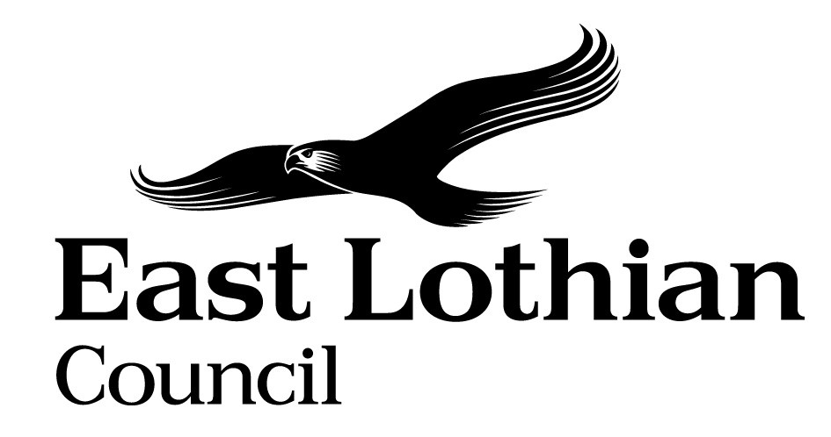

Supporting Good Decisions
Promoting Equality & Human Rights, Reducing Inequality and Protecting the Environment

Integrated Impact Assessment Form

Integrated Impact Assessment Form
Promoting Equality, Human Rights and Sustainability

Title of Policy/ Proposal | Permanent closure of the Macmerry Recycling Centre and disposal of the site
Timescale for Implementation | 2 Months
IIA Completion Date | 23/08/2024
Completed by | Jamie Baker
Lead officer | Tom Reid

Section 1: Screening

1.1 Briefly describe the policy/proposal/activity you are assessing.
Set out a clear understanding of the purpose of the policy/ proposal/ activity being developed or reviewed (e.g. objectives, aims) including the context within which it will operate.

Permanent closure of the Macmerry Recycling centre and disposal of the site.

  - What will change as a result of this policy?
The currently mothballed recycling centre located in Macmerry Industrial Estate will be permanently closed and the site sold by the Council. Members of the public will continue to have access to three other waste disposal sites in East Lothian (the statutory requirement is to provide access to one), as well as access to a service that collects bulky items of waste directly from homes.

  - Deciding if a full Impact Assessment is needed.

Please answer the following questions:

 | Yes | No
- The policy/ proposal has consequences for or affects people e.g. how they can access a service? | x
- The policy/proposal has potential to make a significant impact on equality? |  | x
- The policy/proposal is likely to have a significant environmental impact? |  | x
- The policy/ proposal has implications for the storage/ collection of personal data? |  | x

- If you have answered yes to questions 1 and 2 above, please proceed to complete the Integrated Impact Assessment. If you have answered No then an IIA does not need to be completed. Please keep a copy of the screening paperwork.

- If you have identified that your project will have a significant environmental impact, please proceed to complete the Integrated Impact Assessment. You will also need to consider whether you need to complete a Strategic Environmental Assessment. Please contact

- If you have answered yes to question 4, please seek further advice from the Data Protection Officer.

__________________________________________________________________

Section 2: Integrated Impact Assessment

  - Have those who are affected by the policy had the opportunity to comment on new proposals?

No, from a statutory perspective East Lothian Council is only required to provide one community recycling centre for recycling and waste disposal. The site in question is below standard and is not DDA compliant, in those respects it is objectively not fit for purpose. Alternative services are available.

  - What information/data have you used to inform the development of the policy to date?

Service, technical, and statutory information relating to site suitability.

  - What does the evidence/ research suggest about the policy’s actual or likely impact on equality groups and those vulnerable/ or experiencing socio-economic disadvantage?
Evidence | Comment
Which groups are in in particular need of this service? | Whilst previously providing a service to able-bodied residents with access to a car and within driving distance, the Macmerry site was below standard and not DDA compliant.  Whilst not measured, the level of uptake of the service by those with protected characteristics relating to physical limitations is likely to have been low as the service will have been relatively inaccessible.  The nearby Kinwegar local Community Recycling Centre is a state-of-the-art asset offering more appropriate facilities and superior access, including better parking facilities and access by public transport.  In this respect the alternative site will improve access for all groups with protected characteristics, especially those relating to physical limitations.  The existing site is objectively not fit for purpose, no consultation has been undertaken.
What level of service uptake/ access is there from protected and vulnerable groups?
Can you identify positive outcomes for service users
What is the service user experience of those from protected or vulnerable groups?
What opportunity have those from protected groups had to co-produce or comment on the service/ plans?

  - How does the policy meet the different needs of groups in the community?

Equality Groups  Older people, people in the middle years  Children and young people children  - Women, men and transgender people (includes issues relating to pregnancy and maternity)  - Disabled people (includes physical disability, learning disability, sensory impairment, long-term medical conditions, mental health problems)  - Minority ethnic people (includes Gypsy/Travellers, migrant workers)  - Refugees and asylum seekers  - People with different religions or beliefs (includes people with no religion or belief)  Lesbian, gay, bisexual and heterosexual people  - People who are unmarried, married or in a civil partnership | The policy change, closure of the Macmerry site and provision of the service from the nearby Kinwegar Community Recycling Centre is expected to improve physical access to waste recycling services for local communities. The alternate site offers improved access for all groups with protected characteristics, especially those relating to physical limitations, e.g. older people or those with physical disabilities or limitations. Note that children are not permitted to access waste recycling centres.
Those vulnerable to falling into poverty  - Unemployed  - People on benefits  - Lone Parents  - Care experienced children and young people  - Carers (including young carers)  - Homeless people  - Those involved in the community justice system  - People with low literacy/numeracy  - Families with 3 or more children  - Those with a child/ children under 1 | In practice recycling centres are generally only accessible to those with access to a private motor vehicle due to the bulky nature of the items disposed of. However by way of example, those living in Macmerry could have accessed the local site by bus (6min + 10min walk), the alternative site at Kinwegar can be accessed bus more readily (13min direct). There was realistically no public transport access from Ormiston and Pencaitland (required more than one bus + walking).  All East Lothian residents also have access to a range of kerbside recycling and waste services as well as a bulky uplift service.
Geographical communities  - Rural/ semi rural communities  - Urban Communities  - Coastal communities  - Those living in the most deprived communities (bottom 20% SIMD areas) | Resident of certain postcodes will have to travel marginally further to access improved facilities. The Kinwegar site is readily accessible by public transport, Macmerry 13min, Ormiston 18min, Pencaitland 27min, Haddington 22min.  Additional car miles will be countered by reduced ELC HGV movements and fossil fuel use.
Communication Needs:  - BSL & Gaelic users  - English as a Second Language  - Other e.g. Deaf Blind, Plain English, Large Print | No change but note improved physical access to services.

  - Are there any other factors which will affect the way this policy impacts on the community or staff groups?

No

  - Is any part of this policy/ service to be carried out wholly or partly by contractors?
If yes, how have you included equality and human rights considerations into the contract?

No

  - Have you considered how you will communicate information about this policy or policy change to those affected e.g. to those with hearing loss, speech impairment or English as a second language?

Relevant service information will be updated to reflect the closure.

  - Please consider how your policy will impact on each of the following?
Equality and Human rights
- Promotes / advances equality of opportunity e.g. improves access to and quality of services
- Promotes good relations within and between people with protected characteristics and tackles harassment
- Promotes participation, is inclusive and gives people control over decisions which affect them
- Preserves dignity and self-respect of individuals (does not lead to degrading treatment or stigma)
- Builds support networks, resilience, community capacity
Comments: Improves physical access to services.

Reduces Poverty
- Maximises income and/or reduces income inequality
- Helps young people into positive destinations
- Aids those returning to and those progressing within the labour market
- Improves employability skills, including literacy and numeracy
- Reduces the costs of taking part in activities and opportunities
- Reduces the cost of living

Comments : Improves physical access to services, including by public transport.

Protecting the Environment and Improving Sustainability:
- Reduces the need to travel or increases access to sustainable forms of transport
- Minimises waste / encourages resource efficiency / contributes to the circular economy
- Ensures goods / services are from ethical, responsible and sustainable sources
- Improves energy efficiency / uses low carbon energy sources
- Protects and/or enhances natural environments / habitats / biodiversity
- Promotes the transition to a low carbon economy
- Prepares and/or adapts communities for climate change impacts

Comments: Although certain postcodes will have to travel marginally further to access Kinwegar Recycling Centre, ELC HGV Hooklift and support vehicles will decrease their transport requirements. In this respect, Kinwegar offers a more sustainable solution in handling and transferring waste and recycling materials. It is also more accessible to local communities by public transport than the Macmerry site.

Section 3.Action Plan

What, if any changes will be made to the proposal/ policy as a result of the assessment?
Changes to be made | Expected outcome of the change | Resources Required | Timeline | Responsible person
Ensure service information will is updated, including refence to improved access by public transport. | Service users are aware of the change, some additional journeys may be made by public transport. | Update website, promote on socials. | Within 1 month of decision. | Waste Services
Provide service information in additional languages, incl a BSL video. | More people will be able to access information about a public service. Recycling levels may increase. | Update website, promote on socials. | Within 6 months of decision. | Waste Services

For consideration of the Head of Service

Can you identify any cumulative impacts on equality groups or vulnerable people arising from this policy, when considered alongside other changes across other services?

Sign off by Head of Service

Name: Thomas Reid
Date: 10/10/24

