
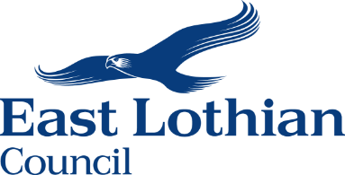
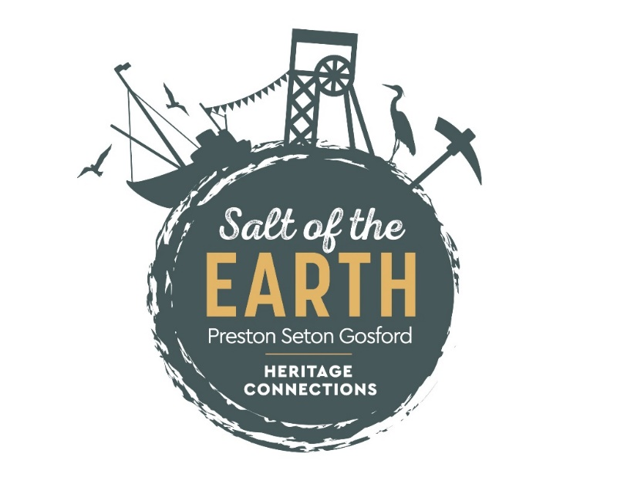

Salt of the Earth
Preston Seton Gosford Heritage Connections

COMMUNITY HERITAGE FUNDING
ROUND TWO GUIDANCE

Funded by the Heritage Lottery, the Preston Seton Gosford Area Partnership, and supported by East Lothian Council, Salt of the Earth aims to support local heritage groups and initiatives by carrying out research, establishing a local heritage network, providing support and training, and providing small grants to local people to help them develop and deliver projects that promote and engage the community with their heritage and help reduce inequalities.

GUIDANCE

The Salt of the Earth Community Heritage Fund is an exciting opportunity for the community to put forward local ideas for projects that will have a positive impact in promoting local heritage and reducing inequalities in our community.


What’s the Process?
The funding is available to anyone in the communities of Prestonpans, Longniddry, Cockenzie & Port Seton.

HOW MUCH MONEY IS AVAILABLE?

A total of £50,000 is available to fund projects.

£25,000 was allocated in Round One

A further £25,000 is now available through Round Two of the Community Heritage Funding - £5,000 for projects of between £100 and £500 and £20,000 for projects between £500 and £5,000.

This funding has been secured from the Heritage Lottery Great Place Scheme and the Preston Seton Gosford Area Partnership.


HOW MUCH CAN I APPLY FOR?

Applications can be made for funding from £100 up to a maximum of £5,000 for a single project.

Note: If your project will cost more than the amount you are applying for, you must show that you will have the rest of the money, and can complete the project. It is also possible to use the funding as match for other funding streams.


KEY DATES

APPLICATIONS OPEN: Thursday 15th April 2021
APPLICATIONS CLOSE: Friday 14th May
(No applications will be accepted after midnight on this date)
SIFTING PROCESS: 18th – 20th May
All applications will be subject to a sifting process to ensure that they meet the criteria rules and aims of this initiative. The decision of the selection panel is final.
NOTIFICATION: Friday 21st May
(Notification to successful projects put forward to the next stage)
ONLINE VOTING PROCESS (if required): FROM 21st to 27th May
FINAL DECISIONS: Friday 28th May


WHO CAN APPLY?

An application can be submitted by any group, organisation or individual serving the communities of Prestonpans, Cockenzie & Port Seton and Longniddry.

Applicants must meet the following criteria:

A – Be a Constituted Group and have a bank account, or
B – If not a Constituted Group, have a sponsor organisation to receive funds on their behalf
C – Must comply with equalities legislation and be proposing a project that provides equal access

Note: Funds can only be transferred to an organisation with a constitution and bank account. If you are applying as an individual, or a group, that does not represent an organisation with a constitution and bank account, please select a sponsor organisation who can receive the funds on your behalf. All successfully funded applicants will be required to provide a finance sheet at the end of their project to show how funds were spent.


WHAT TYPE OF PROJECTS COULD BE FUNDED?

Any type of activity project can be submitted that you think will have a positive effect on the community in promoting heritage and reducing inequalities. We are particularly interested in projects that engage with new audiences, and that help people understand and enjoy their local built, cultural, and natural heritage.

However, you will need to demonstrate clearly which aspects of the following issues your project addresses:

- Will connect people to local heritage
- Will strengthen the community
- Addresses issues related to Covid
- Is inclusive of everyone
- Helps to reduce inequalities
- Includes local volunteering, employment, or training
- Will attract more visitors to the area
- Links communities across Preston Seton Gosford

Note: Applications cannot be submitted to fund ongoing projects. Applications must be for a new project or initiative. (see below)
Your project must:

- Be based within the Preston Seton Gosford Ward, and benefit the communities of Prestonpans, Cockenzie & Port Seton, and Longniddry,
- Be based on activities that promote local heritage and benefit the community.
- Demonstrate a positive impact on reducing inequalities – e.g. helping people with disabilities access heritage.
- Be either a new project or a distinct addition to an existing project, not just a continuation of an existing project.
- Be completed within 10 months of receiving funding.

Example
Help with facilities for socially distanced meet ups for different heritage groups

Example
Guided Heritage Walk on the John Muir Way for people with disabilities

Example
Digital project to allow people to visit local heritage sites on line if housebound.
Example
Outdoor learning or activities in and around heritage and/or natural heritage settings
Example
Intergenerational Oral History project to help reduce social isolation.

WHAT WILL NOT BE CONSIDERED?
- Large-scale capital work to buildings, cultural venues, habitats and other types of heritage asset.
- Organisations, groups/projects that do not comply with equalities legislation.
- Party political, lobbying or religious activity, although applications can be accepted from faith groups for projects that meet the Fund’s criteria.
- Routine property maintenance, repairs, or ongoing running costs; e.g. salaries, electricity, rent/rates, insurance, postage, phone, website.
- Servicing of debt or monies already spent.
- Contributions to larger fund-raising, e.g. for a new building.


APPLICATIONS

Applications forms can found via the following link:
www.eastlothian.gov.uk/heritagefunding

Alternatively paper applications can be sourced by emailing:
psg-ap@eastlothian.gov.uk or jdefresnes@eastlothian.gov.uk

Completed paper applications should be sent to: Jill de Fresnes, Salt of the Earth, Preston Seton Gosford Heritage Connections, Aldhammer House, High Street, Prestonpans, EH32 9SH


OTHER RULES AND CRITERIA

SELECTION PROCESS: All applications will be checked to ensure they meet the criteria. The Salt of the Earth Steering Group will consider each application and the decision of the Group is final. Feedback will be provided to unsuccessful applicants.

SIMILAR APPLICATIONS: If applications are received for similar projects, the respective applicants may be approached to consider a joint working project.

PROJECT PROMOTION: Applicants will be required to provide sufficient information so their project can be viewed online by the public. The format for this will be provided by the Preston Seton Gosford Area Partnership. Support will also be available if required.

MEDIA: Successful applicants may be asked to provide details for media coverage. A date will be chosen for an event where the successful applications will be announced.


HELP!!
We want to ensure that your application has the best possible chance of getting funding and we are happy to help you. If you need any assistance please contact either of the following and we will do our best to provide assistance.

Email: psg-ap@eastlothian.gov.uk or jdefresnes@eastlothian.gov.uk
Phone: Jill on 07969 539707


WHAT HAPPENS IF MY PROJECT IS SUCCESSFUL?
- Funding of all projects will only be to the total value of £25,000.

- If project applications exceed this total then the decision will be made through an online Community Vote

- The successful projects will be announced on 28th May 2021

- Funding will only be paid into a constituted bank account.

- Funds will be available within 14 working days of your bank account being verified.

- You will be required to provide evidence of the spending on the project for the amount successfully funded as required by the Preston Seton Gosford Area Partnership.

- You will be required to provide an interim and final evaluation and update of your project in a format and at a time required by the Preston Seton Gosford Area Partnership

FUNDING FOR TRAINING FOR EXISTING HERITAGE GROUPS AND ORGANISATIONS IS ALSO AVAILABLE NOW THROUGH SALT OF THE EARTH.
PLEASE GET IN TOUCH IF YOU HAVE TRAINING NEEDS – PARTICULARLY IN RELATION TO RE-TRAINING AS A RESULT OF THE PANDEMIC

